1. **Naslov naloge: Nogometni trening**
2. **Zasnovana na** (če obstaja, URL naloge, na kateri temelji):

<https://pisek.acm.si/contents/4907-4902-755538839653978838-1012387714428699274-159713081347676434/>

1. **Predlagatelj** (ime, priimek, e-pošta):

**Alja Herga, ah69923@student.uni-lj.si**

1. **Ilustracija naloge**

**1.level**

|  |  |  |  |  |  |
| --- | --- | --- | --- | --- | --- |
|  |  |  |  |  |  |
|  |  |  |  |  |  |
|  |  |  |  |  |  |
|  |  |  |  |  |  |
|  |  |  |  |  |  |
|  |  |  |  |  |  |
|  |  |  |  |  |  |

**2.level**

|  |  |  |  |  |  |
| --- | --- | --- | --- | --- | --- |
|  |  |  |  |  |  |
|  |  |  |  |  |  |
|  |  |  |  |  |  |
|  |  |  |  |  |  |
|  |  |  |  |  |  |
|  |  |  |  |  |  |
|  |  |  |  |  |  |
|  |  |  |  |  |  |
|  |  |  |  |  |  |
|  |  |  |  |  |  |

**3.level**

|  |  |  |  |  |  |  |  |  |  |
| --- | --- | --- | --- | --- | --- | --- | --- | --- | --- |
|  |  |  |  |  |  |  |  |  |  |
|  |  |  |  |  |  |  |  |  |  |
|  |  |  |  |  |  |  |  |  |  |
|  |  |  |  |  |  |  |  |  |  |
|  |  |  |  |  |  |  |  |  |  |
|  |  |  |  |  |  |  |  |  |  |
|  |  |  |  |  |  |  |  |  |  |
|  |  |  |  |  |  |  |  |  |  |
|  |  |  |  |  |  |  |  |  |  |
|  |  |  |  |  |  |  |  |  |  |
|  |  |  |  |  |  |  |  |  |  |
|  |  |  |  |  |  |  |  |  |  |
|  |  |  |  |  |  |  |  |  |  |

1. **Besedilo**

**Lučka zelo rada igra nogomet, želi pa se še izboljšati, zato vsak dan doma trenira vodenje žoge. Pomagaj ji voditi žogo med drevesi in vse do gola.**

1. **Vnaprej podana koda:**

**/**

1. **Koda rešitve**

**1.level**

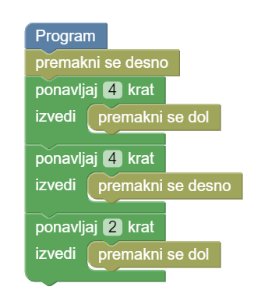

**2.level**

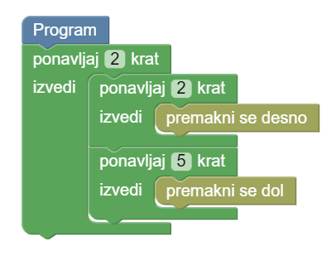

**3.level**

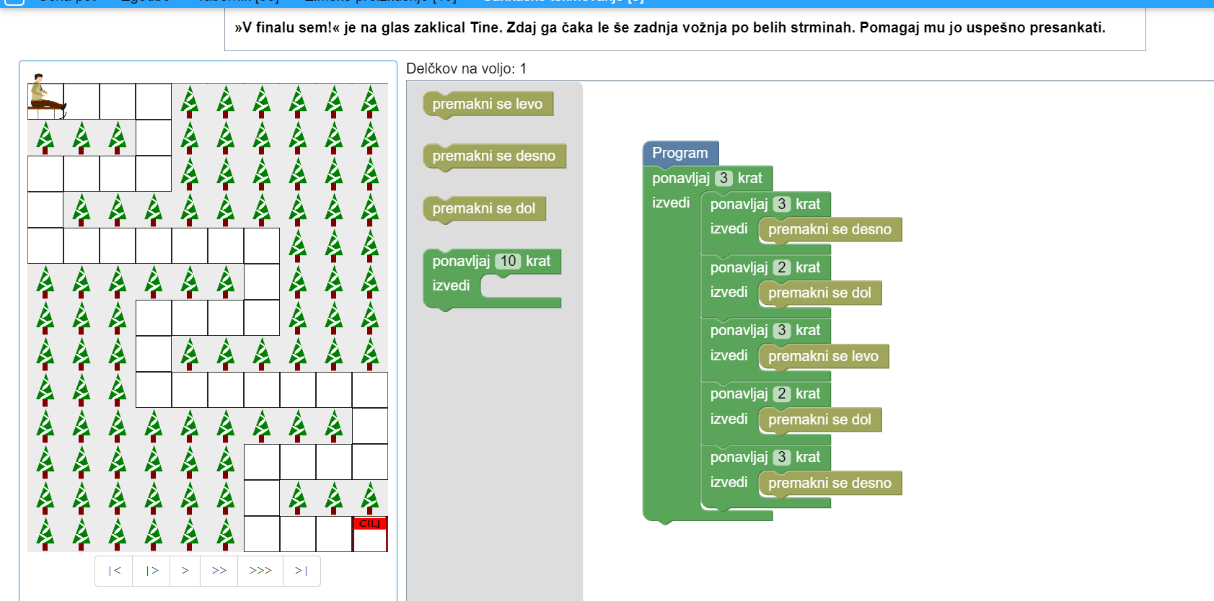

1. **Testni primeri**

DODATNO:

Opombe sestavljavcem, priloga grafične datoteke (z informacijo o avtorju/pravicah), morebitne omejitve glede delčkov, kateri delčki naj bodo, kaj naredijo (če niso standardni), …

Podani delčki (pri vsakem levelu):

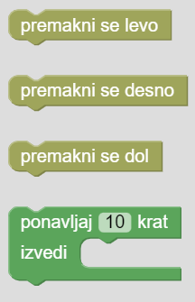

Pri vsakem levelu je tudi omejeno število delčkov na voljo, da se spodbudi uporaba zanke.