Module 6 Part 2

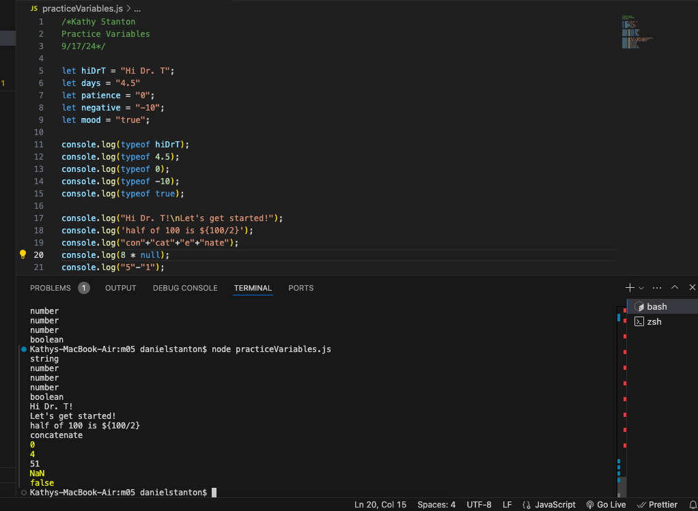

1. I think the set of outputs from #3 (line 5-9) is surprising. I was expecting the same values to be on the terminal, much like the values from #5 (line 17-21).
2. It looks to me like the \n is causing the line break in step 5.1.
3. The + sign combines the terms to create a new word, concatenate, which means to link things together in a chain or series.

5.2 From what I can tell, the $ isn’t an operator in Java. So the statement isn’t returning the expected value rather it’s just printing the statement.

5.3 (“con”+ “cat” + “e” + “nate”) is a series of syllables linked together to make the word concatenate.

5.4 This is a multiplication problem with null=0 so the value returned is 0

5.5 (“5” - 1) returns a 4 because Java takes the “5” string and makes it a number due to the subtraction sign. You wouldn’t use subtraction with text strings, so Java does the math.

5.6 It looks like (“5” + 1) is being concatenated. I found that the 1 is turned into a string so that the program is putting “5” + “1” together to make 51. Because there’s a + sign next to the string, and you can add text strings together, Java assumes the “5” is a string, not a number.

5.7 The string “five” isn’t a number. Java is reading it as text, so it can’t multiply 5\*2, so the output is Not A Number.

5.8 This is boolean logic. The == equal should mean that false equals true, but the statement is false, producing the ‘false’ out put.