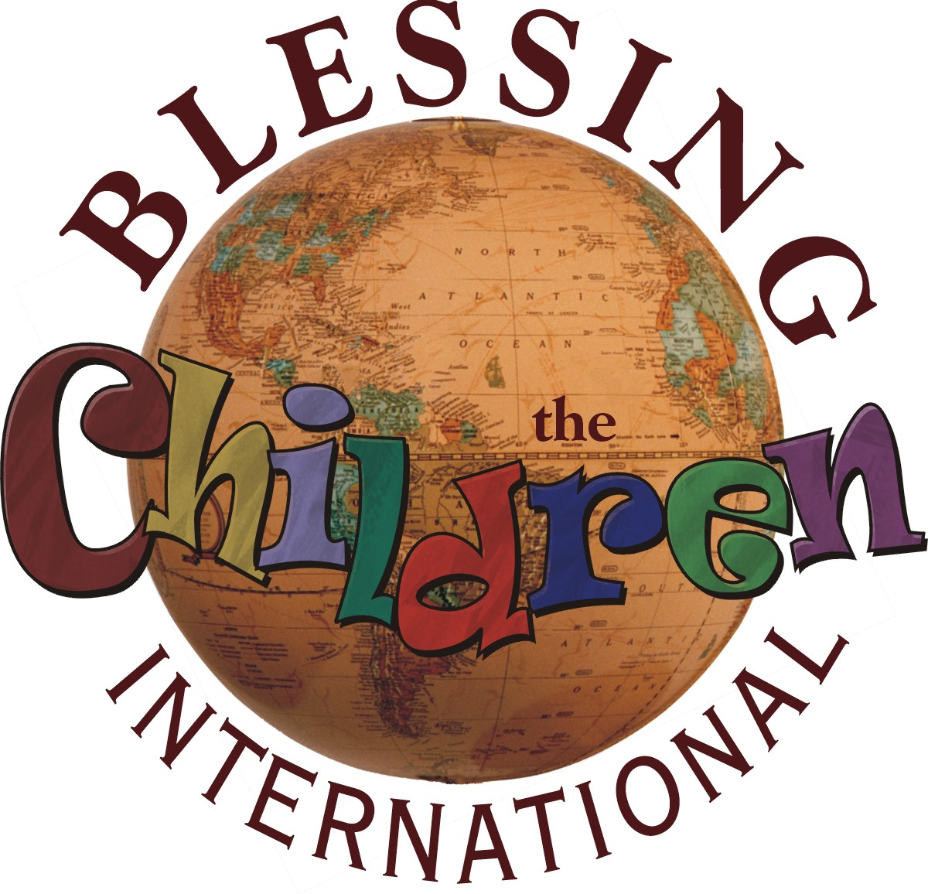

Blessing the Children International

Please attach   
a recent photo here. Attach also to email if emailing this application.

**Missions Application**

Applying for trip to:

Mission Trip – Dates:

Internship – Dates:

Study Abroad – Dates:

Missionary – Dates:

1. General Information

Full Name:    Nickname:

Street Address:

City:         State:       Zip:    Country:

Cell Phone: (      )        -        Best time to call:

Home/Other Phone: (      )         -        Best time to call:

Email:

Gender:       Age:       Date of Birth:

Marital Status: Single Engaged Married Divorced Widowed

If married, spouse’s name:

Are you currently enrolled in college? No Yes *If yes, complete the following:*

Number of semesters completed:     Graduation Year:     GPA (4.0 scale):

College:   Major:

College Address:

## Family Information (if under 21 years of age)

Parent(s)' Name(s):

Street Address:

City:          State:       Zip:

Home Phone: (      )        -        Best time to call:

Other Phone: (      )        -        Best time to call:

Email:

## Employment Information

Occupation:

Company/Employer:

Telephone: (      )        -

Job Description:

Do you wish to serve in this capacity on your trip: No Yes

## Insights

# How did you hear about Blessing the Children?

Google ChristianConnector.com ShortTermMissions.com Other:

# What motivated you to volunteer for this trip?

# List your skills, hobbies and abilities and their relevance during the trip:

# What do you hope to accomplish on this trip?

## Prior Trip Experience

# Have you ever been on a mission’s trip? No Yes If yes, complete the following:

# Name of the agency/ministry served:

# Length of trip(s):

## Travel Information

# Nearest city with a major airport from which you prefer to depart:

# What size t-shirt do you take? Small Medium Large X-Large XX-Large XXX-Large

Country of Citizenship:

Do you have a valid Passport? No Yes, number:

## References (not immediate family members)

# Name & Relation:

Phone & Email:

# Name & Relation:

Phone & Email:

# Name & Relation:

Phone & Email:

For consideration of the acceptance of my application, I do hereby for myself, my heirs, executors, and administrators waive, release, and forever discharge any and all rights and claims for injury or illness (including death) whether physical, mental, or emotional, or property damage or loss of any nature, which I may have or which may hereafter accrue to me against Blessing the Children International, their members, officers, agents, representatives, successors, and/or assigns, individually or collectively for any and all damages and liabilities which may be sustained and suffered by me in connection with my associations with and/or arising out of my traveling to, participation with, and return from any Blessing the Children International work, services, or activities.

I hereby acknowledge that I have read and agree to the *Team and Missionary Policies* and that I have answered the previous questions honestly and accurately to the best of my ability. Team & Missionary Policies available here:  
<http://blessingthechildren.org/Forms/Team_Missionary_Policies.pdf>

**Printed Applicant Name:** *If applicant is under age 18, parent/guardian must sign:*

**Signed** ____________________________Date   **Printed Name:**

**Signed** ________________________ Date

Completed application may be submitted via email to [Trips@BlessingTheChildren.org](mailto:Trips@BlessingTheChildren.org) and the application fee ($40) paid by credit card by calling (888) 269-2719. Otherwise please mail a check with the signed application to:

Blessing the Children International

2265 Fraser Road

Kawkawlin, MI 48631-9145

**A hand-signed application must be mailed, even if submitting the application via   
email or fax. Processing cannot begin without payment of the application fee of $40.**