CTD_techRat

Disclaimer:
This tool has been developed strictly for educational purposes, authorized penetration testing, and remote administration of devices you own or have explicit permission to control. Misuse of this tool is strictly prohibited. The developer is not responsible for any damages, legal consequences, or unethical use of this software. By using this tool, you agree that: You will not use it to access, control, or damage any device or network without explicit authorization. You assume full responsibility for any actions taken using this tool. You comply with all local, national, and international laws. THIS TOOL IS ONLY JUST FOR EDUCATION PURPOSE

Introduction:
CTD_techRat is created by “Cyber Digital Tree” Team. It is a Rat, a sub type of Malware. This tool is only create for learning purpose. By using this tool you will learn about “how hacker download, upload, travers the directory, run and delete one and multiple files. This tool is design only for Window OS. Not for Linux OS. After completing\uploading this project will start working for Linux OS. When you start making any action on user side. Like downloading file then a directory of that user name will create automatically and every client data will handle individually.
I design this tool for those user “who don’t know to use kali linux and are also not good in commands
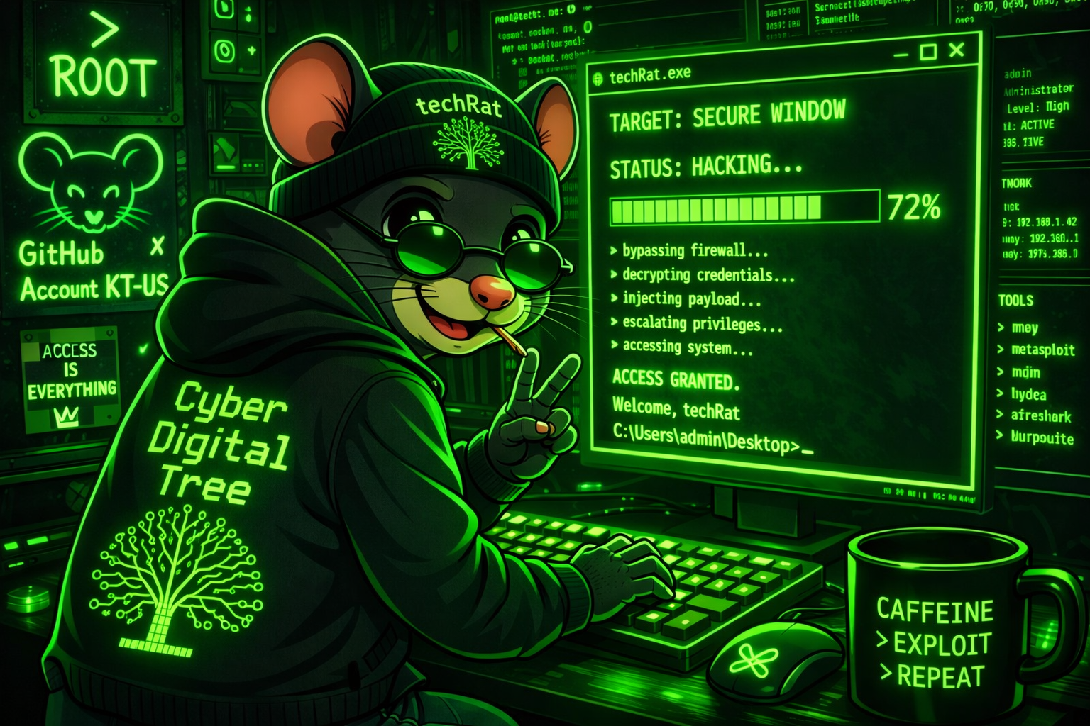

Practical:
So, instead of moving toward theory, I will directly move on practical work.
This tool have capability of handling “one to one” and “one to many” client. You can send command to “one client” or “one to many” at a same time. As you can see in Picture no 1. In this picture you can see only one user is connection. A question came here in our mind “how many number of client can connect with our server”

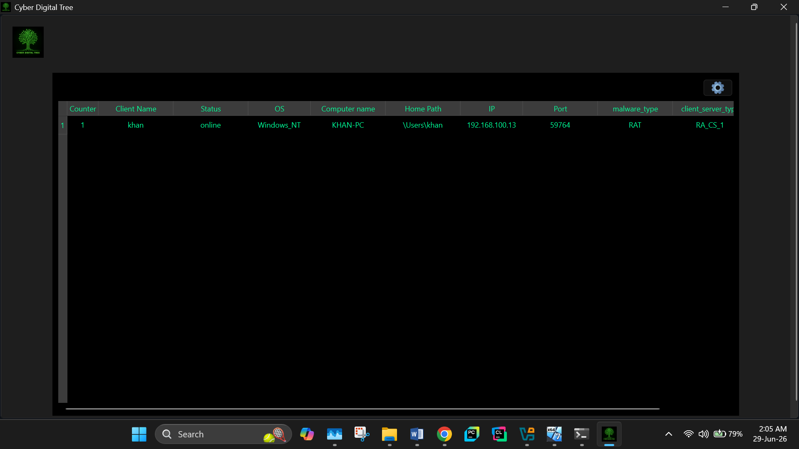
Picture no 1:
The answer of above question is “you can connect 1000 of client with the server at the same time. And also you can send them command individually. You can run “techRat” at window 7/8/10/11.
What happened when you click on any client?
When you click one any user then a new window will popup as you can see in picture no 2.
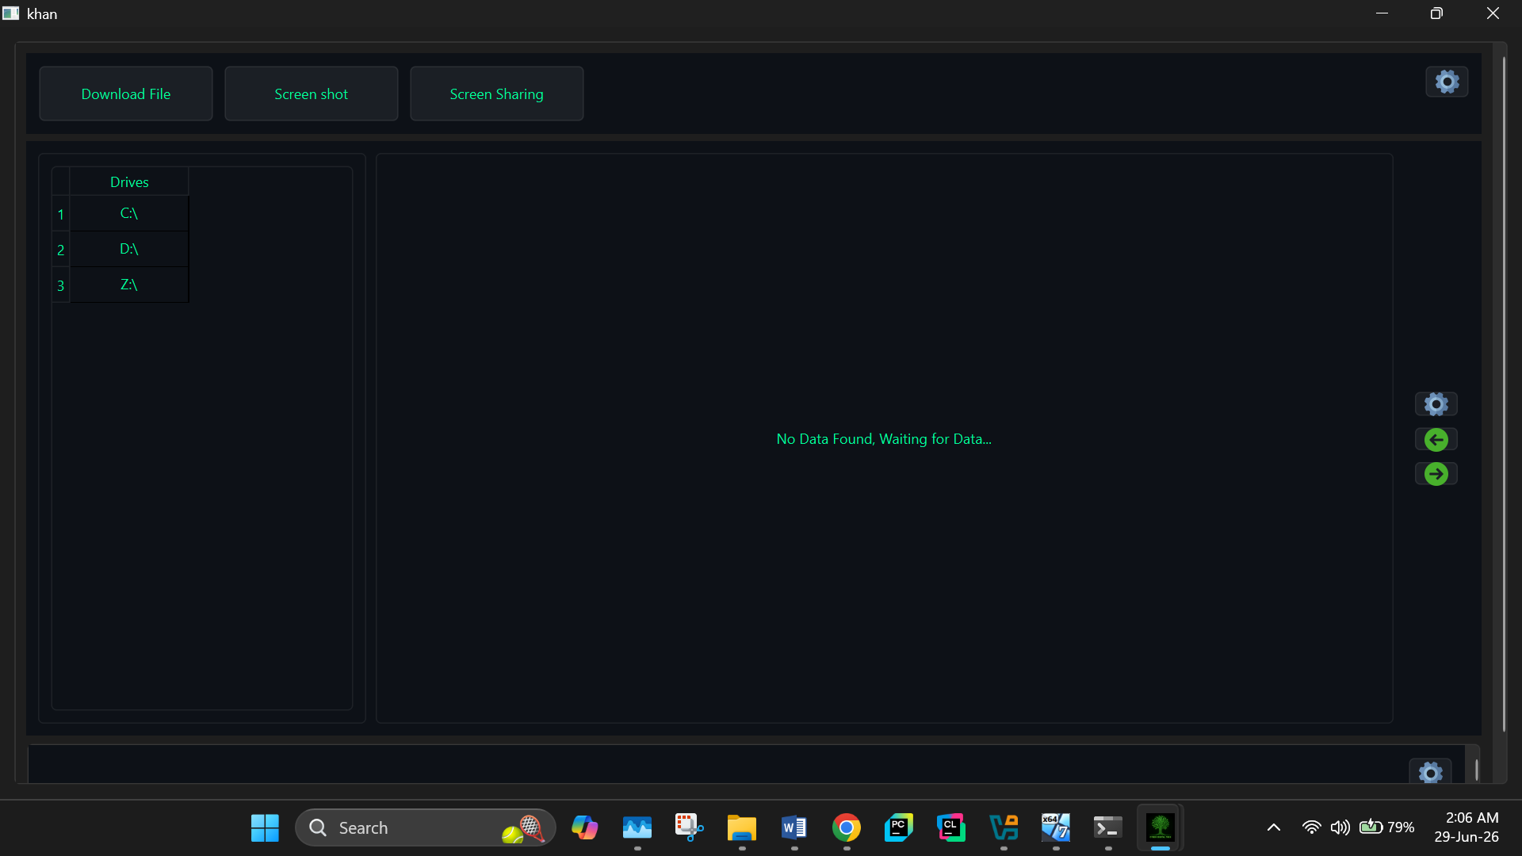
Picture no 2:
Then you can see the number of drives (all the external device like USB are included) a system have like Drive C, D and Drive Z. I am testing my tool in individually Virtual Box. So Drive Z is shared box between my main Machine and virtual box. So, here is the one more question. What happened when we click on any Drive?
Click on Drive:
when you click on drive then you can see al the sub directories that are inside of that drive, Because , I want to let my user file like a real hacker. So he\she can see all the file/folder as like they have sitting in front of their client pc, As you can see in picture no 3. There is also a setting button to change background and text color. Which will also increase my user curiosity and interest and they feel like a real hacker (as like red hat, black hack and green hat hacker). There are also two button which are used to navigate backward and forward as like you see in Desktop -> File Explorer and also when you are using any website. Those arrow key will also make live directory forward and backward traversing.
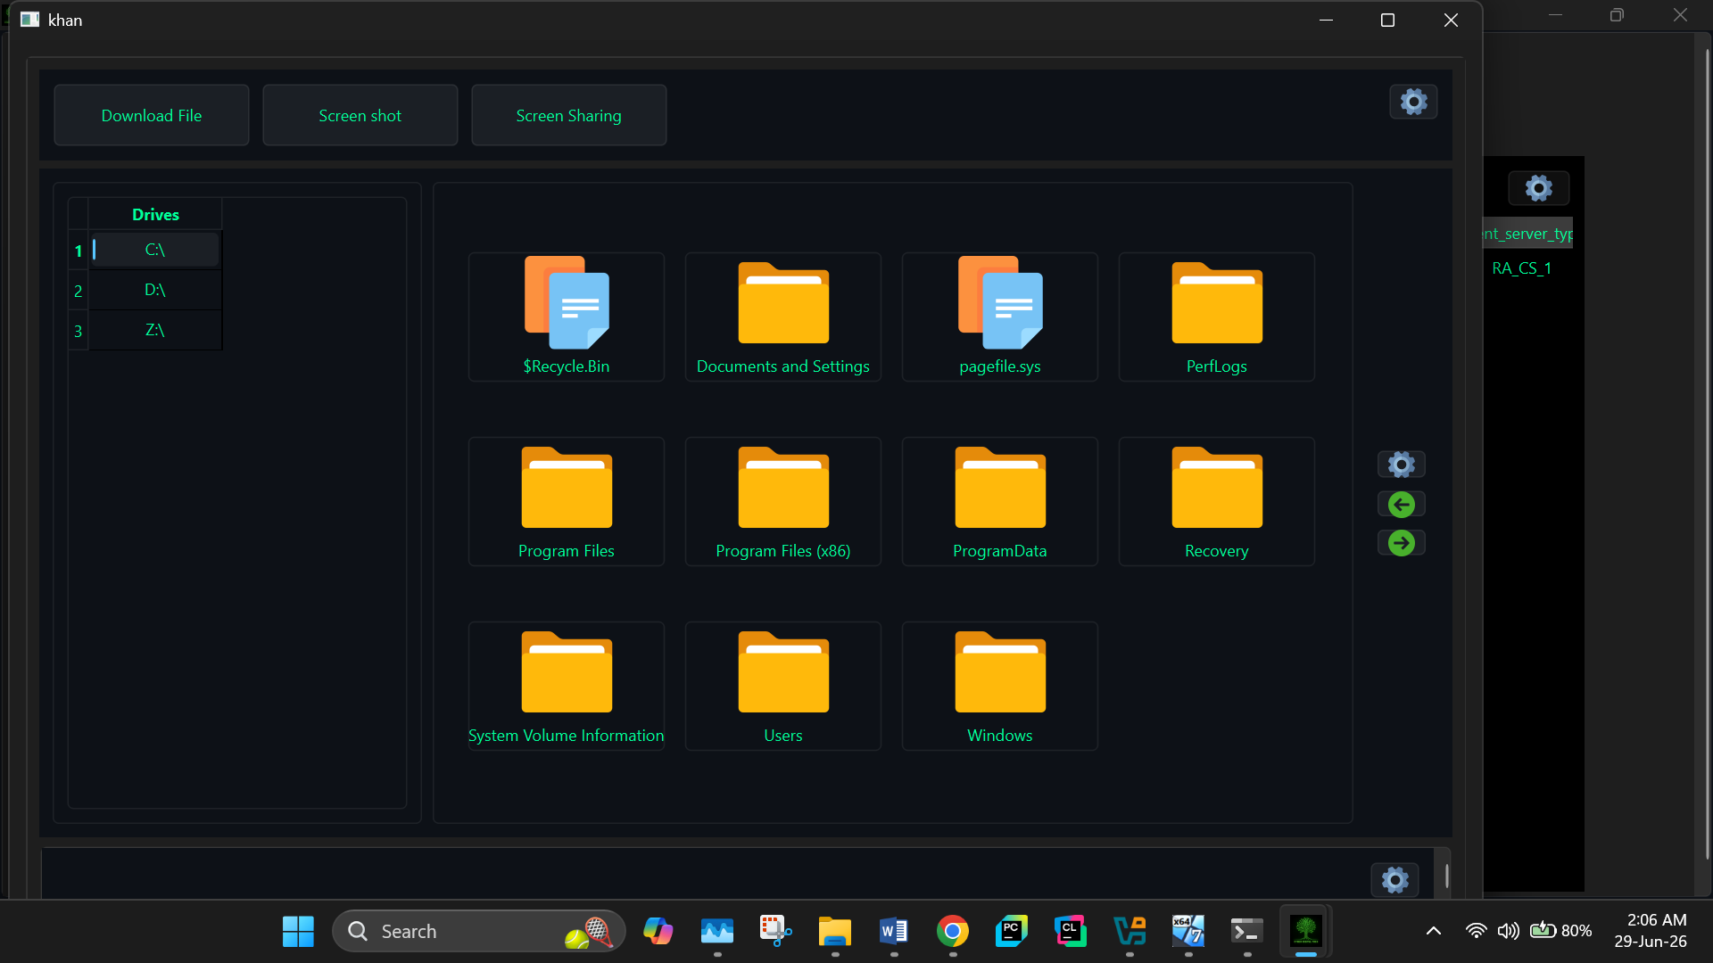
Picture no 3:
In picture no 3, you see there are three buttons.
Download Files:
Then you click on Download file button, then a list of action will appears like. .pdf, .jpd, jpeg. , .png. as you can see in picture no 4. When you click on any option then it will start scanning and searching option like (you click on pdf file extension) then it start from C Drive to all the Drives and try to find out all those files which have “.pdf” file extension. Here is one important thing. When you are using Download file and Screen sharing option. You can only Download all file with same extension from one user and you can only download one file type at a time. If you start downloading file like .png from user A then you are Restricted/ not allowed to download other file any type of file. Because it consume a lot of our system resources. When you start making any action on user side. Like downloading file then a directory of that user name will create automatically and every client data will handle individually.
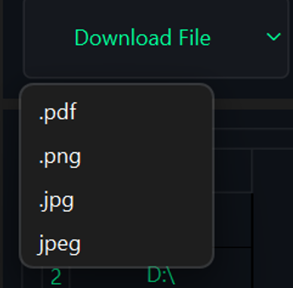
Picture no 4:
In the picture no 5, you can see all the file downloading logs and download file progress bar. You can also see client name and file type that you are downloading. When you start making any action on user side. Like downloading file then a directory of that user name will create automatically and every client data will handle individually.

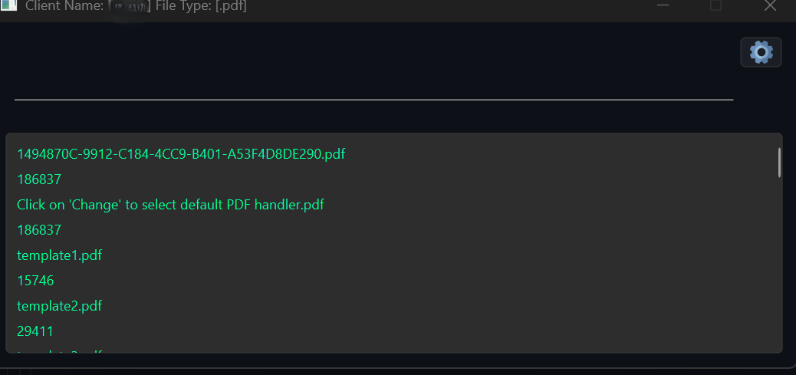
Picture no 5:
Screen Sharing button:
You can live monitor to your client PC screen when you click screen sharing button. Here is one more important. You can only monitor one user screen at a time, Because it consume a lot of our system resources. you can also increase screen Resolution/video quality. As you can in picture no 6.
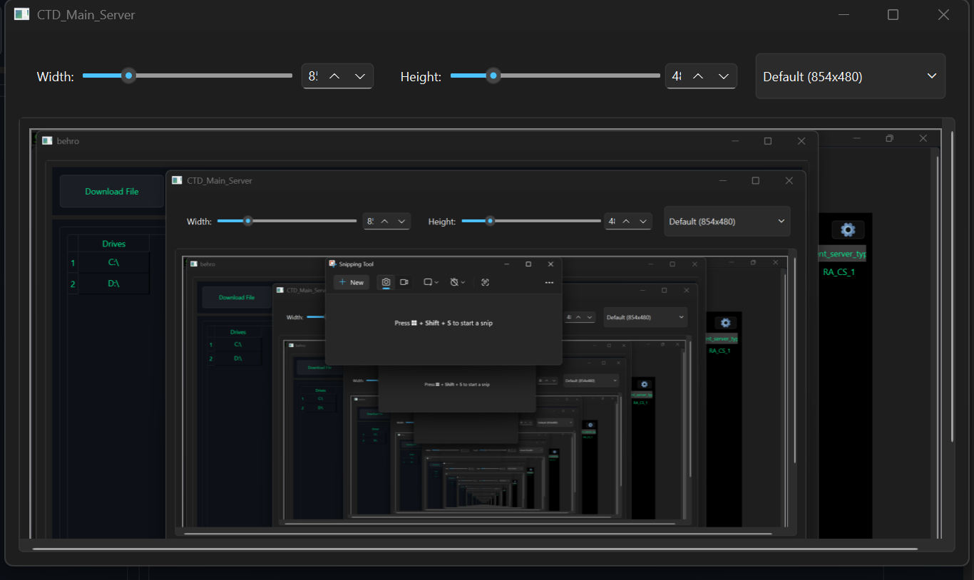
Picture no 6
Screen shot:
You can also take screen shot and it will automatically save according to client name. When you start making any action on user side. Like downloading file/screen shot then a directory of that user name will create automatically and every client data will handle individually.
Download any file:
What if user want to download file like abc.exe from zyz dir. So for that you have to make right click on that file. Then a menu will pop. As like you can see in picture 7; and click on download file buttone then you are able to download that file.
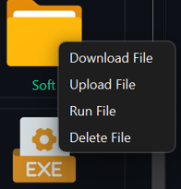
picture 7

Upload file:
If you want to upload any file on you client side. Then you have to make right click on any file/ directory then uploading file navigation window will popup then you have to select one file that you want to upload. Here is one more important thing, if you are in a director abc and you want to upload file into abc dir then you have two options:
- Find any file into abc dir like .txt, .pdf , .png etc. just right click on it then system will automatically detect that file parent dir which is abc dir. As you can in pic 8.
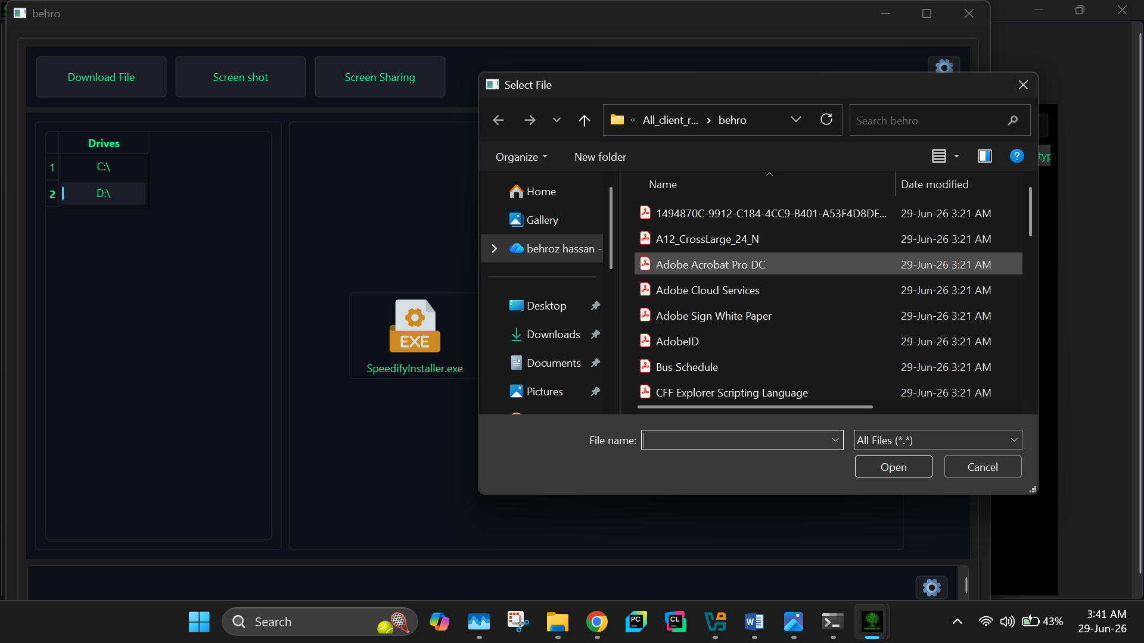
Picture no 8
Else you have to use backward arrow key and go to one dir back then make righ click on abc dir and select upload file option. As you can see in picture 9 and 10.
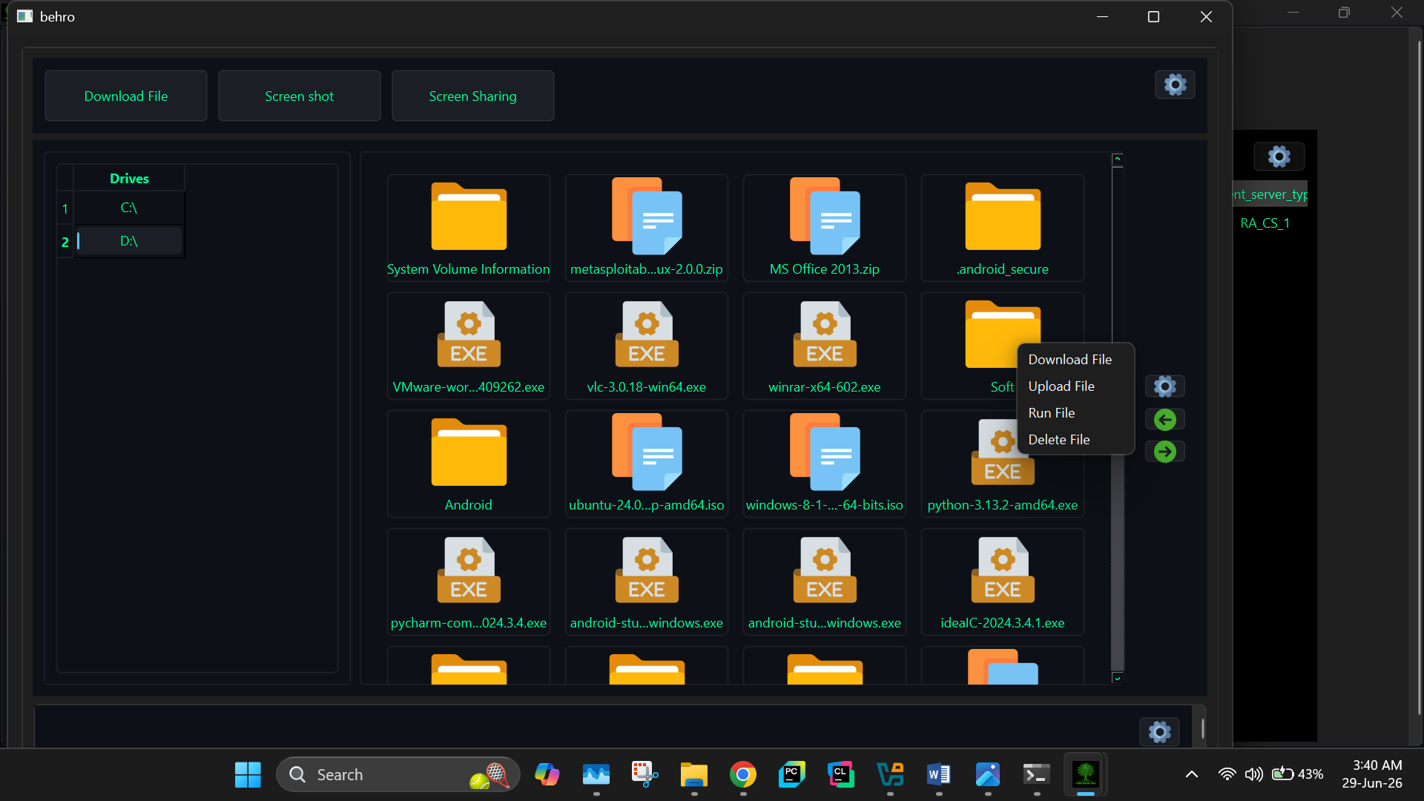
Picture no 9


Picture no 10
Run and Delete any file:
techRat also give you option to run any exe file.it also give you option like delete any type of file from anywhere in the system, as you can see the options in picture no 7.

Wait for my next project where I will teach you about latest anti-virus bypassing technique.

