**Computer Vision HW3 Report**

Student ID: R12K41025

Name: 杜冠廷

**Part 1.**

**• Paste your warped canvas**

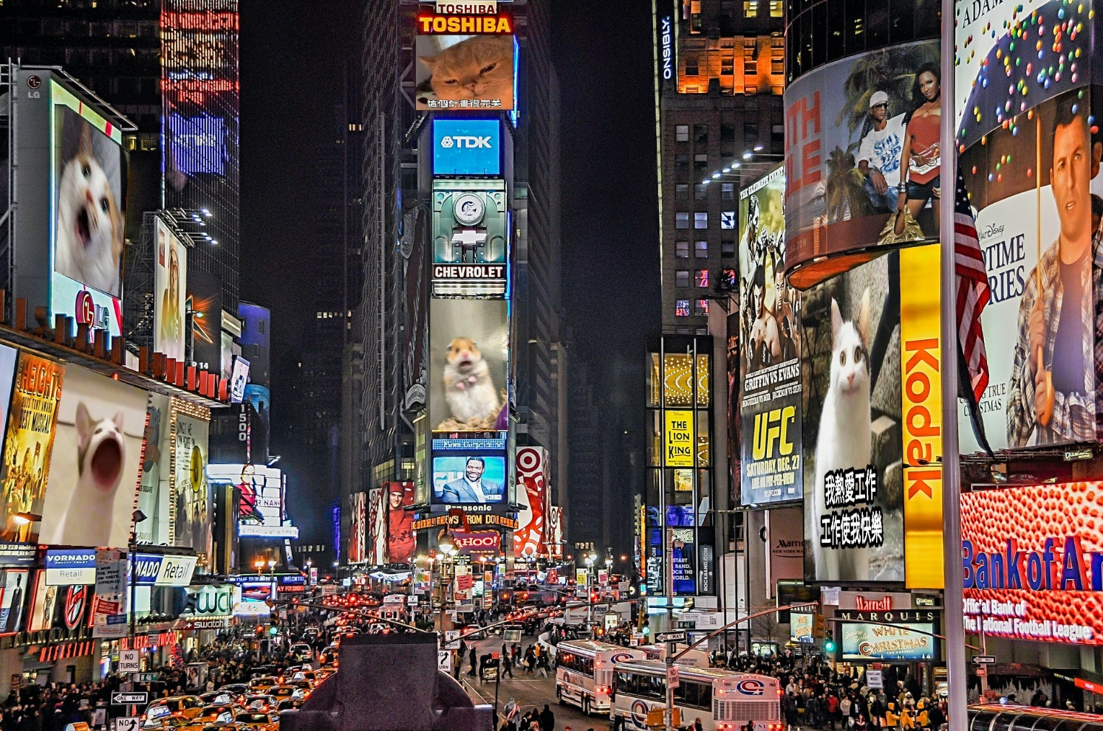

**Part 2.**

**• Paste the function code *solve_homography(u, v)* & *warping( )* (both forward & backward)**

|  |
| --- |
| **solve_homography(u, v)** |
|  |
| **forward warping( )** |
|  |
| **backward warping( )** |
|  |

**• Briefly introduce the interpolation method you use**

We use the nearest neighbor method by rounding the coordinates to the closest integer to get the pixel index. In forward (or backward) warping, we choose the nearest pixel after mapping to the destination (or source) image. In Python, this can be done using the “.astype(int)” function to convert the coordinates to integers.

**Part 3.**

**• Paste the 2 warped images and the link you find**

|  |  |  |
| --- | --- | --- |
| **BL_secret1** | | **BL_secret2** |
|  | |  |
| **Link** | <http://media.ee.ntu.edu.tw/courses/cv/25S/> | |

**• Discuss the difference between 2 source images, are the warped results the same or different?**

The first image (BL_secret1) is projected onto a "planar" projection plane. However, the second image (BL_secret2) is not projected onto a flat projection plane (for example, straight lines in the real world appear curved in the image). To address the issues of distortion and irregularity, we want to process the images on a planar projection plane. Therefore, we can see that the warped result of the BL_secret1 image (on the left) is clearer and more accurate than that of the BL_secret2 image (on the right). Although the scanning results are the same, the two images are not exactly identical.

**• If the results are the same, explain why. If the results are different, explain why?**

Due to the distortion present in the second image, the warped results of the two images are noticeably different. However, the decoded link remains the same. This is likely because QR codes are designed with error correction capabilities, and our mobile phone cameras can handle a certain level of distortion. In other words, as long as the distortion isn't too severe, the phone can still accurately decode the QR code.

**Part 4.**

**• Paste your stitched panorama**

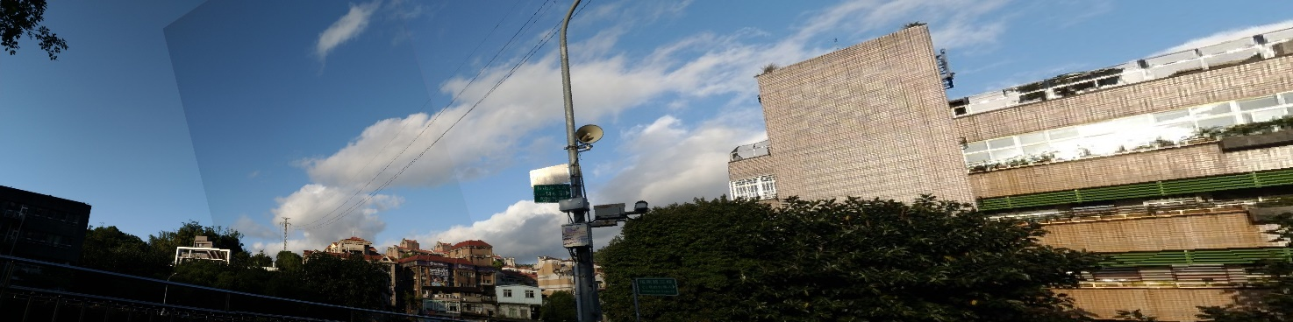

**• Can all consecutive images be stitched into a panorama?**

No. In some condition (e.g., when there are too few matched feature points between images), it's not possible to successfully stitch consecutive images into a panorama.

**• If yes, explain your reason. If not, explain under what conditions will result in a failure?**

To create a panorama by stitching images together, we need to detect features, match them between images, and find a homography matrix that works best for each pair. But if there aren’t enough matching points between two images, or if the matches are incorrect, we can’t figure out the right transformation between them. This can lead to strange warping and heavy distortion in the final stitched result. To avoid this problem, we should choose image pairs with plenty of good matches and try not to use images that have many similar-looking objects, which can confuse the matching process.