Guide to the Annual Bibliometric Monitoring at KTH

2021-02-10

This guide gives an introduction to the Annual Bibliometric Monitoring (ABM) at KTH Royal Institute of Technology. The purpose of the guide is to help you navigate the presentation of results, to understand the bibliometric indicators used in the report, and to interpret the results. More detailed description of indicators and methods are found in [*Description of methods, data and indicators in KTH Annual Bibliometric Monitoring*](https://kth-library.github.io/abm/Description_data_and_methods_ABM.pdf).

Background

The aim of the ABM is to assist monitoring, research evaluation and quality assurance at KTH, but also to provide KTH organizations and researchers with information related to their publications. The ABM was introduced in 2013 and was published annually in the same format since then. In 2019, a project aiming to redesign and develop the ABM was started. This resulted in the current solution, maintaining the same information as in previous years but in a more flexible framework with a presentation that is more dynamic, extendable and easier to maintain. That is the version of ABM described here.

The ABM results are available at different levels, for KTH in total, Schools, Departments and for individual researchers. The report currently has the same format and contents at all levels. Data is presented for the last 6 years with a complete publication record, which in practice means the year before last autumn and the five preceding years (i.e. in the spring of 2021, the ABM contains data for the publication years 2013-2019).

Only publications registered in DiVA and affiliated with KTH are included in the results (i.e. publications that KTH researchers have published at other organizations are excluded). Affiliations to KTH are based on the actual author affiliation as written in the published paper. All citation data and derived indicators are based on Web of Science[1], and indicators are therefore only presented for publications covered by Web of Science.

If a School or Department have changed name or the organizational structure has in any other way changed, publications affiliated to old organizational units have been assigned to the corresponding current unit when possible.

Overview

The *Overview* tab includes key indicators displayed for the latest available time period[2] and general information about ABM and publication activities at KTH. For organizational units, there is also a button leading to the unit’s publications at [altmetric.com](https://altmetric.com).

Most numbers on this tab are based on fractionalized counts, i.e. an author’s share of a publication is counted as 1/n where n denotes the number of authors. The exception is the *Copublication* charts, which are based on full counts.

The overview at the KTH, school and department level is available to everyone, except for the button for publication list download which is only available for logged in KTH users.

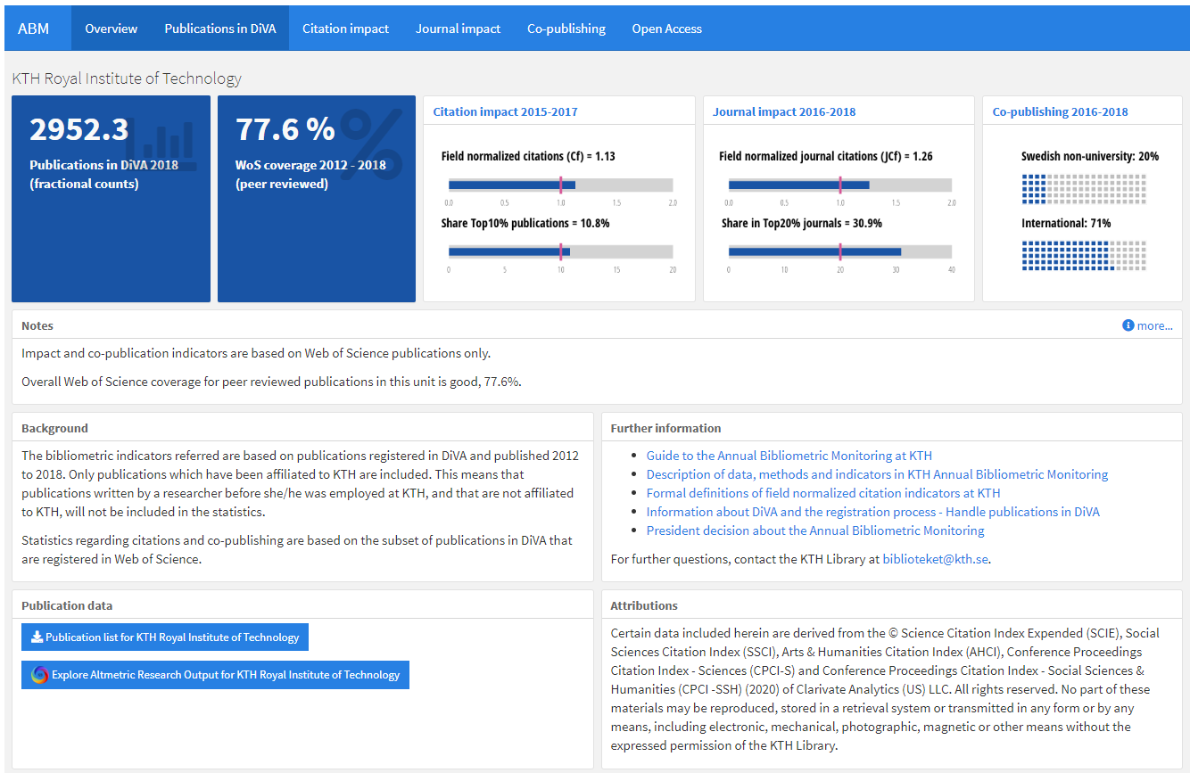

Publication list only available after log-in.

The red lines in the charts mark the world average indicator value.

The individual view, only available to the researcher, also includes a link to edit publications in DiVA.

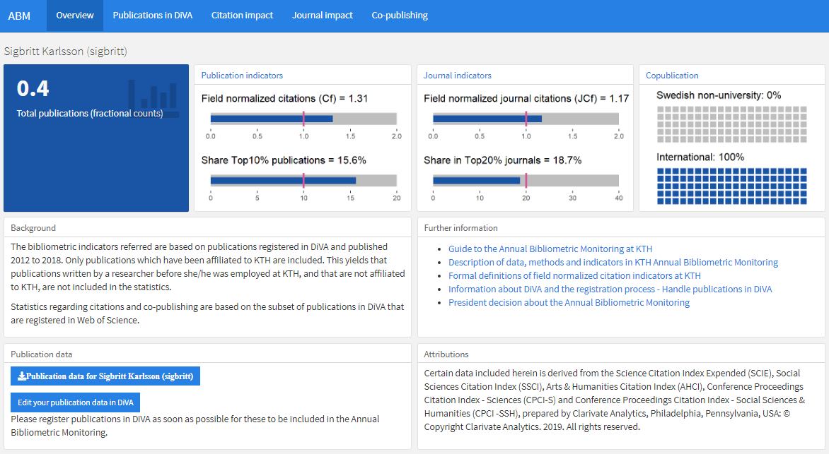

Publications in DiVA

The *Publications in DiVA* tab shows the number of publications registered in DiVA for the researcher or organizational unit, by year and by publication type. Web of Science (WoS) coverage is also shown for each publication type. The validity of bibliometric indicators is in general higher if the share of publications covered is high. Results based on publications with a smaller share covered in WoS should be treated with caution.

All numbers on this tab are based on fractionalized counts. The graphs show the same information as the table.

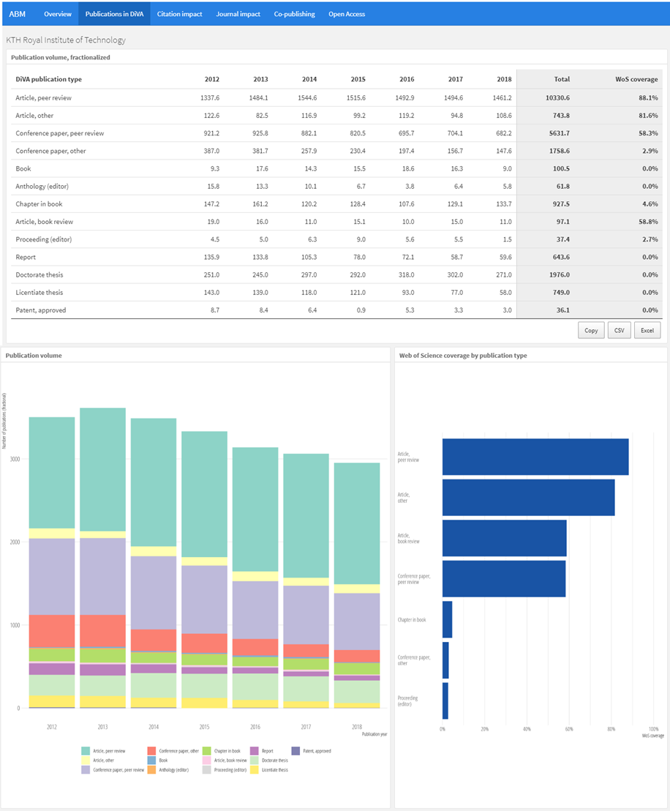

All tables can be copied or downloaded with these buttons

Citation impact

The *Citation impact* tab shows citation impact for the researcher’s/unit’s publications. All numbers on this tab are based on fractionalized counts.

The first table in this view shows the total and average number of citations after three years, i.e. citations received in the publication year and the two directly following years, as well as the number and share of publications that were not cited in that time. This table is based on the Web of Science document types Article, Proceedings paper, Review, Letter and Editorial.

The second table is based on the Web of Science document types Article and Review, and shows Field Normalized Citations (Cf) and the number/share of publications belonging to the 10 percent most cited in its field.

The normalization is done so that the citation value for each publication is divided by the average number of citations received by publications from the same year, within the same Web of Science category (or categories) and of the same document type. For more detailed descriptions of the field normalized indicators used at KTH, see [Formal definitions](https://kth-library.github.io/abm/Formal_definitions_field_normalized_citation.pdf).

Mean-based citation indicators (such as Cf) can be strongly affected by a single publication (or a few) with a very high citation count relative to its field, while the Share Top 10% indicator is less sensitive to outliers. In that sense, Cf and Share Top 10% are complementary. Since field normalized indicators are unstable at low publication counts, this table is presented with overlapping three-year periods. Indicators based on a small number of publications should still be interpreted with caution.

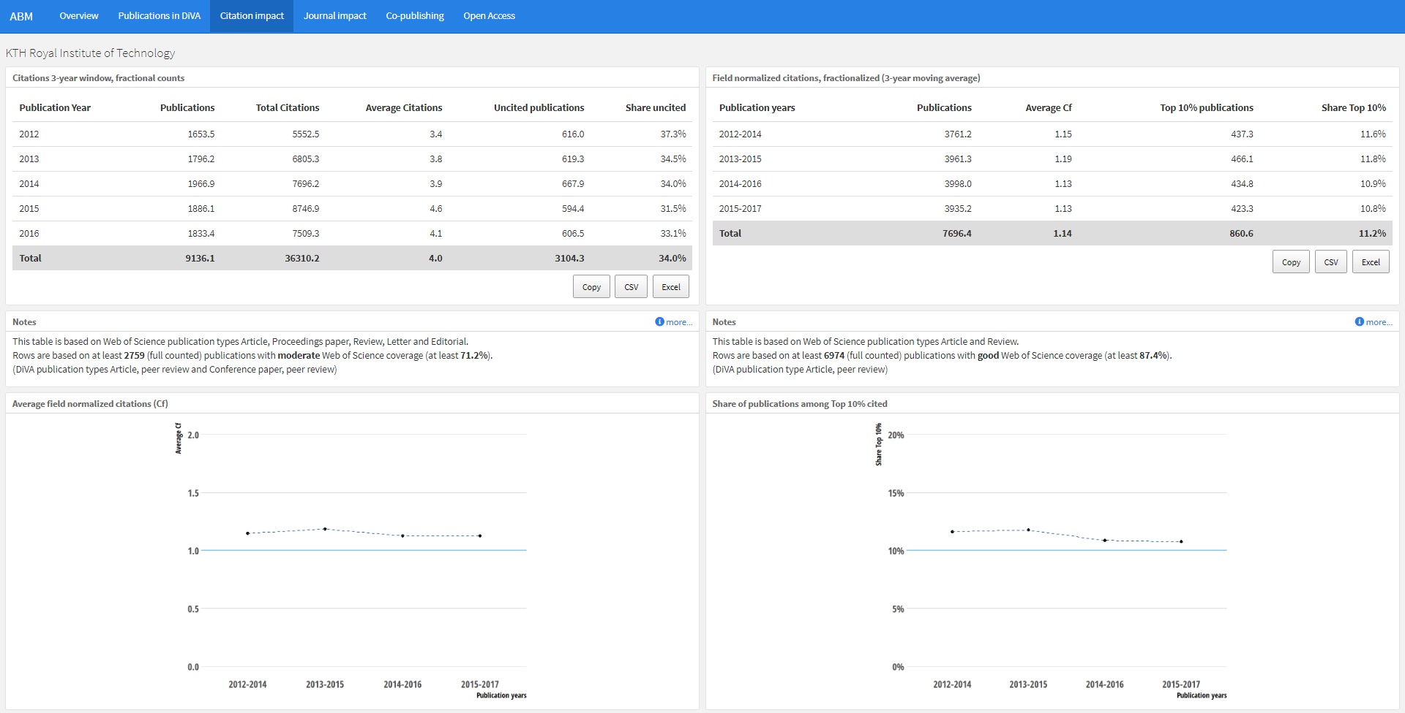

The world average Cf is 1.00 by definition, hence a value of 1.14 means that the publications have been cited 14 percent above world average.

The horizontal lines in the graphs mark the world average indicator value.

Both graphs describe field normalized indicators from the rightmost table.

Journal impact

The *Journal impact* tab shows the average citation impact of the journals where researcher’s/unit’s have published their publications. All numbers on this tab are based on fractionalized counts.

The table shows the average Journal Field Normalized Citations (JCf) and the number/share of publications in the 20 percent most cited journals in its Web of Science subject category/categories. This table is based on the publication types Article and Review.

The JCf and Share Top 20% indicators supplement each other the same way as the Cf and Share Top 10% indicators. By evaluating the impact of the journals rather than the publications themselves, these indicators supplement the picture of the publishing profile, and the journal indicators are often seen as a proxy of the quality of publication channels. JCf is also used as a part of the model for allocating KTH funding to the schools.

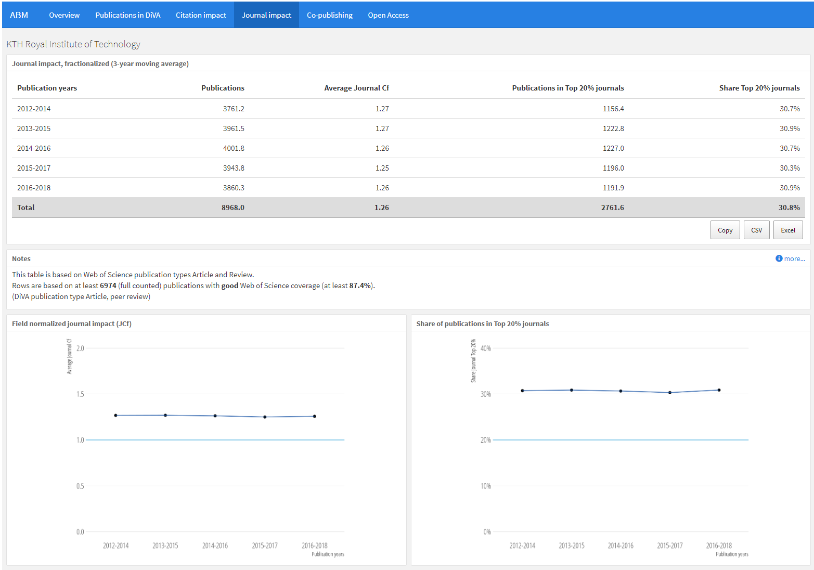

Co-publishing

The *Co-publishing* tab shows the level of co-publication with universities and other organizations. All numbers on this tab are based on the Web of Science categories Article and Review and use full counts, i.e. a publication is counted as one even if there are many co-authors.

Here, a Swedish non-university co-publication means a publication with at least one address belonging to a Swedish organization outside academia while an International co-publication is a publication with at least two countries in the Web of Science addresses field.

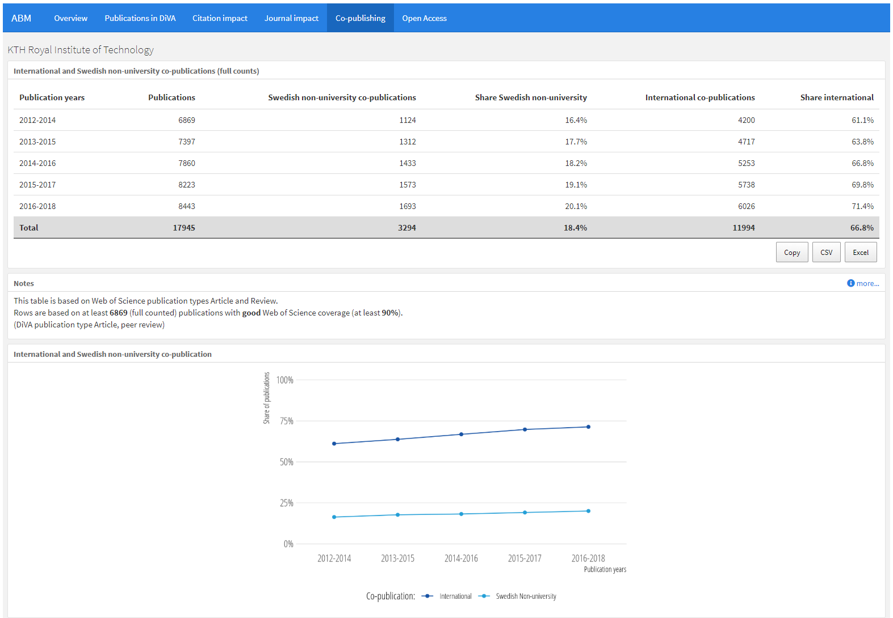

Open Access

The *Open Access* tab shows the OA status of publications according to [Unpaywall](https://unpaywall.org). For a publication to be included, it needs to be marked as a peer reviewed publication in DiVA and have a Digital Object Identifier (DOI) that Unpaywall can recognice and determine an OA status for.

The statuses are presented as defined by Unpaywall. For further information, see “[What do the types of oa status mean?](https://support.unpaywall.org/support/solutions/articles/44001777288-what-do-the-types-of-oa-status-green-gold-hybrid-and-bronze-mean-)” at the unpaywall.org support portal.

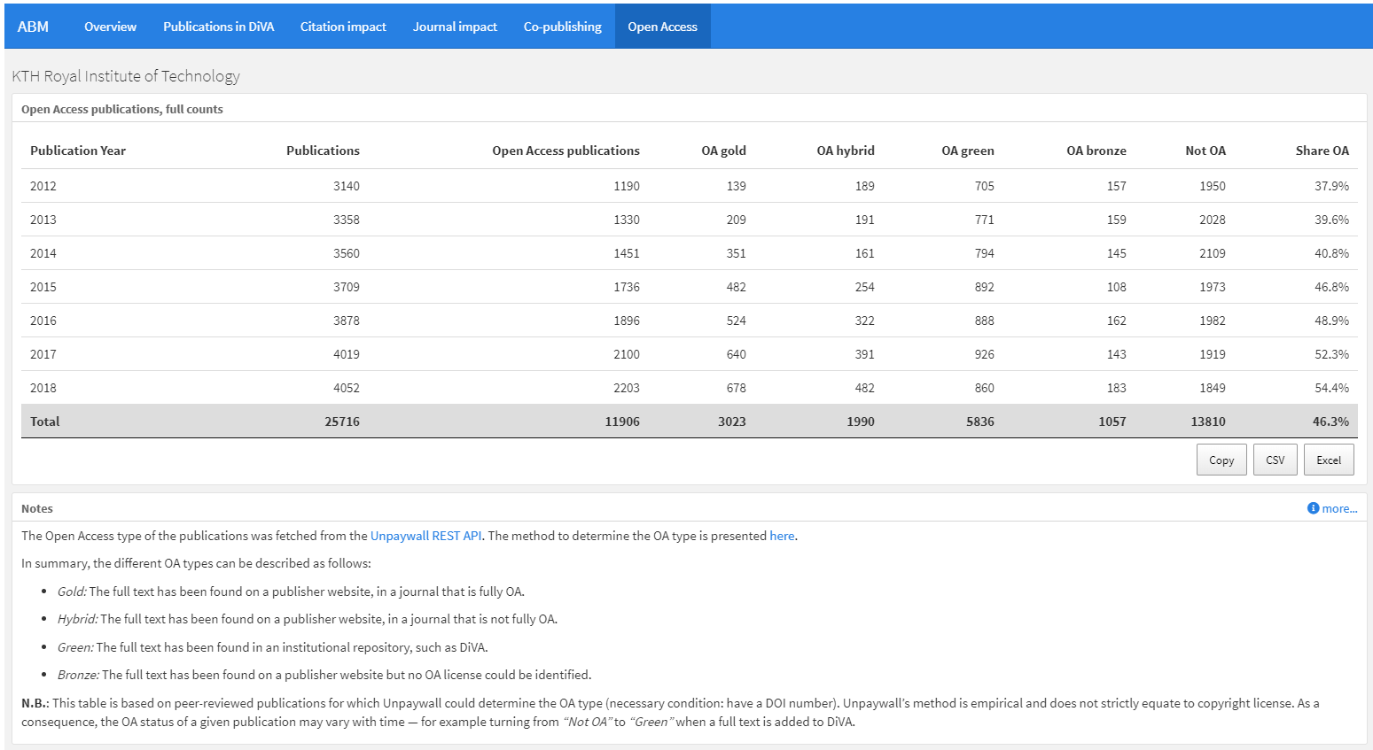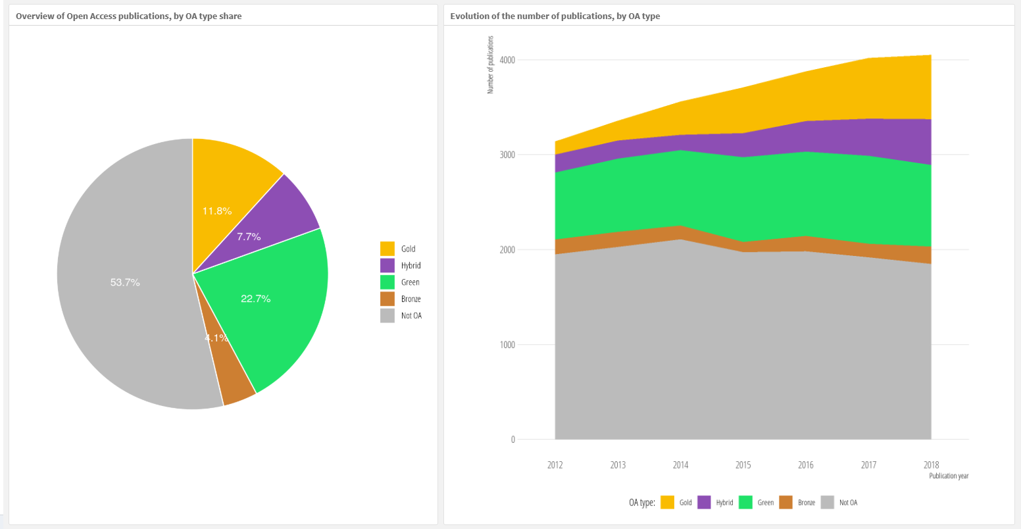

1. Included indices: Science Citation Index Expended (SCIE), Social Sciences Citation Index (SSCI), Arts &Humanities Citation Index (AHCI), Conference Proceedings Citation Index -Sciences (CPCI-S) and Conference Proceedings Citation Index -Social Sciences & Humanities (CPCI -SSH)
2. Last year with a complete publication record in DiVA (usually year of last autumn – 1), with a non-zero count, for the Total publications number, the full period for WoS coverage and last three-year period with an indicator for the other numbers.