**EurekaSim Box Addin Usage**

**Prerequisites**

·.NET4.5.2or above needs to be installed in your computer

·EurekSimApplication

**Instructions**

1.Install **EurekaSimBoxAddin** by double clicking *ES_Box_Setup.exe* and follow the instructions until ‘finish’. You can change destination folder and installation type if you want.

2.Open your **EurekSim** application in open as Administrator and there you can see **EurekaSimBoxAddin.**

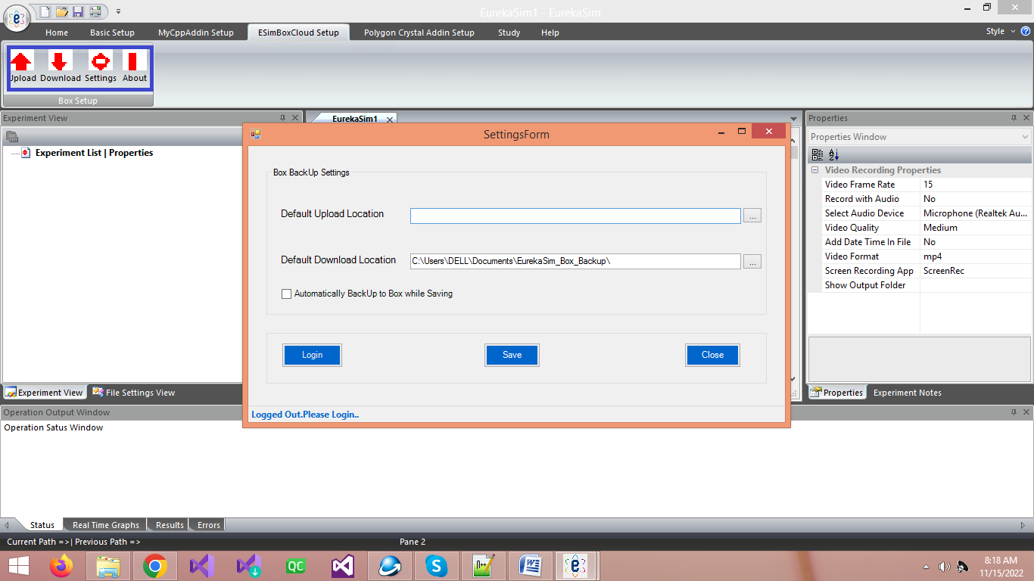

3.To use **EurekaSimBoxAddin** you first need to login to your Box account.Click the settings button.Then click the Login button to login.

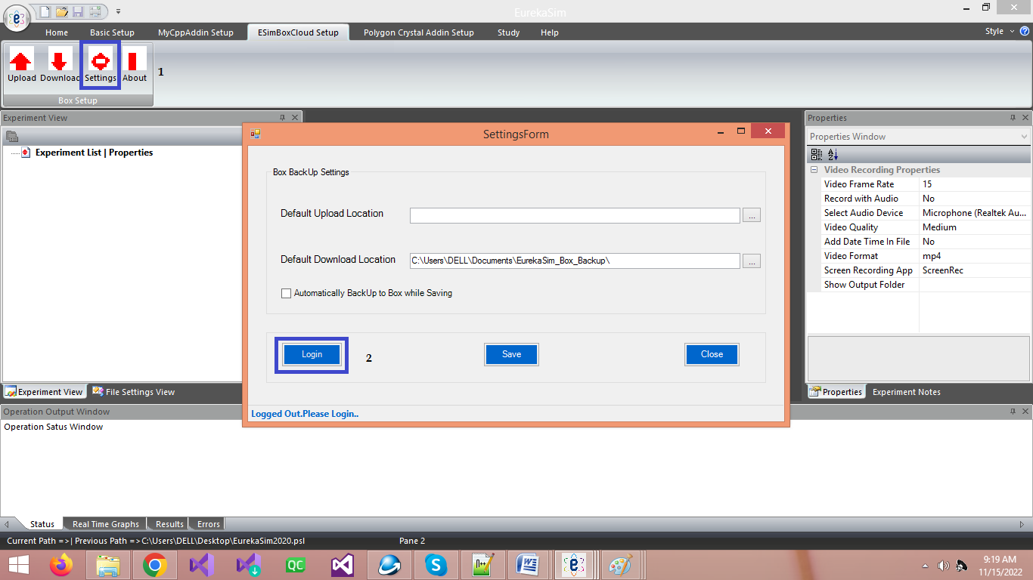

4. You will be taken to Box Login page in your defaultbrowser and there you need to enter your email Id and password for Box.Then Box asks to whether allow EurekaSim Box Addin to access your account.Click allow.

5. Comeback to **EurekaSim** application and there you can see you are logged in.You can see your box account name below your settings Form.From the above picture you can see settings page has three fields for you to set. You can choose the default uploadlocation, default download location and whether you need to upload files automatically while saving.

6. Now,to manually upload a file to your box account you need to click upload button from ribbonbar.If you have saved your current active file before uploading,it will be shown as the file for uploading.You can browse and change it if you want.You can also change the box upload location from its default value if you want.Then click upload.

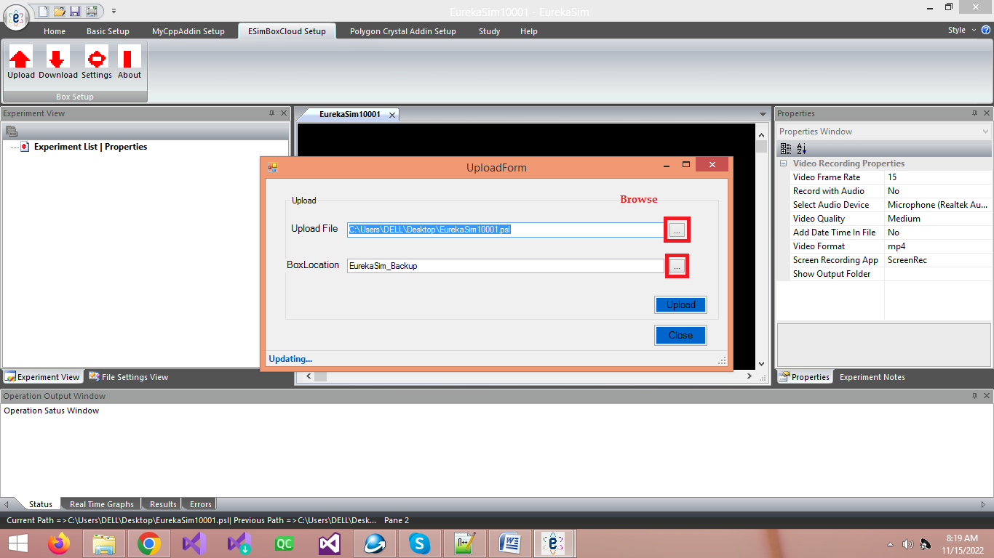

7. For downloading a file from box, you need to click on Download button from ribbon bar.It will then show the download form where you need to browse and select the downloading file. You can also check the check box in the form which loads the downloading file to **EurekaSim** Application automatically after download, if you want.Then you need to click the download button in the dialog which at first asks the download location and then file starts downloading.

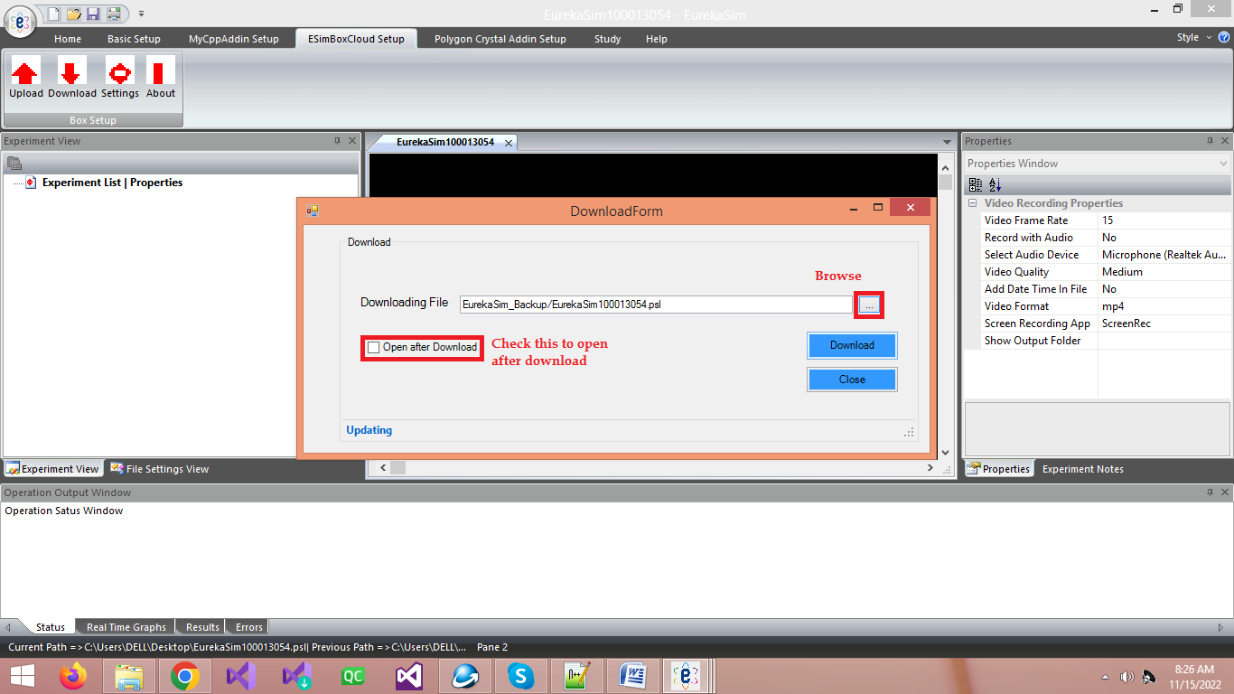

Note: Clicking About button from the ribbonbar will show you the details of the author of **EurekaSimBoxAddin**.

Instructionvideolink: https://youtu.be/ArAul2D1yQo