**EurekaSim GoogleDrive Addin Usage**

**Prerequisites**

* .NET 4.5.2 or above needs to be installed in your computer
* EurekSim Application

**Instructions**

1. Install **EurekaSim GoogleDrive Addin** by double clicking *ES_DB_Setup.exe* and follow the instructions untill ‘finish’. You can change destination folder and installation type if you want.
2. Open your **EurekSim** application and there you can see **EurekaSim GoogleDrive Addin.**

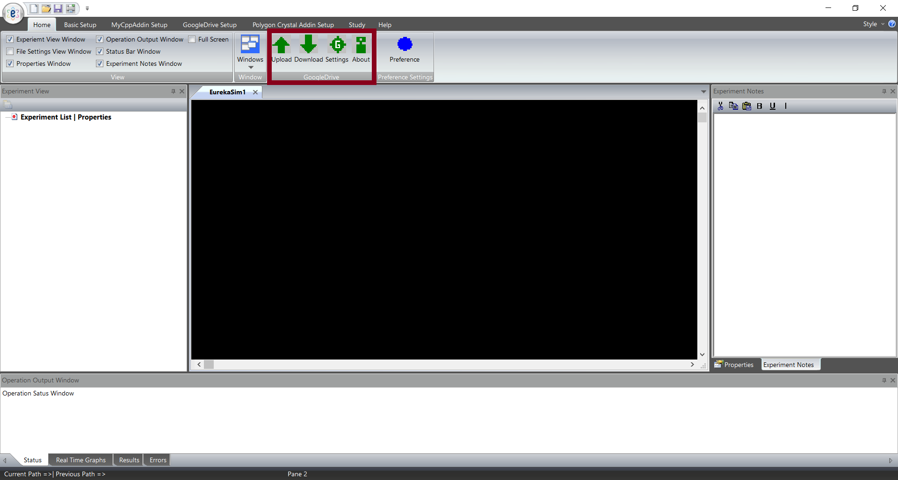

1. To use **EurekaSim GoogleDrive Addin** you first need to login to your GoogleDrive account. Click the settings button. Then click the Login button to login.

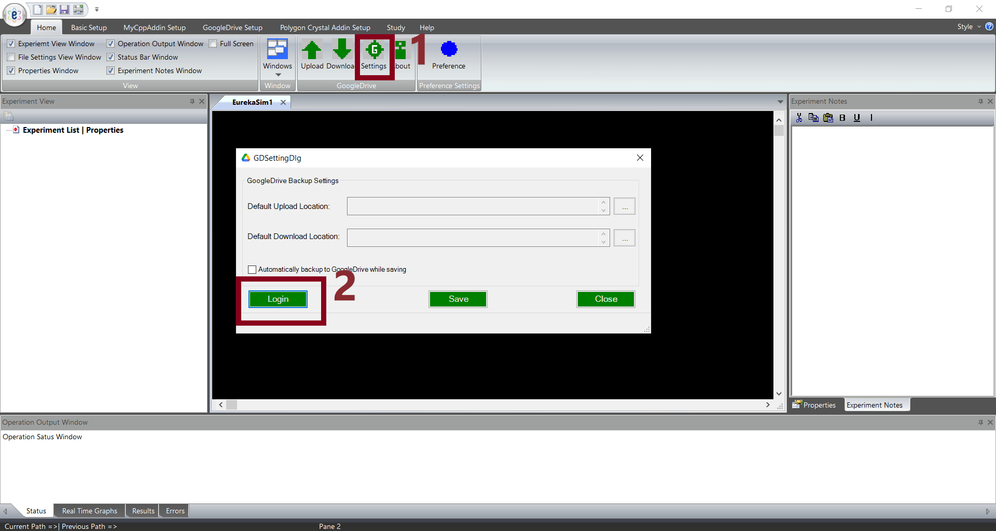

1. You will be taken to GoogleDrive Login page in your default browser and there you need to enter your email id and password for GoogleDrive. Then GoogleDrive asks to whether allow EurekaSim GoogleDrive Addin to access your account. Click allow.
2. Come back to **EurekaSim** application and there you can see you are logged in. You can see your GoogleDrive account name below your settings dialog. From the above picture you can see settings page has three fields for you to set. You can choose the default upload location, default download location and whether you need to upload files automatically while saving.
3. Now, to manually upload a file to your GoogleDrive account you need to click upload button from ribbon bar. If you have saved your current active file before uploading, it will be shown as the file for uploading. You can browse and change it if you want. You can also change the GoogleDrive upload location from its default value if you want. Then click upload.

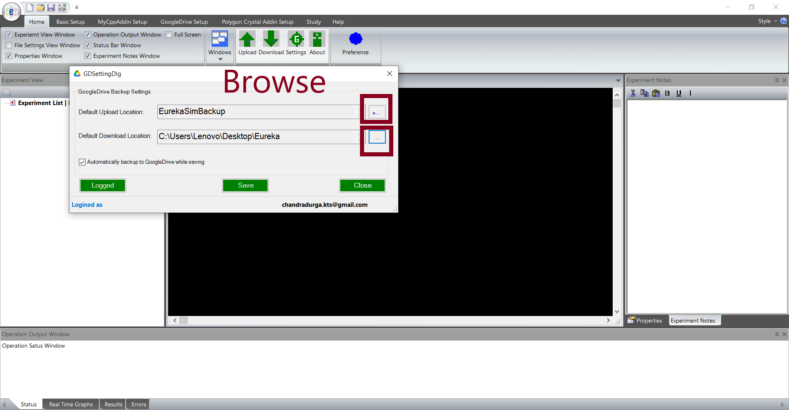

1. For downloading a file from GoogleDrive, you need to click on Download button from ribbon bar. It will then show the download dialog where you need to browse and select the downloading file. You can also check the checkbox in the dialog which loads the downloading file to **EurekaSim** Application automatically after download, if you want. Then you need to click the download button in the dialog which at first asks the download location and then file starts downloading.

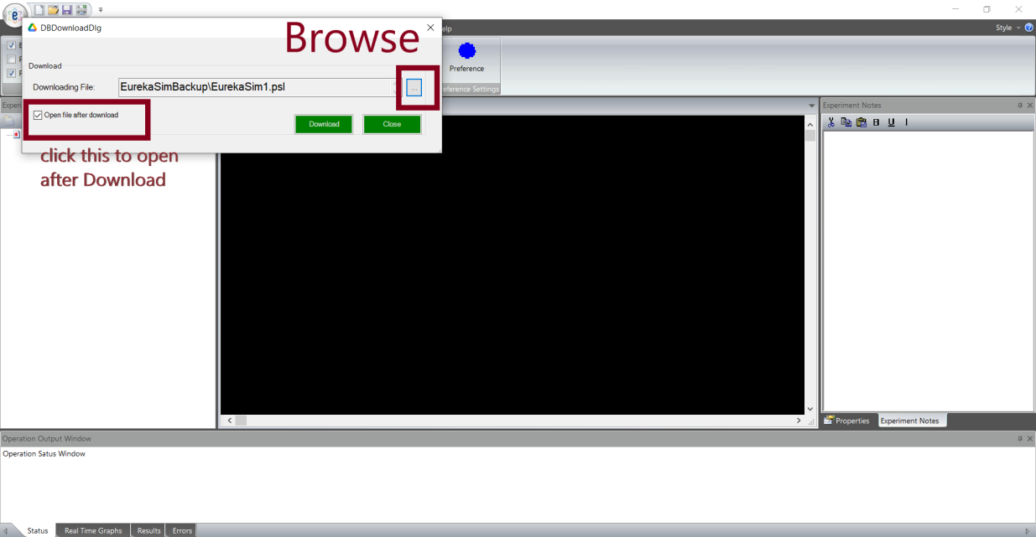

Note: Clicking About button from the ribbon bar will show you the details of the author of **EurekaSim GoogleDrive Addin**.

Instruction video link: