**EurekaSim OneDrive Plugin Usage**

**Prerequisites**

The following applications need to be installed in your computer.

* .NET 4.6 or above
* EurekSim

**How to install OneDrive Plugin**

1. To install OneDrive Plugin, double click the OneDrivePlugin.exe inside Output folder and follow the instructions.

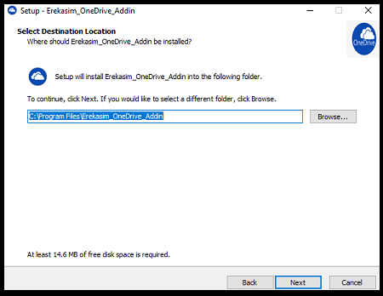

1. You are able to change destination folder and installation type.
2. After installation open EurekaSim application. EurekaSim OneDrivePlugin is installed and ready to use now.

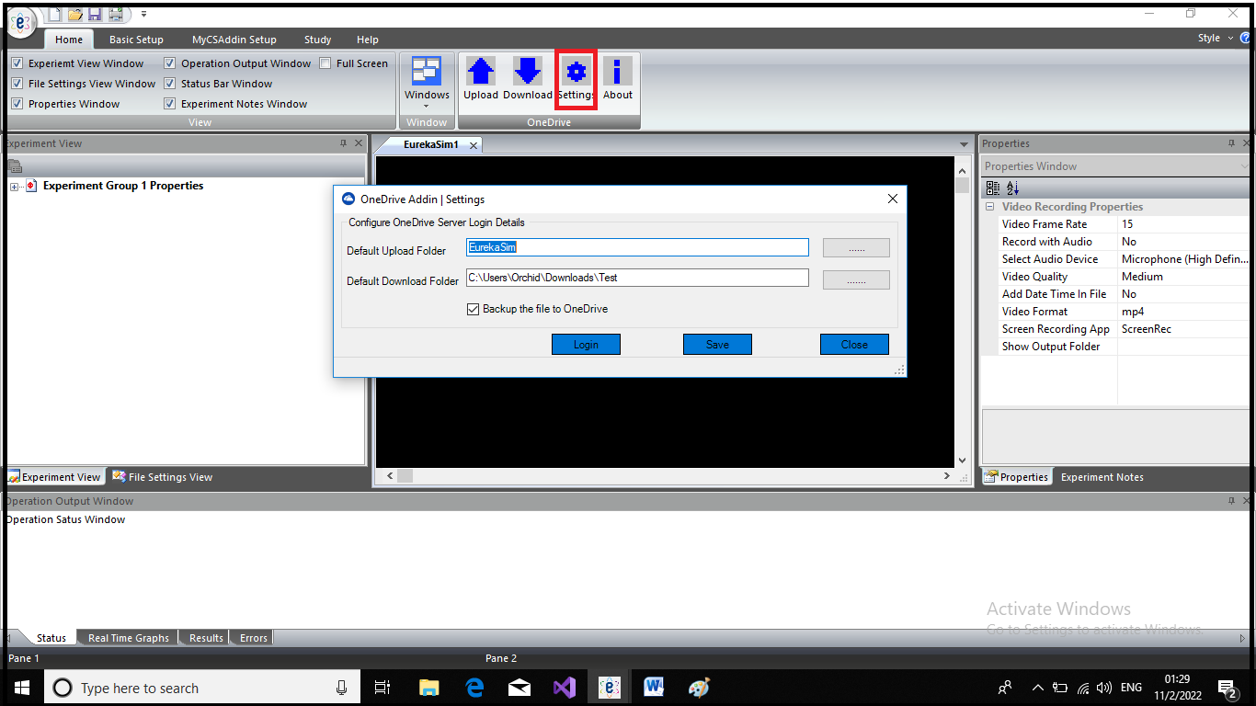

1. To use EurekaSim OneDrive Plugin for backup the EurekaSim file, you have to login to your OneDrive account. Login is provided in the settings dialog. Default upload and download folders are provided in settings dialog. Login will be redirected to the following page, where you have to give permission to access your OneDrive account.

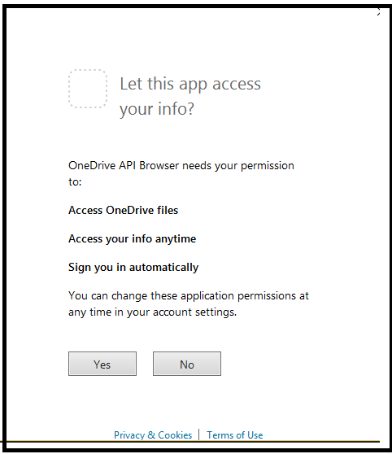

1. Authentication page will appear after giving the permission. Enter the authentication details and you will be logged in to your OneDrive account.

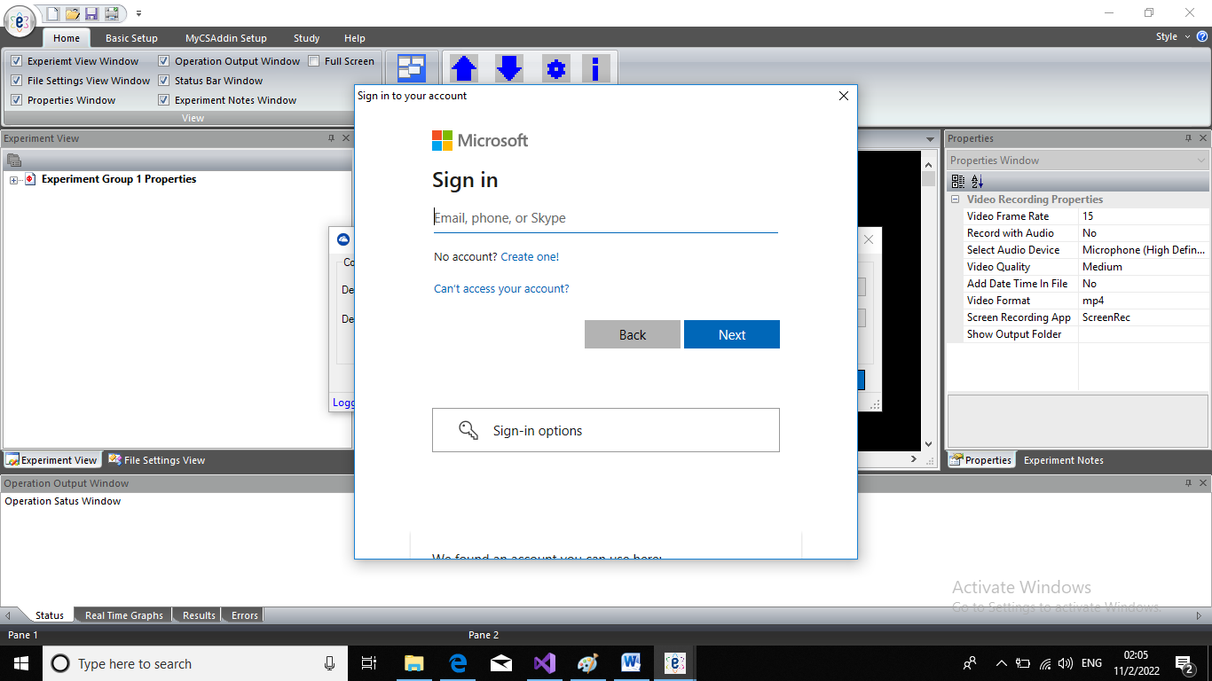

1. If you click the check box in settings dialog it will automatically provide the current saved EurekaSim file path in the upload dialog for uploading.

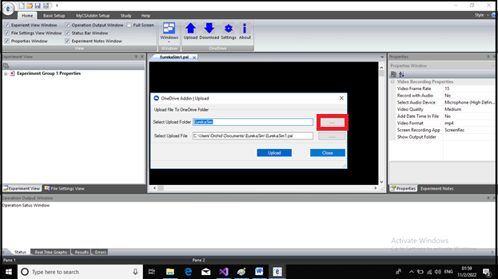

1. Upload and download can be done only after the login. The default upload and download folder once saved in the settings dialog will appear in corresponding upload and download dialogs. You can change the default upload or download folder by browsing. You are able to change upload and download files by browsing.
2. To download a file from OneDrive account, click the browse button, OneDrive folder list will appear in a separate dialog. Download file can be selection can be done by clicking the folders containing them.

