Financial Health Analysis of the Indian Banking Sector
A Comparative Ratio-Based Study of Five Major Indian Banks (FY2023–FY2026)
Submitted by: Sneha Kadappa Timmavvagol
AICTE | IBM SkillsBuild Data Analytics with AI Academic Internship Program
Conducted in association with BharatCares
B.E. in Computer Science and Engineering, Maratha Mandal's Engineering College, Belagavi

1. Introduction
Financial statement analysis is a core skill for both finance analysts and business analysts, involving the interpretation of company-reported data to assess performance, efficiency, and risk. This project applies that skill set to the Indian banking sector, using real financial statement and stock market data to build a comparative, ratio-based health assessment of five major Indian banks.
Unlike typical companies, banks report financial statements differently — there is no standard 'Current Assets' or 'Operating Income' line, since a bank's core business (accepting deposits, issuing loans, earning interest margins) does not fit the conventional company reporting structure. This project therefore adapts standard ratio analysis to the ratios actually used to evaluate banks: Return on Equity, Return on Assets, Net Interest Margin, Equity-to-Assets, and Cost-to-Income.

2. Objective
- To collect real financial statement and stock price data for five major Indian banks using the yfinance Python library.
- To compute bank-specific financial ratios that reflect true operating and financial health, rather than generic corporate ratios.
- To identify and correct data-quality issues arising from inconsistent financial statement reporting across banks.
- To build a composite, peer-relative Financial Health Score ranking the five banks year-over-year.
- To validate unusual trends in the data against real, verifiable corporate events.

3. Dataset
Data was collected live via the yfinance Python library (Yahoo Finance API). No static dataset file was used — running the project notebook fetches current price history and financial statement data directly from Yahoo Finance.
Bank | Ticker (yfinance)
State Bank of India | SBIN.NS
HDFC Bank | HDFCBANK.NS
ICICI Bank | ICICIBANK.NS
Kotak Mahindra Bank | KOTAKBANK.NS
Axis Bank | AXISBANK.NS

Two data types were pulled per bank: two years of daily price history (open, high, low, close, volume) and four years of annual financial statements (income statement and balance sheet), covering fiscal years 2023 through 2026.

4. Methodology

4.1 Ratio Definitions
Because banks' core business does not fit conventional corporate ratio categories (e.g. current ratio, quick ratio), the following bank-specific ratios were used instead:
Ratio | Formula | What it measures
ROE | Net Income / Stockholders Equity | Shareholder profitability
ROA | Net Income / Total Assets | Asset-efficiency profitability
NIM | Net Interest Income / Total Assets | Core lending margin
Equity-to-Assets | Stockholders Equity / Total Assets | Capital cushion / stability
Cost-to-Income | Operating Expense / Total Revenue | Operating efficiency (lower is better)

4.2 Data-Quality Handling
During ratio computation, two data-quality issues were identified and corrected:
- Double-counted operating expense: Initially, HDFC Bank's operating expense was reconstructed by summing individual expense line items (salaries, occupancy, depreciation). This produced an implausible spike in Cost-to-Income for FY2024–FY2025, because 'Selling, General & Administrative Expense' in HDFC's filings is itself an aggregate that already includes those component lines — summing them separately double-counted the same cost. This was corrected by using the single SG&A aggregate line directly.
- Cross-bank reporting inconsistency: HDFC Bank and ICICI Bank's filings do not report a single 'Operating Expense' line; SG&A expense was used as a proxy. This likely understates their true cost base relative to SBI, Kotak Mahindra Bank, and Axis Bank, which report operating expense directly. This limitation is disclosed explicitly (see Section 6) rather than presenting Cost-to-Income as directly comparable across all five banks.

4.3 Composite Financial Health Score
A single composite score was designed to rank the five banks by overall financial health, combining five ratios with the following weights:
- Return on Equity — 25%
- Return on Assets — 25%
- Net Interest Margin — 20%
- Equity-to-Assets — 15%
- Cost-to-Income — 15% (reported-basis banks only)
Each ratio was min-max normalized within each fiscal year separately, so that scores reflect a bank's standing relative to its peers at that point in time, rather than being distorted by universal balance-sheet growth across years. To avoid letting the Cost-to-Income reporting inconsistency (Section 4.2) unfairly benefit HDFC Bank and ICICI Bank, their Cost-to-Income component was scored neutrally (0.5) rather than computed from a biased basis.

5. Findings and Visualizations

5.1 Return on Equity (ROE) Trend
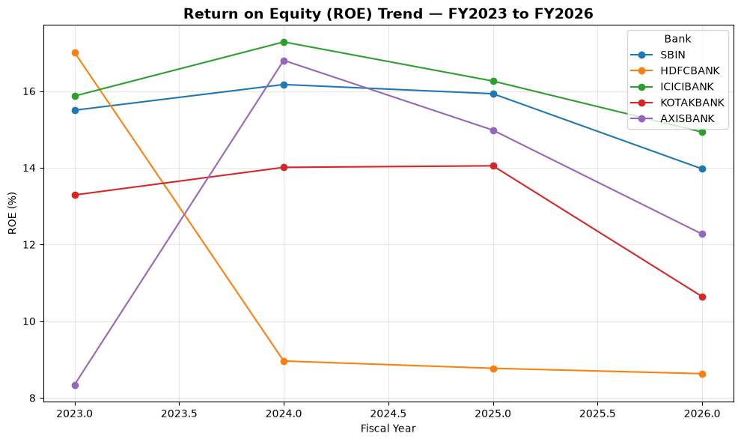
Figure 1: ROE trend across five banks, FY2023–FY2026
ICICI Bank and SBI show the most stable ROE across the period. HDFC Bank's ROE falls sharply from 17.0% (FY2023) to approximately 9.0% (FY2024) and remains lower thereafter — this coincides with HDFC Bank's merger with HDFC Ltd, effective July 1, 2023, which substantially expanded its equity base and diluted ROE in the near term, a structural effect rather than a decline in underlying profitability. Axis Bank shows the opposite pattern: its lowest ROE (8.3%) occurs in FY2023, coinciding with one-time costs from its acquisition of Citibank India's consumer banking business, completed March 1, 2023, before recovering to 16.8% in FY2024.

5.2 Return on Assets (ROA) and Net Interest Margin (NIM)
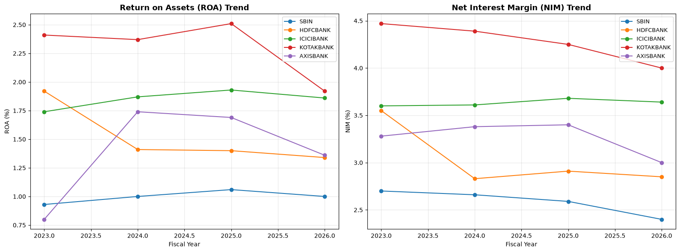
Figure 2: ROA and NIM trends across five banks, FY2023–FY2026
Kotak Mahindra Bank leads on both ROA and NIM throughout the period, consistent with its smaller, more tightly managed balance sheet. SBI is lowest on both metrics across all four years — a structural characteristic of its scale as India's largest public-sector bank, rather than a year-over-year deterioration. The same HDFC and Axis patterns observed in ROE (Section 5.1) are visible here as well, confirming they are genuine, dated corporate events rather than data artifacts.

5.3 Cost-to-Income Ratio
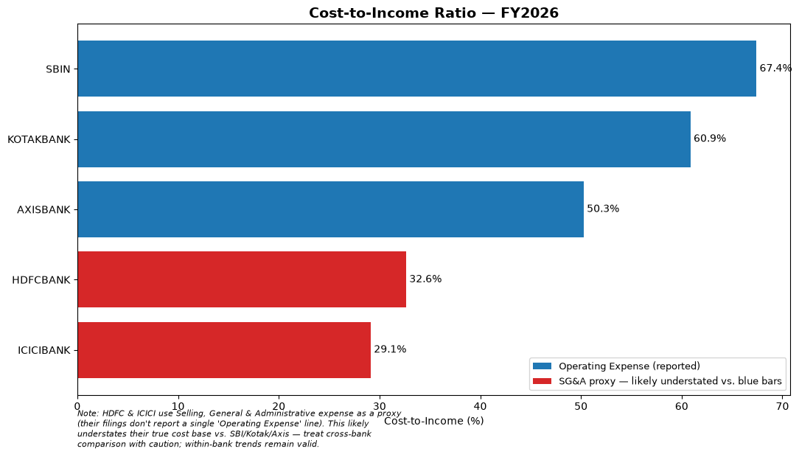
Figure 3: Cost-to-Income ratio, FY2026, with reporting-basis caveat
SBI shows the highest Cost-to-Income ratio (67.4%), consistent with its large branch network. HDFC Bank and ICICI Bank (red bars) appear far more 'efficient', but as discussed in Section 4.2, this is partly a measurement artifact from their SG&A-based reporting rather than fully comparable cost data.

5.4 Composite Financial Health Score
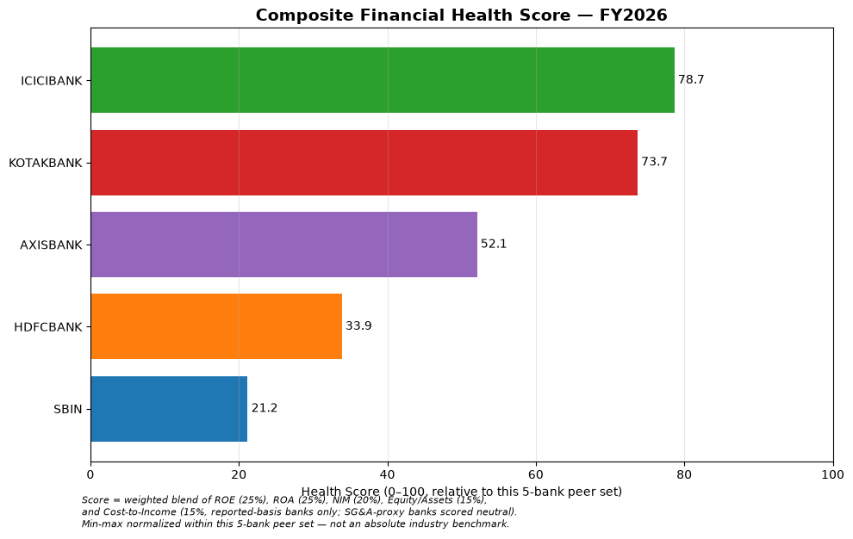
Figure 4: Composite Financial Health Score, FY2026 snapshot
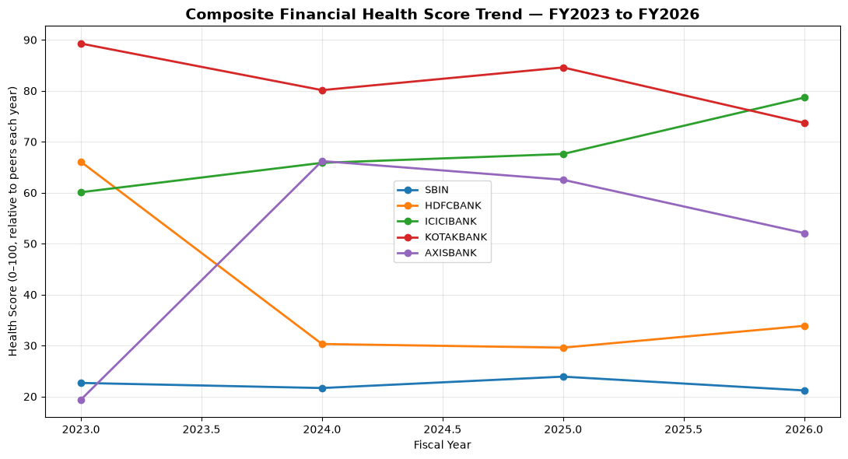
Figure 5: Composite Financial Health Score trend, FY2023–FY2026
ICICI Bank and Kotak Mahindra Bank lead the peer set across most years on the composite score. SBI remains structurally at the bottom across all four years — flat, not declining. HDFC Bank's score drops sharply from FY2023 to FY2024 in line with its merger, and Axis Bank's lowest point is FY2023, in line with its Citibank India acquisition costs, both verified against real corporate events.

6. Limitations
- Cost-to-Income basis differs between banks (SG&A proxy for HDFC/ICICI vs. reported Operating Expense for SBI, Kotak, Axis); cross-bank comparisons on this metric should be read with caution.
- Min-max normalization with only five banks is sensitive to outliers — each year's scale is anchored by whichever bank is highest or lowest that year.
- Four fiscal years is a relatively short window for long-term trend analysis.
- Composite score weights (25/25/20/15/15) reflect a reasonable, but subjective, analytical judgment rather than an industry-standard formula.

7. Conclusion
This project demonstrates a complete financial-analyst workflow: adapting standard ratio analysis to an industry-specific reporting structure, identifying and correcting a real data-quality issue rather than trusting computed numbers blindly, transparently disclosing a remaining data limitation instead of hiding it, and validating unusual patterns in the data against real, independently verified corporate events. Among the five banks studied, ICICI Bank and Kotak Mahindra Bank consistently rank as the strongest performers on a peer-relative basis, while SBI's lower ranking reflects its structural scale as a public-sector bank rather than declining performance.

8. Tools and Technologies Used
- Python
- pandas — data structuring and ratio computation
- yfinance — live financial statement and stock price data
- matplotlib — data visualization
- Jupyter Notebook — development environment

