**An Idea Model of the Immune System**

**CS 423/523 Spring 2018**

George Boujaoude

Department of Computer Science

University of New Mexico

Albuquerque, New Mexico

gboujaoude@unm.edu

Justin Hall

Department of Computer Science

University of New Mexico

Albuquerque, New Mexico

amunra@unm.edu

Justin Hall

George Boujaoude

***Abstract*— Comprised of many intricate, moving parts, the innate immune system is pertinent to our everyday wellbeing and livelihood. To this day, we are still working towards better understanding this complex adaptive system. In this project we sought to observe the relationship between the innate and adaptive portions of the immune system. We constructed an idea model of the immune system which contained related components such as Macrophages and Lymphocytes. This provided us an environment in which we could isolate components and related behaviors to better conduct analysis on our hypotheses.**

I. INTRODUCTION

The human body comes equipped with a highly complex and adaptive machine known as the immune system. From a high-level view it boils down to two major sections: the innate and adaptive immune system. Innate falls under the category of *static defense*. Put simply, this has evolved a generalized defensive strategy that is good for a large amount of different foreign substances. It may not be the most effective at dealing with any one thing, but it is perfect as a means of providing an initial response to a new threat.

Adaptive, on the other hand, is the exact opposite. It provides a highly specialized response for each type of antigen. If an adaptive component has specialized to deal with an antigen of type A, for example, then only when that exact antigen enters the body (or something very close as explained by space-shape theory) will that component be activated.

A “separation of powers” clearly exists, but this separation very quickly raises interesting questions: How do the innate and adaptive immune system communicate with each other? In the event that the adaptive immune system is unresponsive or unreachable, can the innate hold its own against an invasion? Can differing patterns in communication result in different behaviors from the adaptive immune system?

In this paper we will explore these questions using a simulated idea model of the immune system. A breakdown is as follows:

1. Within our model, we will observe the ramifications of an unresponsive/unreachable adaptive immune system. We hypothesize that in the absence of an adaptive response, the innate immune system will ultimately be unable to fully halt a sizeable foreign threat to the body.
2. In our model we will define a very simple means of communication based on cytokine proteins. During our initial runs we noticed that simple changes to the communication patterns resulted in two categories of behavior within the adaptive immune system. The first was a random-walk behavior, and the second was more of a patrol behavior through the tissue. We hypothesize that the patrol behavior will be more successful in stopping an invasion than the random walk behavior.
3. In a system like this, it is expected that the speed of communication should lead to a faster response. We make the hypothesis that increasing the speeds of which a component of the immune system can move result in higher success rates in halting a foreign threat.

II. METHODS

Given the time, it became clear very quickly that a full-scale model of the immune system was simply not possible. To tackle this, we decided to define a very simple model with simple, configurable components. This model was then programmed as an externally-configurable simulation (i.e., through configuration files read in at startup) that would allow us to explore the questions in the introduction and test our hypotheses. The individual components are specified below, followed by information on how we conducted our experiments.

*A. Assumptions*

We went forward under the assumption that all events in our simulation were taking place within the liver. We also assumed that 1 pixel is equal to 1 micrometer. Finally, we assumed that there is only 1 type of virus, and any response displayed by the adaptive immune system was directly for that specific virus. This means that most of space-shape theory became unusable in our simplified model, and we were not testing the interaction between T-Cells and B-Cells as it appears in real life.

*B. Idea Model Components*

*B.1 Macrophage*

This represents the entirety of the innate immune system in our model. It is only allowed to exhibit random-walk behavior, roughly based on the real world where a macrophage changes direction randomly every 5 minutes (5 seconds in our model). Its job xis to patrol the liver tissue for any foreign substances or infected cells, destroying them if found.

Each macrophage has a cytokine pouch. This pouch refills at a rate of 1 cytokine per 2 seconds until its upper limit is reached.

As figure 1 will show, the macrophage is made up of two parts: an outer perimeter and a cell body. The perimeter is seen as the lighter-green region, while the cell body is the dark inner circle.



Figure 1: Diagram of the macrophage as it appears in our simulation. The light green, transparent region is the perimeter while the dark inner circle is the cell body.

Each part plays a different role. The outer perimeter allows the macrophage to gather information about the world around it. If at any point 10 or more virus particles enter its outer perimeter and the macrophage and its cytokine pouch is at maximum capacity, it will release all of its cytokines into the environment. This in-turn will eventually draw the attention of the adaptive immune system.

The cell body is there to do the actual destroying of virus particles or infected cells. Its size is 30 micrometers, which is 9 micrometers larger than they are in reality.

Configurable parameters are the number of initial macrophages, their speed, and the maximum number of cytokines they can store.

*B.2 Cytokine*

We have one type of cytokine protein in our model. Cytokines are only ever released by a macrophage, and each one contains information about some area where they first came from. In our model these are very small (only 5 micrometers) as we made the decision to make them the same size as our viruses.

There is always a primary cytokine, which in our model is simply one of the original cytokines released by a macrophage. Primary cytokines are the only ones that can move through the liver, periodically duplicating themselves and seeding their clones with information about location they are currently at. This then forms a trail that can be followed, where each cytokine essentially says “go in this direction from where you currently are”.

Aside from the primary cytokine, there is one other special cytokine in our model. This is always designated as the first cytokine that a primary cytokine creates, and it represents the stop signal. While other cytokines represent a “go here” signal, this cytokine represents a “stop and search this area” signal.

If a primary cytokine never gets intercepted by a lymphocyte and instead exits the bounds of our simulation, we consider that cytokine to have exited the liver and entered the bloodstream. The simulation interprets this as a need for more lymphocytes, so it begins summoning them to the area.

Configurable parameters are speed, seconds until duplication, and lymphocytes per second in the event that a cytokine exits the liver.

*B.3 Lymphocyte*

The lymphocyte, in our model, is essentially the merger of the B-Cell, T-Cell, and Natural Killer Cell. By default they are deactivated, which in our model simply means that they are not actively searching for anything to kill. In terms of positioning, they come after the macrophage/liver cell layer (layer diagram to be explained below). Unlike a macrophage, they only contain a cell body but no outer perimeter. Their cell body measures 25 micrometers in radius.

A lymphocyte responds to a cytokine released by a macrophage. This causes the lymphocyte to become activated and begin to actively seek out foreign substances.

If the cytokine it intercepts contains information about direction, the lymphocyte will modify its speed to head in the generate direction that the cytokine indicated. If the cytokine represents a stop-and-search signal, then the lymphocyte modifies its behavior to engage in a random walk. At this point it mimics the macrophage in that it has a probability of 0.5 that it will change its direction after 5 seconds.

Along with this, once a lymphocyte has been activated, it has a lifespan counter measured in seconds. After that counter is up, the lymphocyte dies.

Configurable parameters are the initial number of lymphocytes, speed, and lifespan.

*B.4 Liver Cells*

Each liver cell is made up of a cell body that measures 50 micrometers in radius. Real liver cells have an average radius of 42 micrometers.

To simplify our model, we decided not to have them replicate as they do in real life. This was a welcome simplification since our runtimes tend to be very short rather than being large-scale, drawn-out simulations.

Each cell starts out as healthy. If they come into contact with a virus, they become infected cells. This triggers an internal change, enabling the cell to become a virus factory to make copies of the virus that infected it. When the cell achieves a critical mass of viruses inside of it, it bursts and releases them.

Configurable parameters are the initial number of liver cells, viruses an infected cell can create per second, and the number of viruses it can hold before it bursts.

*B.5 Viruses*

The virus is the simplest component that makes up our model. It simply enters the world and travels until it finds a cell. If the cell it finds appears healthy, it will enter it and infect it. If the cell has been marked by a previous virus to indicate that it has already been infected, the virus moves on.

In real life, the largest known viruses are ~1 micrometer in length. For our model we scaled this up to be 5 micrometers.

Configurable parameters are the initial number of viruses and speed.

*C. Layered Liver Approach*

To model the liver, we adopted a very simple three-layer approach. Figure 2 illustrates this nicely by showing the layers in order as they appear in our simulation as well as which components occupy each layer.

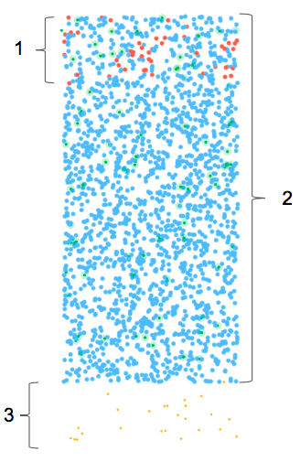

Figure 2: This illustrates the layers of our liver model. (1) indicates the layer that the initial viruses are inserted into. (2) overlaps slightly with (1) and contains the liver cells and macrophages. (3) indicates the layer where all the initial lymphocytes reside as well as where all new lymphocytes are inserted into the system.

It is important to note that all viruses have a downward movement tendency, moving from layer 1 towards layer 3 and beyond.

We consider everything after layer 3 to be outside of the liver.

*D. Experiments*

With the above definitions and configurable parameters, this gave us all the tools we needed to

test all of our hypotheses.

*D.1 Unresponsive Adaptive Immune System*

To test this, we left all default configuration settings the same except for one: we set the cytokine carrying capacity for the macrophages to 0.

What this meant was that even when the macrophage felt overwhelmed, it would not have any cytokines that it could release into the environment. Because of this, no lymphocytes would ever get the signal that something was wrong.

We then went one step further and tested to see what happens when we vary the number of initial viruses injected into the liver. We did this for 10 initial viruses, 25, 50, 100, 150 and 250.

Each configuration was run 20 times through our simulation for a total of 120 runs.

*D.2 Altered Communication Patterns*

When we first observed some lymphocytes who never switched to their random walk behavior, we thought there was something wrong. However, we then realized that it was because the stop-and-search cytokine for the particular trail they were following had been intercepted already by another lymphocyte. In effect, they were permanently stuck in what we now call “patrol behavior”.

This behavior is characterized by larger sweeping movements to the liver. The lymphocyte moves until it reaches one edge of the liver, turns around and moves until it reaches the other end, and then repeats the cycle until it dies.

To replicate this and see which behavior was better, we configured the cytokine’s “seconds until replication” parameter to be a very large number. This caused the primary cytokine to never replicate, meaning no stop-and-search cytokines were ever created, forcing all lymphocytes to engage in patrol behavior.

We ran this 40 times total. The first 20 were with unmodified cytokine parameter (our control group) while the next 20 were with the modified cytokine parameter.

*D.3 Speed of Communication*

This one seemed very obvious, but we decided to test it anyway since it was a question we had and wanted to verify. To achieve this, we simultaneously varied the cytokine movement speed and lymphocyte movement speed. This means that the time it took for a macrophage to send a signal to a lymphocyte was decreased, and the time it took for the lymphocyte to respond and move towards the macrophage was also decreased.

The speeds we used were (all in micrometers/second): 90, 120, 150, 180, and 225.

These numbers may seem random, but they have some biological basis. For example, the fastest known cell in the body moves at a rate of 15 micrometers per second. In order to speed up our simulation, we then scaled all of our speeds by powers of 15.

So, 90 is 6 micrometers/sec * 15. 120 is 8 micrometers/sec * 15, and so on until 225 which is 15 micrometers/sec * 15.

Like previous tests, each configuration was run 20 times through our simulation for a total of 100 runs.

*E. Data Collection*

During any given simulation we collected a reasonably large amount of information for analysis. This included the amount of time before the last virus and infected cell were eliminated, the total number of healthy cells versus infected cells over time, the total number of lymphocytes over time and the total number of viruses over time.

Since our simulation takes place over a large rectangular space where agents can roam freely, each individual component would log its own events of interest with our global database.

For example, if a virus was created, it would report this. If a healthy cell was infected, it would report this. Each new lymphocyte that was spawned would be reported, and so on.

We adopted the policy that each component would log its own events. So, viruses log virus-related events, etc. This way we could avoid the possibility that the same event would be reported from multiple sources and skew our data.

3. RESULTS

*A. Control Group*

Defining a control group for this experiment proved by itself a slight challenge of its own. Considering that we are testing hypotheses on a virtual simulation, we needed a control group whose results would allow enough headway for hypotheses to be made. Figure [CONTROL_GROUP] is that control group who still leaves room for hypotheses to be made. In reference, let’s look at the virus and lymphocyte curves shown in figure [CONTROL_GROUP]. Near the beginning of the figure, the virus count moves quickly from its initial condition to roughly 1750 viruses at timestep 140. Then around timestep 150, the virus curve makes a dramatic shift and decreases until its ultimate downfall around timestep 280. During this time, it can be seen that the lymphocyte count makes a very small appearance in the immune system, more specifically increasing it’s count to roughly 200 between timestep 100-250. Although it is obvious in this figure that the virus attack was squelched, the results in this figure do not point directly towards a specific causal of the defeat. Thus we accepted these results to represent our control group when testing our hypotheses.

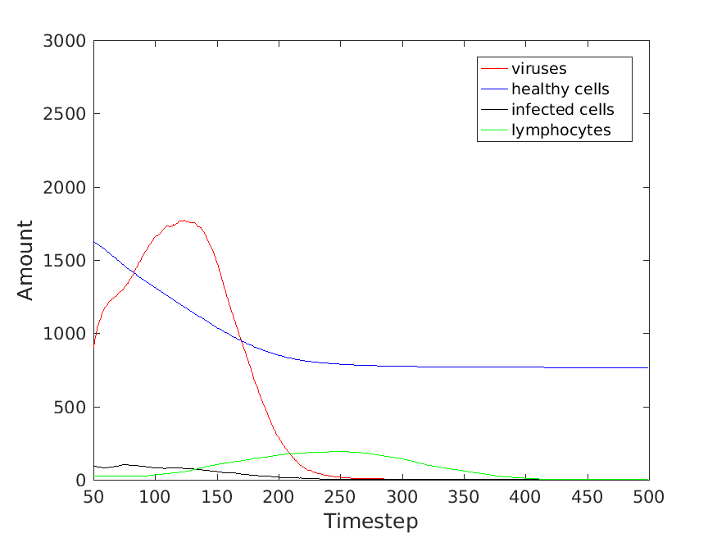

Figure [CONTROL_GROUP]

*B. Immune Response with no Lymphocytes*

*B.1 Initial Viruses equaling 250*

In figure [MACRO_ONLY_250], we see the results of introducing an initial 250 viruses into the idea model where lymphocytes are unavailable to the adaptive immune response. As seen by the blue line, the healthy cell count begins to make a decrease until it reaches 0 around timestep 350. Additionally, as seen by the red curve, the virus count increases throughout the duration of the experiment until the viruses enter the rest of the human system around timestep 350l. As there are no more remaining healthy cells, we consider that the result of this experiment seen in figure [MACRO_ONLY_250] as a failure of the immune system’s response. This classification is made because, as can be seen around timestep 350, the healthy cell count drops completely to 0.

As a side note we would like to explain to the reader why the virus count suddenly decreases near the 350 timestep mark. Our analysis of this model focused on the count of a component, in this case a virus, at a specific timestep. Additionally, whenever a virus reached the “bottom” of our idea model, we considered the virus as having migrated into the rest of the system. Subsequently this would exclude that particular virus from being included in that specific time step’s virus count. In hindsight, this method of not counting “exited” viruses to be problematic in any future, larger scaled implementation. In the case of this paper’s experiments, we were able to calculate the expected exiting of the virus into the rest of the human system.

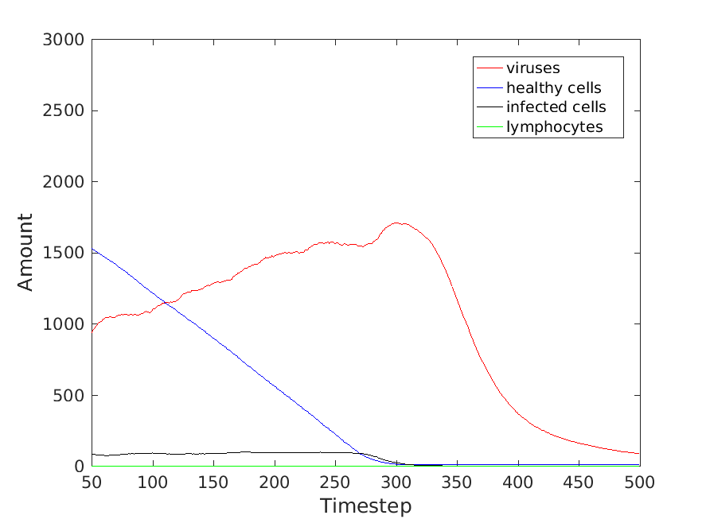

Figure [MACRO_ONLY_250]

*B.2 Initial Viruses equaling 10*

In this experiment we introduced into the system only 10 viruses (in comparison to the 100 viruses in the control group). As seen by figure [MACRO_ONLY_10], the viruses had some initial difficulty remaining in the system until they began to flourish around timestep 75-100. The healthy cell count, however, began to drop where able to halt their decline around timestep 350 leaving approximately 100 healthy cells in the model. The plateau of healthy cell count around 350 timesteps also coincides with the timeframe where viruses tend to reach the bottom of the model and enter the rest of the human system.

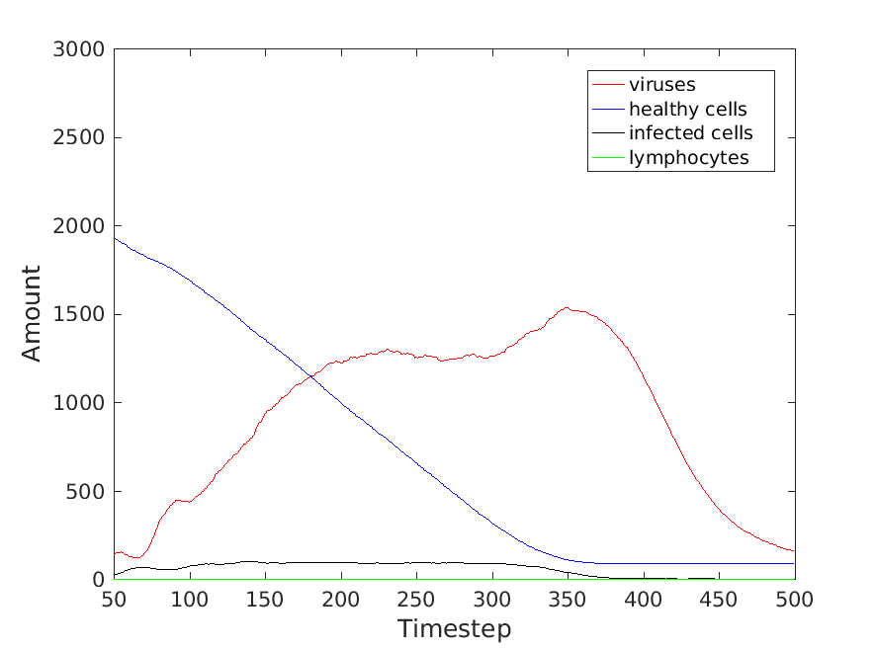

FIGURE [MACRO_ONLY_10]

*C. Varying Lymphocyte Speed*

*C.1 Lymphocyte Speed 225 Micrometers per Second.*

In our control group, each lymphocyte had a starting speed of 150 micrometers a second, which can be see in the control group figure discussed above. Figure [CYTO_LYMP_225] displays the results when lymphocytes had a speed of 225 microunits. Similar to the behavior of the control group, figure [CYTO_LYMP_225] shows a successful halt to a virus attack. Specifically, the virus curve reaches a global maximum around the 90-100 timestep, which coincides with the increasing lymphocyte curve seen in green. In contrast to the control group, the healthy cell curve in this experiment plateaus with over 1000 healthy cells remaining in the system.

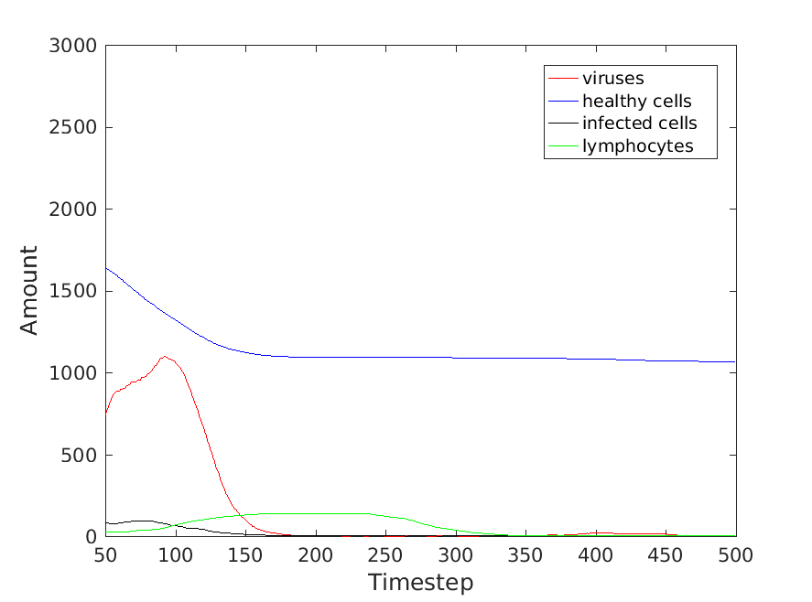

Figure [CYTO_LYMP_225]

*C.2 Lymphocyte speed at 90 Micrometers per second.*

In contrast to the previous experiment, figure [CYTO_LYMPH_90] exhibits the results when lymphocytes have a speed of 90 micrometers per second. At the onset of the virus attack healthy cells begin to drop, however they do seem to plateau around 450-500 cells. The virus however is a little more difficult in interpreting in this certain experiment. The virus curve contains a global maximum at around 200 timesteps and subsequently begins to decrease. Around the same time of decrease, the lymphocyte curve becomes very prominent exhibiting behavior similar to experiments discussed before. However what’s unusual about this experiment is that the virus curve never reaches a value of 0 and instead appears to be increasing again around 375 timesteps. A possibility for this behavior was that there may have been some untouched, infected cells around the 375 mark. As the lymphocytes began to die off, the infected cells may have started to burst. Additionally, it can be seen that there still remain a handful infected cells as the 375 timestamp is approached.

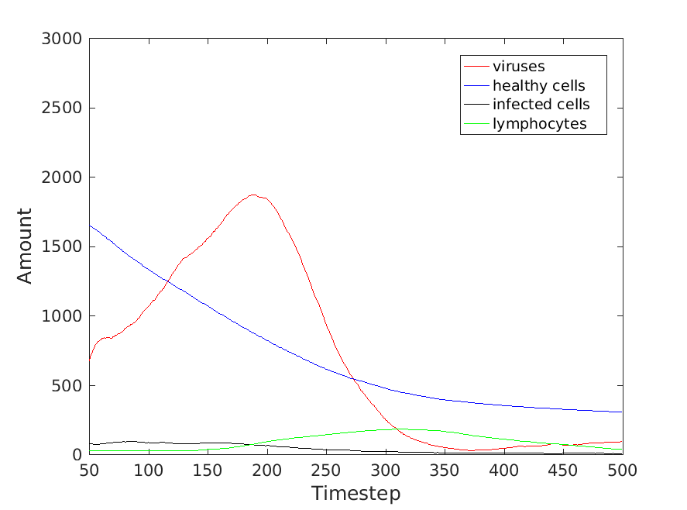

Figure [CYTO_LYMPH_90]

*D. Varying Lymphocyte Behavior*

As discussed in the methods portion of this paper, lymphocytes follow a path of cytokines in order to find the general area of virus attack. Once the lymphocyte reaches what it believes is the general area of attack the lymphocyte conducts a random search. An alternative behavior that the lymphocyte could perform is essentially a patrol behavior once it reaches the attack area. As the control group already exhibits the random search pattern, in this section we will show the results when the pattern is changed to a random walk.

In figure [HYPO7_NoCytoDup], it is shown that the virus count reaches a global maximum before the 150 timestep. In addition, at this maximum the count of viruses barely surpasses that of 1000. The lymphocyte count begins to increase at this time, as well as a contrasting decrease seen in the infected cell count. Notably the healthy cells plateau at just under 1000 healthy cells.

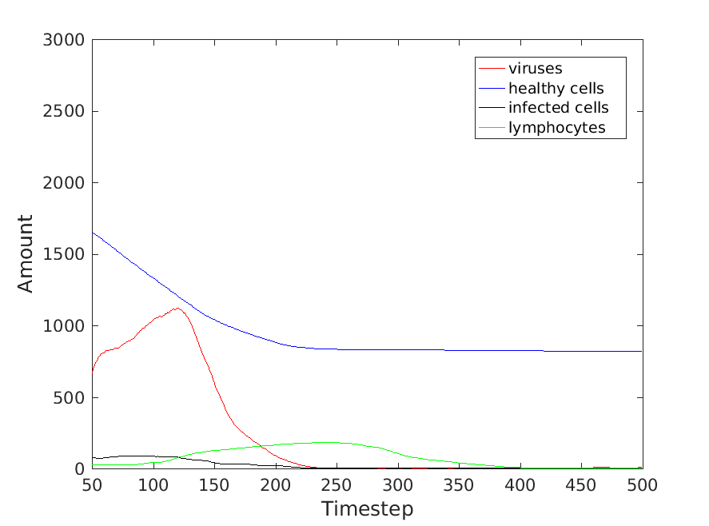

Figure [HYPO7_NoCytoDup]

*IV. Discussion and Conclusion*

WRITE A LITTLE SOMETHING ON DISCUSSION.

In this project we made hypotheses in regards to the behavior of macrophages in scenarios which may have required the help of lymphocytes in order to stop an attack by a foreign substance. In order to test these hypotheses, we constructed our own idea model of the immune system. In this system we implemented idea components of the immune system, which include: Lymphocytes, Macrophages, Healthy Cells, Viruses, as well as Cytokines. Upon constructing this model and fine tuning a control group, we then conducted experiments in order to test our hypotheses. We conducted our experiments by varying the availability of lymphocytes in the system, the speeds that the lymphocytes travelled, as well as the behavior of a lymphocyte upon reaching their final destination. We found that Macrophages do require the help of Lymphocytes in fending off a virus attack. We also found that the speed at which Lymphocytes travel will directly affect the speed at which a virus attack will be halted. Lastly, we found that although a random search pattern does effectively stop a virus attack, a patrol pattern is more efficient in doing so.

*V. References*

NEED TO CITE REFERENCES