SAINTE TECHNOLOGIES, INC.
Organizational Chart
V5.0 — CONFIDENTIAL

Complete corporate tree with visual diagrams for each pillar.

March 2026

SAINTE Society
Consumer Product Lines

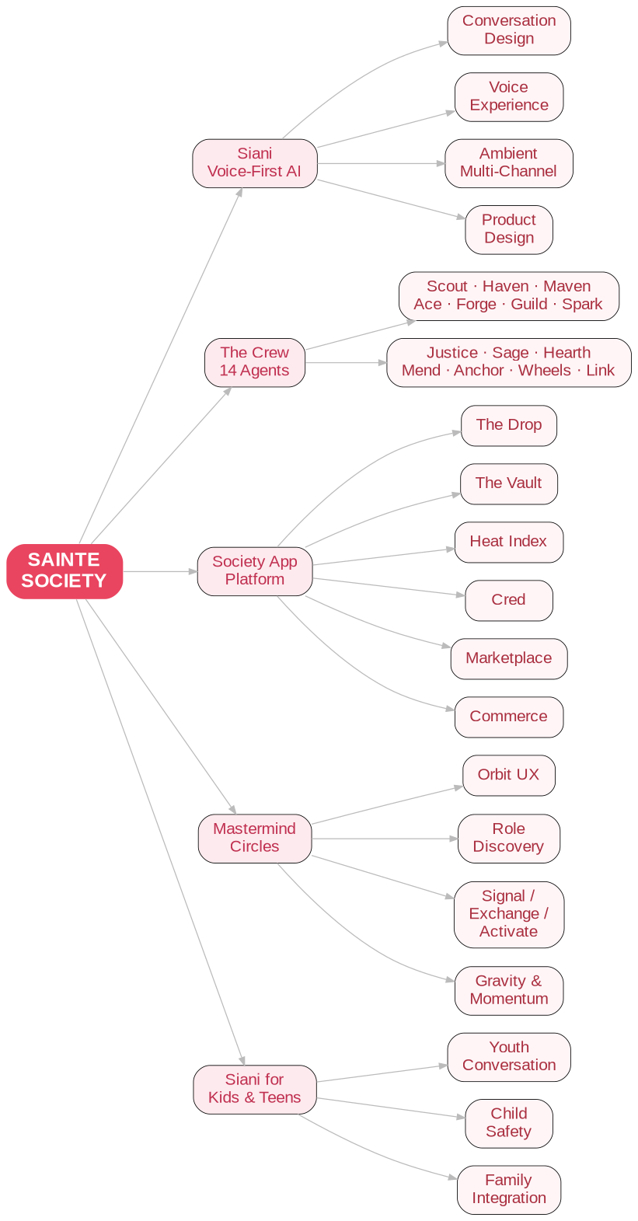

SAINTE Society — Detailed Structure

- Siani — Voice-first relational AI presence
- Conversation Design — 10 interaction modes, mirror mechanics
- Voice Experience — STT, TTS, VAD, <1100ms
- Ambient / Multi-Channel — SMS, smart speakers, wearables, in-car
- Product Design — Organic futurism
- The Crew — 14 specialized AI agents (canDoWithYou)
- Scout — Food & Resources
- Haven — Housing
- Maven — Benefits
- Ace — Money
- Forge — Employment
- Guild — Trades
- Spark — Entrepreneurship
- Justice — Legal
- Sage — Education
- Hearth — Family
- Mend — Healthcare
- Anchor — Crisis
- Wheels — Transportation
- Link — Digital Access
- Society App / Community Platform — Digital membership world
- The Drop — Invite-only access, Founding Voices, Slow Reveal
- The Vault — Personal collection & identity archive
- Heat Index — Real-time cultural pulse
- Cred — Reputation & trust currency
- Roles + Trust Network — Identity & permissions
- Marketplace — P2P commerce
- Commerce — First-party DTC
- Mastermind Circles — Strategic relationship infrastructure
- Orbit / Constellation UX — Visual circle builder
- Role Discovery — Universal contribution roles
- Signal / Exchange / Activate — Three core actions
- Gravity & Momentum — Status-based gamification
- Opportunity Capsules — Real-world opportunities
- Cross-Pathway Design — Tech, trades, business, creative, education
- Siani for Kids & Teens — Age-adapted relational AI
- Youth Conversation Design — Developmentally appropriate
- Child Safety Architecture — COPPA, mandatory reporting
- Family Integration — Parent dashboards

SAINTE Culture
The Reason Everything Works

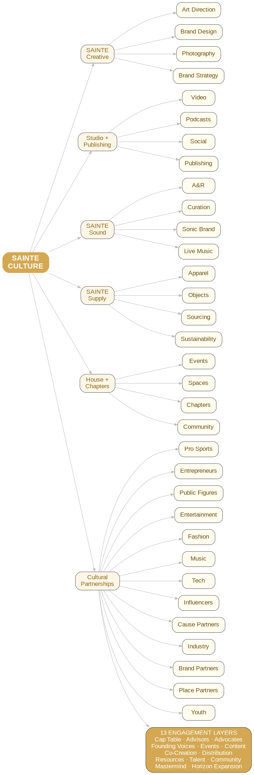

SAINTE Culture — Detailed Structure

- SAINTE Creative — In-house agency / taste authority
- Art Direction — Campaigns, launches
- Brand Design — Typography, layouts
- Photography & Styling — All verticals
- Brand Strategy — Positioning
- Production — Shoots, budgets
- SAINTE Studio + Publishing — Media & narrative voice
- Video Production — Docs, films, campaigns
- Audio / Podcasts — Narrative audio
- Social Content — TikTok, Reels, Shorts, X
- Motion Design — Animations
- Publishing — Books, zines, editorial
- SAINTE Sound — Sonic architecture
- A&R — Emerging artists
- Music Curation — All SAINTE spaces
- Sonic Branding — Audio logos
- Live Music — House events
- SAINTE Supply — Elevated luxury streetwear + Objects
- Apparel Design — Seasonal collections
- Objects — Home, tech, art
- Sourcing & Production — Manufacturing, QA
- Sustainability — Ethical sourcing
- SAINTE House + Chapters — Physical presence
- Flagship Events — Tentpole activations
- Branded Spaces — Spatial + sensory
- Chapters Network — City-based nodes
- Community Events — Local gatherings
- Cultural Partnership Ecosystem — 13 categories × 13 engagement layers
- Pro Sports
- Thought Leader Entrepreneurs
- Public Figures
- Entertainment
- Fashion
- Music
- Tech
- Top Influencers
- Purpose-Driven / Cause Partners — JUMP, Way.org type
- Industry Leaders
- Brand Partnerships
- Place Partnerships
- Youth — Sports, programs, creators

Engagement Layers: Cap Table · Advisors · Advocates · Founding Voices · Events · Content · Co-Creation · Distribution · Resources · Talent Pipeline · Community Presence · Mastermind · Horizon Expansion

Sainte Labs
Research, Science + IP — Where Value Is Created

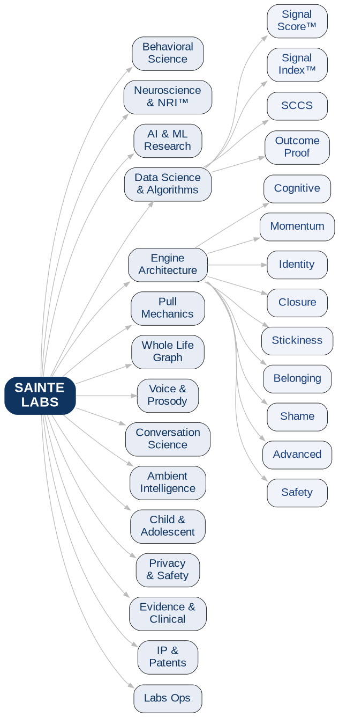

Sainte Labs — Detailed Structure

- Behavioral Science — Shame, avoidance, capacity restoration, intervention design
- Neuroscience & NeuroRelational Intelligence™ — 9-circuit: Polyvagal, Dopamine, Oxytocin, Serotonergic, DMN, ACC, PFC, HPA, Hippocampus
- AI & ML Research — Multi-engine, multi-agent, NLP, applied AI
- Multi-Engine Research — Parallel at <2.9s P95
- Multi-Agent Research — Crew architecture
- NLP & Conversation — Signal extraction
- Applied AI — Research → product
- Data Science & Algorithms — Signal Score™, Signal Index™, SCCS, DRR
- Signal Score™ — T, A, R, C, S
- Signal Index™ — Cohort metric
- SCCS Algorithm — Readiness windows
- Outcome Proof Architecture — DRR, CLPPM
- Intelligence Engine Architecture — 25+ engines
- Cognitive Engine
- Momentum / Behavioral
- Identity Transformation
- Closure Engine
- Stickiness Engine
- Belonging Engine
- Shame Extraction
- Advanced Systems
- Safety / Crisis
- Pull Mechanics Research — Reverse-engineering addiction for good
- Variable Reward Research
- Engagement Loop Design
- Anti-Dependency Research
- Whole Life Graph & Ontology — Survival Data Ontology, causality, Invisibility Architecture
- Voice & Prosody Research — Vocal biomarkers, emotionally adaptive synthesis
- Conversation Science — Turn-taking, pacing, mirror mechanics, culture-coded language
- Ambient Intelligence Research — Life Double: autonomous multi-channel presence
- Child & Adolescent Development — Developmental neuroscience, youth safety, family systems
- Privacy & Safety Research — Federated learning, AI safety, anti-dependency
- Evidence & Clinical Research — Outcomes, HEOR, IRB
- Health Economics
- Biostatistics
- Clinical Research Ops
- IP Development & Patents — 4 independent claims, 5-layer moat
- Labs Operations — Compute, experiment tracking, research admin

Product & Engineering
Distribution Vehicles Built From Labs’ Research

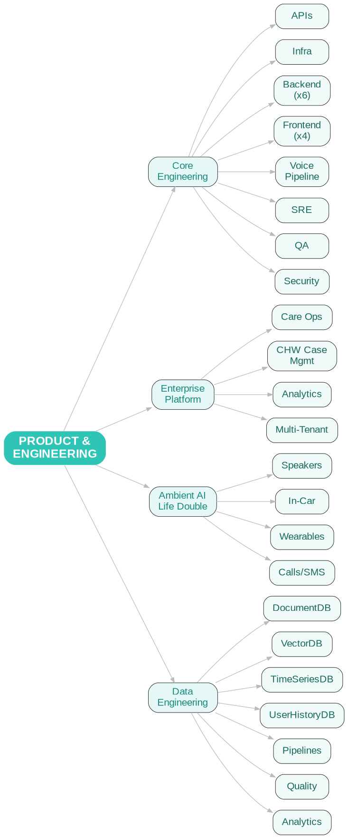

Product & Engineering — Detailed Structure

- Core Engineering — APIs, Event Bus, voice pipeline, infra, SRE, security, QA
- Platform / Core APIs
- Infrastructure
- Backend (x6)
- Frontend / Mobile (x4)
- Voice Pipeline (x2)
- SRE / DevOps (x2)
- QA (x3)
- Security (x2)
- Enterprise Platform — Dual-Reality Architecture™
- Care Ops Dashboards
- CHW Case Management
- Analytics & Reporting
- Multi-Tenant Architecture
- Ambient AI / Life Double — Multi-channel autonomous presence
- Smart Speakers
- In-Car
- Wearables
- Proactive Calls + SMS
- Data Engineering — Production data stack
- DocumentDB
- VectorDB
- TimeSeriesDB
- UserHistoryDB
- Pipelines
- Quality
- Analytics Eng

Sainte Solutions
Enterprise Revenue

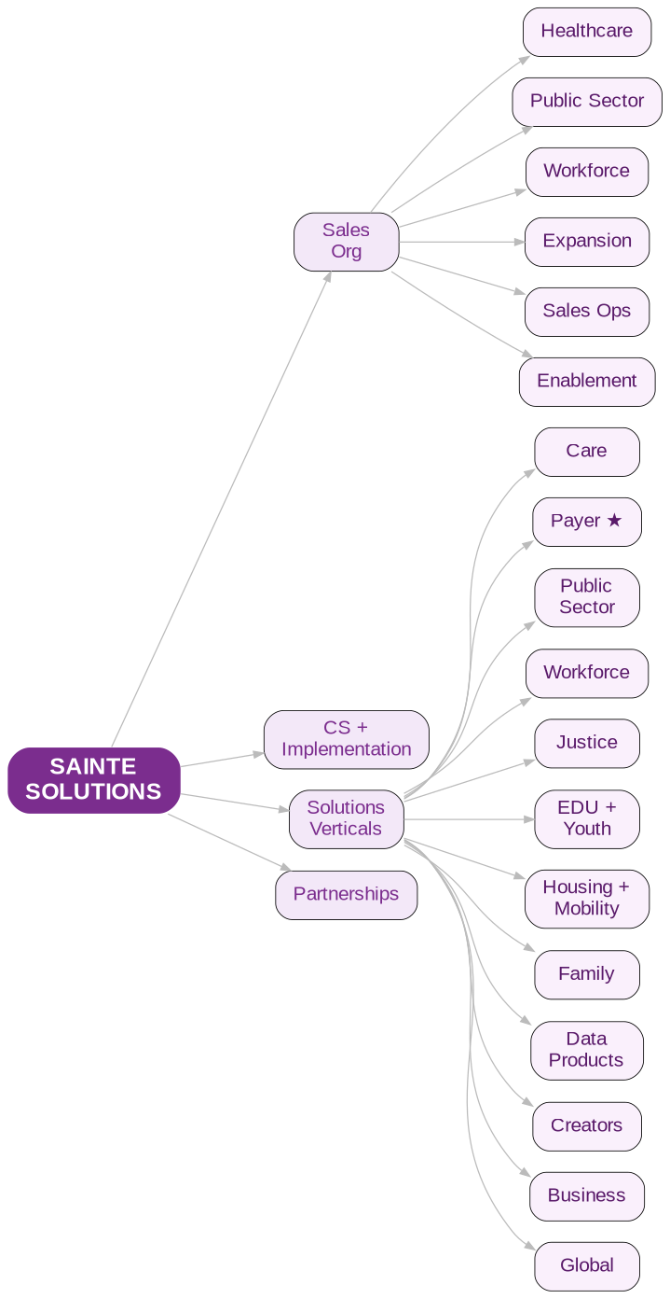

Sainte Solutions — Detailed Structure

- Sales Organization — CFO-aligned
- Sales Dir, Healthcare
- Sales Dir, Public Sector
- Sales Dir, Workforce
- Sales Dir, Expansion
- Sales Operations
- Sales Enablement
- Customer Success + Implementation — Post-sale
- CSMs (x4)
- Head of Implementation
- Solutions Engineers (x3)
- Implementation PMs (x2)
- Solutions Verticals — 13+ business units
- Sainte Care
- Sainte Payer — PRIMARY REVENUE WEDGE
- Sainte Public Sector
- Sainte Workforce + Benefits
- Sainte Justice — Intercept 0–5
- Sainte EDU + Youth
- Sainte Housing + Mobility
- Sainte Family Services
- Sainte Data Products
- Sainte Creators
- Sainte Business
- Sainte Global
- Partnerships + Channel — Tech + channel
- Sainte Network — EHR, HRIS, payer integrations
- Partner Network — Consulting, SIs, resellers

Corporate / Holdings
Governance Backbone

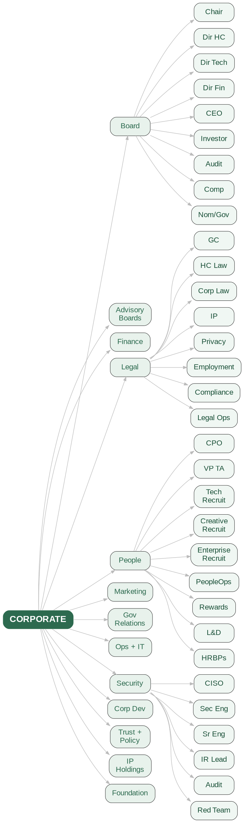

Corporate / Holdings — Detailed Structure

- Board of Directors — Fiduciary oversight
- Board Chair
- Independent Dir, Healthcare
- Independent Dir, Technology
- Independent Dir, Finance
- CEO / Founder Seat — Katy Kelly
- Investor Seat(s)
- Committees — Audit, Compensation, Nom/Gov
- Advisory Boards
- Clinical Advisory Board (5–7)
- Technical Advisory Board (3–5)
- Cultural Advisory Board (3–5)
- Enterprise Advisory Board (3–5)
- Finance
- CFO
- VP Finance / Controller
- Head of FP&A
- Treasury
- Tax
- Sr. Accountant (x2)
- IR Manager
- Legal + Compliance
- General Counsel
- VP Legal, Healthcare
- VP Legal, Corporate
- IP Counsel
- Privacy Counsel
- Employment
- Compliance Manager
- Legal Ops (x2)
- People + Talent
- CPO
- VP Talent Acquisition
- Recruiting Lead, Technical
- Recruiting Lead, Creative
- Recruiting Lead, Enterprise
- Head of PeopleOps
- Head of Total Rewards
- Head of L&D
- Sr. HRBP (x3)
- Marketing + Growth + Comms
- CMO
- VP Enterprise Marketing
- VP Communications + PR
- Content Marketing
- Digital Marketing
- Events
- Analyst Relations
- Government Relations
- Head of GR
- State Regulatory Analyst
- Policy Researcher
- Operations + IT
- VP Operations
- Head of IT
- Procurement
- Head of BI
- Facilities
- Process Analyst (x2)
- Security + Risk
- CISO
- Head of Security Eng
- Sr. Security Eng (x2)
- IR Lead
- Compliance & Audit
- Red Team
- Corporate Development
- Head of Corp Dev
- Corp Dev Analyst
- Trust + Safety + Policy
- Chief Trust Officer
- Head of AI Ethics
- Head of Data Governance
- Sr. Policy Analyst (x2)
- Sainte IP Holdings
- VP IP Strategy
- Trademark Manager
- Licensing Manager
- Sainte Foundation
- Executive Director
- Head of Programs
- Impact Analyst
- Community Engagement Lead

SAINTE. This is what we’re on now.

