SAINTE TECHNOLOGIES, INC.
Team Org Charts + Role Specifications
V5.0 — CONFIDENTIAL — 45 TEAMS — 200+ ROLES

Every team. Every seat. Every mandate. Every exemplar profile.

March 2026

SAINTE Society
Consumer Product Lines — 5 Teams

Siani — Voice-First Relational AI Presence
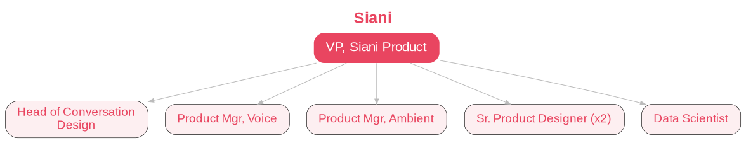
■ VP, Siani Product
Owns the entire Siani product experience: roadmap, UX, interaction design, voice quality, ambient channels, and the emotional intelligence that makes Siani feel like a trusted friend rather than a chatbot. Must deeply understand trauma-informed design, conversational AI, and why shame-aware interaction is fundamentally different from standard UX. Accountable for DAU, session depth, Signal Score improvement, and the qualitative experience of ‘feeling known.’
Think: Eugenia Kuyda (Replika — built the most successful relational AI consumer product), Aza Raskin (Center for Humane Technology — ethics-first consumer AI), Cathy Pearl (Google — author of Designing Voice User Interfaces)
■ Head of Conversation Design
Designs Siani’s personality across all 10 interaction modes (Stabilize, Elevate, Challenge, Reflect, Hype, Decode, Clarify, Reframe, Ground, Move). Owns turn-taking rules, emotional pacing, best-friend mirror mechanics, culture-coded language, silence architecture, and response length governance. This person defines what Siani says, how she says it, and when she says nothing. The difference between a product people open once and one they open every day lives in this role.
Think: James Giangola (Google — pioneered conversational persona design for Google Assistant), Wally Brill (Google — Head of Conversation Design), Margaret Urban Walker (conversational ethics and tone)
■ Product Manager, Voice
Owns the real-time voice experience: speech-to-text (ASR), text-to-speech (TTS), voice activity detection (VAD), prosody extraction, and the end-to-end latency budget (<1100ms). Must ship a voice experience that feels like talking to a person, not dictating to a machine. Handles degraded-mode fallbacks, noise tolerance, accent robustness, and emotional speech handling (crying, anger, shutdown).
Think: Rohit Prasad (Amazon — led Alexa’s voice AI for a decade), Toni Reid (Amazon — scaled Alexa consumer experience), Vlad Sejnoha (Nuance — pioneered commercial voice recognition)
■ Product Manager, Ambient
Owns Siani’s presence across non-app channels: SMS, smart speakers (Alexa, Google Home), wearables (Apple Watch), in-car (CarPlay/Android Auto), and proactive phone calls. The goal is zero-UI interaction — Siani acts autonomously on behalf of the user without them opening an app. This is the Life Double concept in product form.
Think: Imran Chaudhri (Humane — designed ambient AI hardware), Mark Weiser (Xerox PARC — coined ubiquitous computing), Yoky Matsuoka (Nest/Apple — ambient intelligence in consumer products)
■ Sr. Product Designer (x2)
Design the visual and interaction layer across all Siani surfaces. Must execute organic futurism: black-on-black, material-based depth, sacred interface. Never clinical, never corporate, never superhero. The aesthetic must signal ‘this is a lifestyle product for people who have taste’ while simultaneously being accessible to someone in crisis at 2 AM.
Think: Mike Matas (Push Pop Press / Facebook Paper — redefined mobile interaction design), Linda Dong (Apple Vision Pro — spatial interaction), Matias Duarte (Google Material Design — built a design system used by billions)
■ Data Scientist
Measures everything: Signal Score effectiveness, engine accuracy, engagement persistence, intervention timing, and the relationship between Siani interactions and real-world outcomes (ER reduction, referral completion, retention). Runs experiments to validate that the product actually works, not just that people use it.
Think: DJ Patil (former U.S. Chief Data Scientist — defined the data science function), Hilary Mason (Cloudera Fast Forward Labs — applied data science), Emily Robinson (author of Build a Career in Data Science)

The Crew — 14 Specialized AI Agents
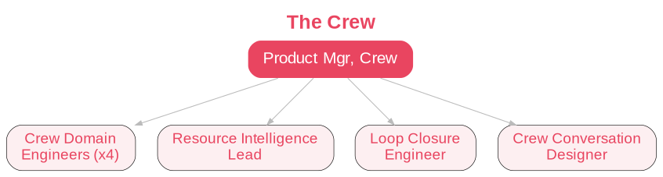
■ Product Manager, Crew
Owns the multi-agent system: 14 agents (Scout, Haven, Maven, Ace, Forge, Guild, Spark, Justice, Sage, Hearth, Mend, Anchor, Wheels, Link), each with a distinct personality, domain, and the mandate to close the loop. Manages the handoff UX from Siani to Crew members (‘I got a friend who knows about this’). Ensures the ‘canDoWithYou’ model builds user autonomy rather than dependency.
Think: Harrison Chase (LangChain — multi-agent orchestration), Div Garg (MultiOn — autonomous agent actions), Joon Sung Park (Stanford — generative agents research)
■ Crew Domain Engineers (x4)
Each engineer owns 3–4 Crew agents and builds their domain capabilities: resource databases, form navigation, application logic, appointment scheduling, legal translation. These engineers don’t just build APIs — they build agents that can walk someone through a Medicaid renewal via voice while detecting shame signals that would cause them to abandon the process.
Think: Adept AI engineering team (built ACT-1 for real-world task completion), Amelia Wattenberger (AI UX engineering), Lilian Weng (OpenAI — agent systems research)
■ Resource Intelligence Lead
Builds and maintains the real-time resource matching engine: which organizations actually pick up the phone, which have capacity, which follow through. Manages Red Tape Penalties (organizations that create friction), Provider Reliability Scores, and the organizational accountability layer that tracks whether referrals actually result in service delivery.
Think: Erin Dalton (Allegheny County DHS — pioneered predictive analytics in social services), Tina Rosenberg (author of Join the Club — social resource networks), Geoffrey Canada (Harlem Children’s Zone — built the gold standard in connected service delivery)
■ Loop Closure Engineer
Builds the Closed-Loop Referral Engine™: tracks every referral from initiation through verified completion by both member AND provider. In current systems, 60–70% of referrals disappear into silence. This engineer builds the infrastructure that ensures none do. Integrates with provider systems, manages confirmation workflows, and builds the accountability data that enterprises pay for.
Think: Todd Park (former U.S. CTO — interoperability and health data infrastructure), Aneesh Chopra (former U.S. CTO — open data and closed-loop systems), Niko Skievaski (Redox — healthcare API infrastructure)
■ Crew Conversation Designer
Designs each Crew member’s distinct personality, voice, and interaction pattern. Scout sounds different from Justice sounds different from Anchor. Each must feel like a real person with expertise, not a menu system with a name. Manages the transition moments when a Crew member hands back to Siani.
Think: Chris Noessel (author of Designing Agentive Technology), Robert Moore (author of Conversational UX Design), Leigh Clark (Swansea — social robot/agent personality research)

Society App / Community Platform — Digital Membership World
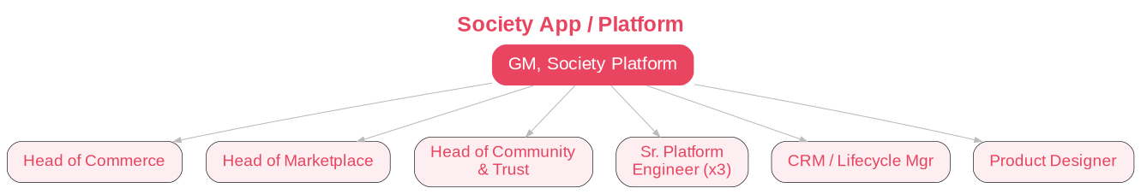
■ GM, Society Platform
P&L owner for the platform: The Drop, The Vault, Heat Index, Cred, Roles + Trust Network, Marketplace, and Commerce. Must build a premium digital world that feels like a private club, not an app store. Manages the tension between exclusivity (which creates desire) and accessibility (which creates scale). Revenue responsibility across DTC commerce, marketplace take rate, and membership.
Think: Sarah Tavel (Benchmark — wrote the definitive framework on engagement hierarchies), Emily Weiss (Glossier — built community-first commerce), Tobi Lütke (Shopify — commerce infrastructure for creators and brands)
■ Head of Commerce
Runs first-party DTC sales: SAINTE Supply products, limited drops, exclusive collaborations. Must build a commerce experience that feels like buying from Supreme or Kith, not Amazon. Manages inventory, merchandising, checkout, post-purchase, and the cultural moment around each drop.
Think: Brendon Babenzien (Noah — culturally elevated DTC streetwear), Angelo Baque (Awake NY — community-driven commerce), Emily Oberg (Sporty & Rich — built cult DTC brand from zero)
■ Head of Marketplace
Runs P2P marketplace operations where members trade, sell, and collaborate. Trust scoring via Cred, escrow, dispute resolution, authentication. Must prevent the marketplace from feeling like a flea market while enabling genuine value exchange.
Think: Josh Luber (StockX — built authentication + trust in resale), Manish Chandra (Poshmark — social commerce at scale), Tracy Sun (Poshmark — marketplace community mechanics)
■ Head of Community & Trust
Owns Cred scoring, Roles, Trust Network, and community moderation. This person designs the reputation and permission system that makes the platform self-governing. Cred must feel like social capital, not gamification points. Trust Network must enable genuine relationships, not follower counts.
Think: Evan Spiegel (Snap — designed social mechanics around authenticity), Bailey Richardson (co-author of Get Together — community-building frameworks), David Spinks (CMX — community strategy)
■ Sr. Platform Engineer (x3)
Build the technical infrastructure: commerce engine, marketplace, Drop mechanics, Vault storage, Heat Index real-time feeds, Cred scoring, and Roles/Trust Network permissions. Must handle high-concurrency drop events where thousands of members attempt access simultaneously.
Think: Guillermo Rauch (Vercel — real-time web infrastructure), Paul Graham (built marketplace infrastructure at Viaweb/Yahoo Store), James Long (Stripe — commerce engineering)
■ CRM / Lifecycle Manager
Owns post-purchase experience, reactivation, loyalty, and the member journey across all platform features. Builds the automated communication that keeps members engaged without feeling spammy. Must understand that SAINTE members are not ‘users’ — they are members of a movement.
Think: Kipp Bodnar (HubSpot CMO — lifecycle marketing at scale), Joanna Lord (ClassPass / Skyscanner — retention-focused growth), Gia Laudi (Forget the Funnel — jobs-to-be-done lifecycle design)

Mastermind Circles — Strategic Relationship Infrastructure
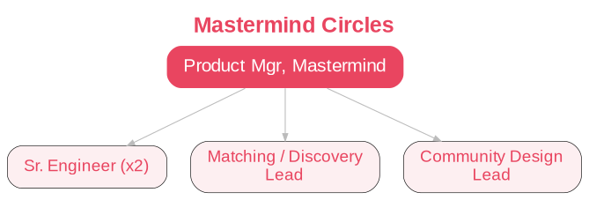
■ Product Manager, Mastermind
Owns the orbit/constellation UX, role discovery system, matching algorithm, Signal/Exchange/Activate mechanics, Gravity and Momentum gamification, Opportunity Capsules, and cross-pathway design. Must build a product that works for tech founders AND tradespeople AND students AND small business owners simultaneously. Must ensure the system never feels like networking, help-seeking, or mentorship — always strategic proximity and opportunity exchange.
Think: Reid Hoffman (LinkedIn co-founder — professional network design), Keith Ferrazzi (author of Never Eat Alone — strategic relationship architecture), Sarah Tavel (Benchmark — engagement hierarchy theory applied to networks)
■ Sr. Engineer, Mastermind (x2)
Build the orbit visualization with dynamic positioning (stronger relationships closer to center), real-time momentum scoring, opportunity capsule delivery, cross-circle discovery, and the animation/haptics that make the interface feel alive. Must handle real-time social mechanics at scale without the product feeling like a game.
Think: Bret Victor (Dynamicland — spatial interface pioneer), Evan Wallace (Figma co-founder — real-time collaborative interfaces), Lauren McCarthy (p5.js — creative interactive systems)
■ Matching / Discovery Lead
Builds the intelligence that suggests who belongs in someone’s circle and why. Must analyze interaction patterns, community behavior, trajectory alignment, and contribution signals to surface relevant people — not random recommendations. The quality of matching determines whether circles produce real value or feel hollow.
Think: Jonathan Goldman (LinkedIn — built People You May Know, drove 30% of LinkedIn connections), Carlos Gomez-Uribe (Netflix — recommendation systems), Piotr Indyk (MIT — nearest-neighbor algorithms)
■ Community Design Lead
Designs the rules, norms, and cultural dynamics that keep circles high-signal. Must prevent extraction (people only asking), ensure reciprocity, and make contribution feel natural. Designs the cross-pathway value exchange mechanics so a contractor and a founder can find genuine mutual value.
Think: Richard Millington (FeverBee — community strategy), Jono Bacon (author of People Powered — community architecture), Fabian Pfortmüller (Together Institute — intentional community design)

Siani for Kids & Teens — Age-Adapted Relational AI
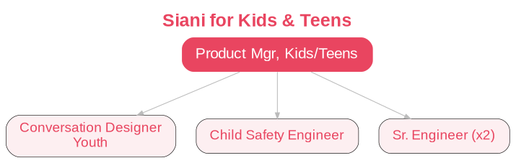
■ Product Manager, Kids/Teens
Owns the youth-adapted Siani product: age-appropriate conversation design, family integration, developmental sensitivity, and a safety-first architecture that meets COPPA requirements while still feeling genuine to young users. Must navigate the tension between parental oversight and teen autonomy. The product must feel cool enough that a 15-year-old wants to use it, safe enough that a parent trusts it, and effective enough that a pediatrician recommends it.
Think: Tracy Elizabeth (Common Sense Media — child digital safety), James P. Steyer (Common Sense Media founder — children’s digital policy), Justine Cassell (CMU/INRIA — pioneered children’s conversational agents)
■ Conversation Designer, Youth
Adapts Siani’s 10 interaction modes for developmental appropriateness. A 12-year-old processes shame differently than a 35-year-old. A 16-year-old’s identity instability is developmentally normal, not pathological. This designer must understand child and adolescent psychology deeply enough to calibrate every response for the user’s developmental stage.
Think: Alison Gopnik (UC Berkeley — children’s cognitive development), Patricia Kuhl (UW — early language and social cognition), Deborah Tannen (Georgetown — conversational style across age groups)
■ Child Safety Engineer
Builds the safety architecture: content filtering, age-gating, mandatory reporting compliance, parental controls, and the detection of situations requiring human intervention. Must implement COPPA compliance at the technical level while ensuring safety mechanisms don’t make the product feel surveilled or controlled.
Think: Antigone Davis (Meta — Head of Global Safety), Hany Farid (UC Berkeley — digital forensics and child safety technology), Yiota Souras (NCMEC — technology-driven child protection)

SAINTE Culture
The Reason Everything Works — 6 Teams

SAINTE Creative — In-House Agency / Taste Authority
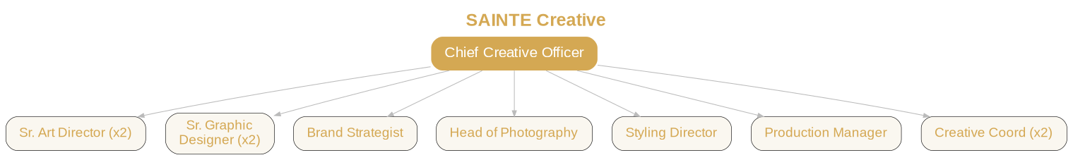
■ Chief Creative Officer
The taste authority for the entire company. Every visual, every word, every spatial experience, every product that carries the SAINTE name passes through this person’s standard. Defines and enforces the design language: organic futurism, black-on-black, material-based depth, sacred interface. Must be equally credible in a fashion showroom, a tech product review, and a healthcare conference. Prevents SAINTE from ever looking, sounding, or feeling like a healthcare company.
Think: Virgil Abloh (Off-White/Louis Vuitton — redefined luxury through streetwear and systems thinking), Tremaine Emory (Supreme/Denim Tears — cultural identity through product), Heron Preston (fashion + technology + sustainability convergence)
■ Sr. Art Director (x2)
Lead visual direction for campaigns, product launches, cultural activations, and brand collaborations. Must produce work that would be credible in Highsnobiety, not just a SaaS marketing blog. One AD focused on digital/motion, one on physical/print/experiential.
Think: Fabien Baron (Baron & Baron — iconic fashion art direction for Calvin Klein, Dior, Burberry), M/M Paris (art direction for Givenchy, Balenciaga, Kanye), Willy Vanderperre (photographer/AD for Raf Simons, Prada)
■ Sr. Graphic Designer (x2)
Execute the SAINTE visual system: typography, layouts, digital and print collateral. The emblem must feel like it was pressed into stone. Every piece of collateral must be undeniably premium.
Think: Peter Saville (Factory Records/Joy Division — defined music-meets-design), Neville Brody (The Face magazine, Fuse — editorial design pioneer), Jessica Walsh (Sagmeister & Walsh — emotionally provocative design)
■ Brand Strategist
Positions SAINTE in culture. Competitive analysis against both healthcare tech AND cultural brands. Tracks how the brand is perceived across different audiences: Medicaid members, MCO executives, fashion editors, athletes, investors. Must articulate why SAINTE is a cultural movement that happens to solve healthcare’s most expensive problem.
Think: Ana Andjelic (author of The Business of Aspiration — cultural brand strategy), Douglas Holt (author of How Brands Become Icons — cultural strategy), Denise Lee Yohn (author of What Great Brands Do — brand-as-business strategy)
■ Head of Photography
Establishes the photographic language for SAINTE: how people look in the world, how products are shot, how spaces feel. Must build a network of photographers who understand that SAINTE imagery is neither clinical nor aspirational-toxic. People should look real, elevated, and alive.
Think: Tyler Mitchell (first Black photographer to shoot Vogue cover — elevated everyday life), Campbell Addy (i-D, Vogue — Black beauty and identity), Dana Scruggs (ESPN Body Issue — athlete dignity and form)
■ Styling Director
Visual styling across all brand imagery: product, editorial, events, content. Controls what SAINTE looks like on people. Must bridge streetwear, luxury, and everyday accessibility without defaulting to any one register.
Think: Ibrahim Kamara (Dazed creative director — Afro-diasporic luxury styling), Carlos Nazario (Vogue, W — celebrity styling with cultural intelligence), Gabriella Karefa-Johnson (Vogue — defining contemporary fashion language)

SAINTE Studio + Publishing — Media & Narrative Voice
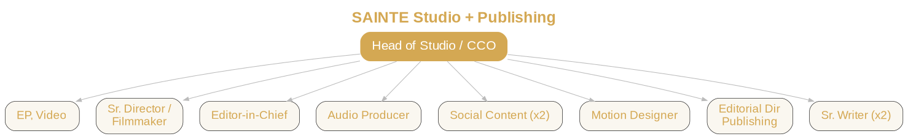
■ Head of Studio / Chief Content Officer
Owns the narrative: what SAINTE says to the world, how it sounds, what stories it tells. Manages video production, podcasts, social content, and the editorial voice. Every piece of content must make someone who has never heard of SAINTE feel like they have been missing something. Not a content mill. A media company within a technology company.
Think: Ava DuVernay (Array — built a media empire from a justice-centered worldview), Maverick Carter (SpringHill Co. — culture + athlete storytelling at enterprise scale), Casey Neistat (built authentic creator media to 12M+ subscribers)
■ Executive Producer, Video
Manages all video production: budgets, crews, post-production, distribution strategy. Must produce at the quality of a Vice or Netflix documentary while moving at the speed of a startup.
Think: Raeshem Nijhon (SpringHill — athlete/culture doc production), Joe Berlinger (Oscar-nominated documentarian), dream hampton (Time: The Kalief Browder Story — justice + storytelling)
■ Editor-in-Chief
Owns the written voice of SAINTE: website copy, editorial features, social captions, investor communications tone. Must be a real writer, not a content marketer. The written voice should feel like The Fader meets MIT Technology Review meets a letter from your smartest friend.
Think: Tyler Brûlé (Monocle founder — built a global editorial brand from a worldview), Lindsay Peoples Wagner (The Cut/Teen Vogue — culturally intelligent editorial leadership), Rembert Browne (New York Magazine — culture writing with depth and humor)
■ Audio Producer
Podcasts and audio experiences. SAINTE’s audio content must feel like premium storytelling, not marketing. Manages production, guests, distribution, and the relationship between audio content and the SAINTE Sound sonic identity.
Think: Hrishikesh Hirway (Song Exploder — intimate creative storytelling), Alex Blumberg (Gimlet — built narrative podcasting into an industry), Jenna Wortham (NYT — culture/tech podcasting with depth)
■ Social Content Lead (x2)
Platform-native content across TikTok, Instagram, YouTube Shorts, X. Must understand algorithmic distribution without sacrificing brand integrity. Content should feel organic and culturally credible, never corporate or forced. One lead for short-form video, one for static/editorial social.
Think: Jack Conte (Patreon founder — creator-first social strategy), Karen X Cheng (viral creative content engineer — 100M+ views), Daquan Gesese (built one of Instagram’s largest meme brands into a media company)

SAINTE Sound — Sonic Architecture
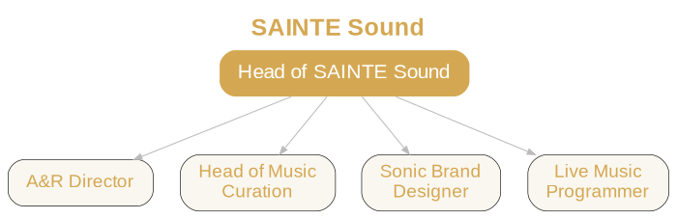
■ Head of SAINTE Sound
Defines the sonic identity of the entire movement: what SAINTE sounds like in House events, in the app, in Siani’s ambient mode, in retail spaces, in content. Sound is not background music. Sound regulates the nervous system. This person understands that a specific frequency and rhythm can shift someone from threat detection to belonging in 30 seconds.
Think: Joel Beckerman (Man Made Music — sonic branding for CBS, AT&T, Goldman Sachs), Luiz Guilherme (Sixieme Son — European sonic branding pioneer), Brian Eno (ambient music pioneer — invented the concept of generative music for spaces)
■ A&R Director
Scouts and develops emerging artists who align with SAINTE’s cultural identity. Not mainstream pop. Artists who represent resilience, authenticity, and the intersection of struggle and beauty. Manages artist partnerships, exclusive releases, and the creative pipeline that keeps SAINTE Sound culturally relevant.
Think: Motown Berry Gordy (Motown — cultural A&R that shaped American identity), Jean-Michel Basquiat circle (art-meets-music cultural curation), Virgil Abloh’s approach to cross-genre creative curation
■ Head of Music Curation
Builds playlists and sonic environments for every SAINTE context: House events, Chapter gatherings, app ambient mode, Siani’s voice sessions, retail pop-ups. Understands psychoacoustics: how tempo, key, and texture affect nervous system regulation.
Think: Zane Lowe (Apple Music — global curation with cultural authority), Tuma Basa (YouTube Music — built Spotify’s RapCaviar into a cultural institution), Austin Kramer (Spotify Head of Hip-Hop)

SAINTE Supply — Elevated Luxury Streetwear + Objects
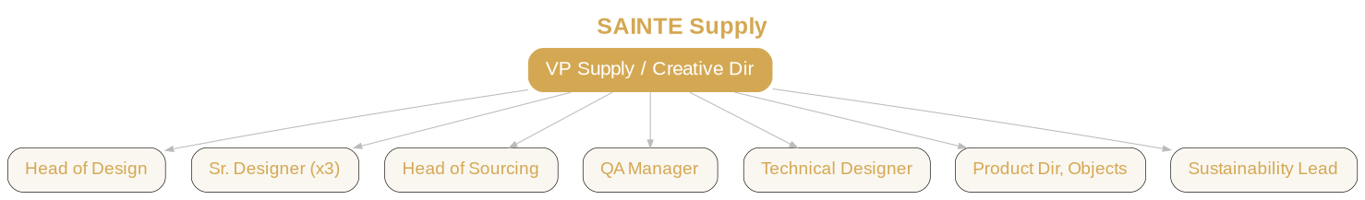
■ VP of Supply / Creative Director
Leads the entire wearable identity line: apparel, accessories, lifestyle goods, and the Objects line. Must produce fashion that stands alongside Fear of God, Aimé Leon Dore, and A-COLD-WALL* in quality and design. The moment Supply feels like branded merch for a health program, the entire cultural system breaks.
Think: Jerry Lorenzo (Fear of God — built luxury streetwear from a spiritual/cultural foundation), Teddy Santis (Aimé Leon Dore — community-rooted luxury streetwear), Samuel Ross (A-COLD-WALL* — industrial design meets fashion meets social commentary)
■ Head of Design
Leads design across all product categories: apparel, accessories, lifestyle. Must understand fabric, construction, fit, and the visual language that makes someone look at a garment and know it’s SAINTE before seeing the label.
Think: Emily Bode (Bode — narrative-driven fashion design), Grace Wales Bonner (Wales Bonner — culturally rooted luxury design), Kerby Jean-Raymond (Pyer Moss — activism embedded in fashion design)
■ Head of Sourcing & Production
Manages the entire supply chain: factories, suppliers, timelines, quality control, cost management. Must maintain luxury-grade quality at startup-grade speed and cost. Ethical sourcing is non-negotiable.
Think: Stella McCartney’s supply chain team (pioneered ethical luxury production), Everlane’s radical transparency model (Michael Preysman), Patagonia’s supply chain (built the gold standard in responsible sourcing)

SAINTE House + Chapters — Physical Presence
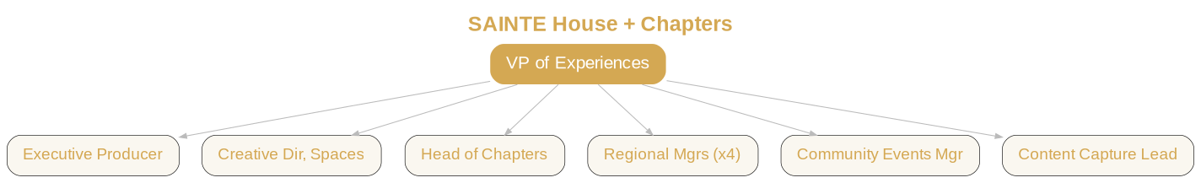
■ VP of Experiences
Owns all IRL programming: flagship events, branded spaces, Chapter infrastructure, and community gatherings. Must produce physical experiences that turn digital community into tribe. Understands that physical co-presence with people who share your identity accelerates belonging through neurological mechanisms (oxytocin, mirror neuron activation, co-regulation) that digital alone cannot replicate.
Think: Rafaela de Oliveira (Soho House — built global membership experience brand), Alex Porat (Meow Wolf — immersive experience at scale), Nick Jones (Soho House founder — defined the modern members club)
■ Creative Director, Spaces
Designs the physical and sensory environments where SAINTE events happen. Lighting, materials, flow, sound, scent. The space must shift someone’s nervous system from the moment they walk in. Sacred, not sanitized. Warm, not clinical. Elevated, not pretentious.
Think: Ilse Crawford (StudioIlse — human-centered interior design for Aesop, IKEA), Winka Dubbeldam (Archi-Tectonics — experiential spatial design), David Adjaye (Adjaye Associates — culturally meaningful architecture)
■ Head of Chapters
Builds and manages the global Chapters model: leader selection, quality standards, programming frameworks, and the systems that allow SAINTE’s physical presence to scale without losing cultural integrity. Each Chapter must feel locally authentic and globally connected.
Think: Priya Parker (author of The Art of Gathering — definitive work on intentional gathering design), Scott Heiferman (Meetup founder — scaled local community globally), Fabian Pfortmüller (Together Institute — community infrastructure design)

Cultural Partnerships — 13 Categories × 13 Engagement Layers
■ VP of Cultural Partnerships
Owns the entire cultural relationship ecosystem: sourcing, negotiating, managing, and activating partnerships across Pro Sports, Entertainment, Music, Fashion, Tech, Influencers, Cause Partners, Industry Leaders, Brand Partners, Place Partners, and Youth. Each category operates through 13 engagement layers (Cap Table, Advisors, Advocates, Founding Voices, Events, Content, Co-Creation, Distribution, Resources, Talent Pipeline, Community Presence, Mastermind, Horizon Expansion). This person is the connective tissue of the entire cultural operation.
Think: Rich Kleiman (Thirty Five Ventures — Kevin Durant’s business empire, athlete-as-cultural-infrastructure), Troy Carter (Atom Factory/Cross Culture — artist management to tech investing pipeline), Maverick Carter (SpringHill — athlete storytelling to enterprise media)
■ Head of Athlete & Sports Partnerships
Manages the Pro Sports category across all engagement layers. Athletes on the cap table, on advisory boards, as natural advocates who wear and use SAINTE, as Founding Voices who anchor Drops, as event hosts, as content collaborators, as product co-creators, and as distribution channels to their audiences.
Think: Paul Wachter (Main Street Advisors — manages athlete/celebrity investments for LeBron, Bono, Schwarzenegger), Nicole Lynn (first Black woman sports agent — Quinnen Williams, Jalen Ramsey), Adisa Bakari (Roc Nation Sports — athlete empowerment strategy)
■ Head of Entertainment & Music Partnerships
Entertainment + Music categories: film, TV, music, performance. Manages relationships with artists, labels, production companies, and cultural institutions. Every entertainment partnership must feel organic to the SAINTE identity — never a paid endorsement.
Think: Pharrell Williams (cultural polymath — music, fashion, business), Kenya Barris (black-ish creator — culture through entertainment), Issa Rae (built media empire from YouTube to HBO — authentic cultural entrepreneurship)
■ Head of Fashion & Brand Partnerships
Fashion + Brand + Place Partnerships categories. Manages collaborations with fashion houses, DTC brands, retailers, and physical locations. Every brand partnership must elevate both SAINTE and the partner — never dilute either.
Think: June Ambrose (cultural stylist + brand consultant to Jay-Z, Missy Elliott), Aurora James (15 Percent Pledge — systemic brand inclusion), Jeff Staple (Staple Design — streetwear collaboration pioneer)
■ Head of Tech & Industry Partnerships
Tech + Industry Leaders + Thought Leader Entrepreneurs categories. Manages relationships with technology companies, industry executives, and entrepreneurial thought leaders who can provide cap table investment, advisory relationships, distribution, and credibility in enterprise sales contexts.
Think: David Singleton (CTO Google DeepMind — tech leadership ecosystem), Arlan Hamilton (Backstage Capital — underrepresented founder ecosystem), Ben Horowitz (a16z — builder-operator-investor ecosystem)
■ Head of Impact & Cause Partnerships
Purpose-Driven / Cause Partners category (organizations like JUMP, Way.org). Manages relationships with nonprofits, social enterprises, and cause-driven organizations. Must ensure these partnerships are authentic and mutually beneficial, not performative corporate social responsibility.
Think: Jacqueline Novogratz (Acumen — impact investing pioneer), Scott Harrison (charity: water — cause marketing innovation), Deray McKesson (activist + organizer — movement-building infrastructure)
■ Horizon Expansion Coordinator
Designs and executes experiences that open members’ minds to what is possible for them. Creates exposure to worlds they didn’t know existed: backstage at events, factory tours, studio sessions, mentorship dinners, career discovery days. This role exists because aspiration requires imagination, and imagination requires exposure.
Think: Geoffrey Canada (Harlem Children’s Zone — systematic exposure programs), Marco Davis (New Profit — social mobility through exposure), Reshma Saujani (Girls Who Code — exposure as pathway to identity shift)

Sainte Labs
Research, Science + IP — 15 Divisions

Behavioral Science Division — Shame, Avoidance, Capacity Restoration
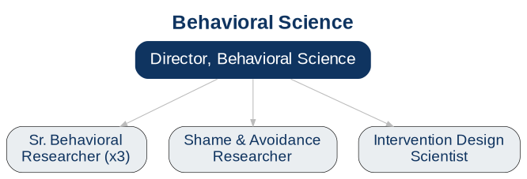
■ Director of Behavioral Science
Sets the research agenda for understanding human decision-making under compressive load. Studies WHY people collapse inside bureaucratic systems and WHAT restores sovereign motion. Produces the behavioral models that inform every engine, every conversation design pattern, every intervention the Crew executes. Must bridge academic rigor with product applicability.
Think: Sendhil Mullainathan (University of Chicago — co-author of Scarcity, proved cognitive bandwidth tax), Eldar Shafir (Princeton — co-author of Scarcity, decision-making under poverty), BJ Fogg (Stanford — Behavior Model, Tiny Habits — behavioral intervention design)
■ Sr. Behavioral Researcher (x3)
Conduct primary research on decision-making under cognitive depletion, survival mode dynamics, and the effect of relational presence on behavioral capacity. Publish findings, translate to product specifications, and validate that interventions work in real-world conditions.
Think: Katy Milkman (Wharton — behavioral science of behavior change), Angela Duckworth (Penn — self-regulation and perseverance), Todd Rogers (Harvard — behavioral science applied to public policy)
■ Shame & Avoidance Researcher
Specialized in the psychobiology of shame: how shame collapses identity, triggers avoidance cascades, and blocks system navigation. Designs anti-shame intervention mechanics that translate into Siani’s conversation design and the Shame Extraction Engine’s 6-step dissolution protocol.
Think: Brené Brown (University of Houston — defined modern shame research), Jessica Tracy (UBC — emotions of self-assessment, pride and shame), June Price Tangney (George Mason — shame, guilt, and self-conscious emotions)
■ Intervention Design Scientist
Designs and tests behavioral micro-interventions that translate to product features. Runs experiments to validate that specific conversational patterns, notification strategies, and Crew actions produce measurable behavioral change. Bridge between research and product engineering.
Think: Kevin Volpp (Penn/CHIBE — behavioral economics in health, intervention design), Mitesh Patel (Penn Medicine Nudge Unit — scaled behavioral nudges in health systems), Dean Karlan (Northwestern — RCT-driven behavioral intervention research)

Neuroscience & NeuroRelational Intelligence™ — 9-Circuit Neural Mapping
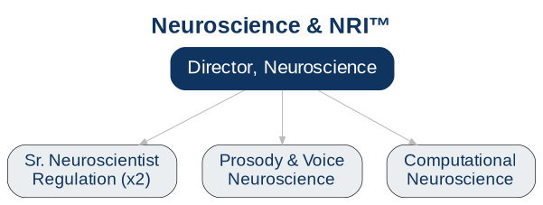
■ Director of Neuroscience Research
Leads the NeuroRelational Intelligence™ framework: mapping how voice prosody, conversational pacing, and relational consistency activate specific neural circuits (Polyvagal, Dopamine, Oxytocin/Mirror Neurons, Serotonergic, DMN, ACC, PFC, HPA Axis, Hippocampus). Translates neuroscience findings into product features that make Siani neurologically effective, not just psychologically pleasant.
Think: Stephen Porges (Indiana University — Polyvagal Theory, the neuroscience of safety), Lisa Feldman Barrett (Northeastern — constructed emotion theory, redefining how we understand affect), Antonio Damasio (USC — somatic marker hypothesis, emotion and decision-making)
■ Prosody & Voice Neuroscience Researcher
Studies how vocal prosody activates neuroception and safety circuits. This is the science behind WHY Siani’s voice must sound a specific way: the right frequency, pace, and warmth activate the ventral vagal system (safety) rather than the sympathetic system (threat). Directly informs TTS parameters.
Think: Diana Deutsch (UCSD — psychology of music and speech prosody), Sophie Scott (UCL — neuroscience of speech, laughter, and vocal communication), Emily Mower Provost (University of Michigan — computational affect from speech signals)

AI & Machine Learning Research — Multi-Engine, Multi-Agent, NLP
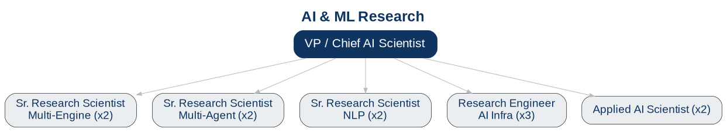
■ VP / Chief AI Scientist
Sets the AI research agenda. Recruits world-class researchers. Bridges frontier ML research with SAINTE’s applied needs: multi-engine orchestration at <2.9s P95 latency, multi-agent personality design, prosody-conditioned memory retrieval, neuroadaptive response policies. Must attract researchers from top labs while maintaining focus on shipping.
Think: Yann LeCun (Meta — Turing Award, VP AI Research, Facebook AI), Andrej Karpathy (built Tesla Autopilot AI, OpenAI founding team), Daphne Koller (Insitro — Stanford ML professor who built an applied AI biotech company)
■ Sr. Research Scientist, Multi-Agent (x2)
Design the multi-agent architecture that powers The Crew: agent personality, domain specialization, trust transfer between agents, and the autonomy-over-dependency constraint that ensures agents build user capacity rather than replacing it.
Think: Joon Sung Park (Stanford — generative agents with believable behavior), Percy Liang (Stanford HELM — language model evaluation and multi-agent systems), Noah Shinn (Reflexion — self-improving agent architectures)
■ Sr. Research Scientist, NLP (x2)
Extract shame markers, avoidance signals, capacity indicators, and identity shifts from natural conversation. This is not sentiment analysis. It is detecting when someone says ‘I’m fine’ and meaning ‘I’m shutting down.’ Directly feeds the Signal Score™ and engine routing decisions.
Think: Christopher Manning (Stanford — foundational NLP, co-created Stanford NLP tools), Emily Bender (UW — ethics and limitations of language models), Diyi Yang (Stanford — social and emotional NLP)

Data Science & Algorithms — Signal Score™, SCCS, DRR
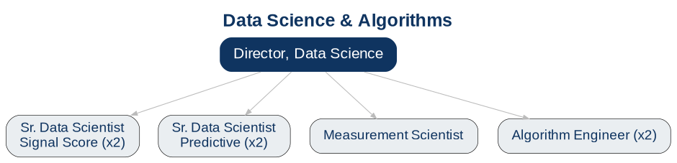
■ Director of Data Science
Owns the mathematical foundations: Signal Score™ (Self-Trust, Agency, Regulation, Coherence, Shame Load), Signal Index™ (cohort metric), SCCS Algorithm (readiness window detection), DRR (Drift Recovery Rate), and all predictive models for crisis anticipation. Must be rigorous enough for peer-reviewed publication and practical enough for real-time product deployment.
Think: Susan Athey (Stanford — economics of AI, causal inference at scale), Judea Pearl (UCLA — Turing Award, causal inference framework), Andrew Gelman (Columbia — Bayesian statistics, hierarchical modeling)
■ Measurement Scientist
Designs the Outcome Proof Architecture: how SAINTE proves it works. DRR₇ ≥ 60%, DRR₁₄ ≥ 70%, Recurrence ≤ 30%. Builds severity-adjusted metrics, CLPPM (cost avoidance per member per month), and the evidence methodology that converts ‘presence works’ from thesis to proven intervention.
Think: David Spiegelhalter (Cambridge — public understanding of statistics, risk communication), Donald Rubin (Harvard — Rubin Causal Model, gold standard for treatment effect estimation), Miguel Hernan (Harvard — causal inference in medicine)

Intelligence Engine Architecture — 25+ Engine Specifications
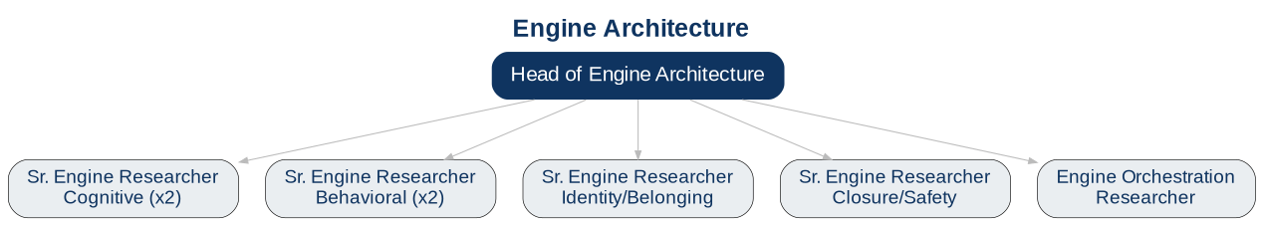
■ Head of Engine Architecture
Owns all 25+ engine specifications and the inter-engine orchestration logic. Must hold the entire intelligence mesh in their head: Cognitive, Momentum/Behavioral, Identity Transformation, Closure (25+ mechanisms), Stickiness, Belonging, Shame Extraction, Advanced Systems (future self, floor raising, attunement, resistance, mini-repair, depth scaler), and Safety/Crisis. Defines the priority hierarchy: Safety > Stability > Growth. This is the most architecturally complex role in the company.
Think: Stuart Russell (UC Berkeley — foundational AI textbook author, complex multi-agent systems), Melanie Mitchell (Santa Fe Institute — complexity science, analogical reasoning in AI), Michael Wooldridge (Oxford — multi-agent systems, rational agents)

Pull Mechanics Research — Reverse-Engineering Addiction for Good
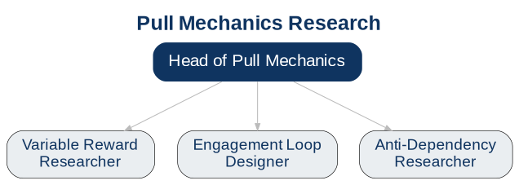
■ Head of Pull Mechanics
Studies the exact neurological mechanics that make gambling, social media, and substances addictive — variable reward timing, anticipation loops, identity attachment, compulsion patterns, loss aversion — and reverse-engineers them to drive follow-through, capacity building, identity stability, and healthy return behavior without dependency. One of the most novel and defensible research divisions in the company.
Think: Nir Eyal (author of Hooked — habit formation product design), Natasha Dow Schüll (NYU — author of Addiction by Design, slot machine mechanics), Tristan Harris (Center for Humane Technology — understanding and reversing addictive design)
■ Anti-Dependency Researcher
Ensures pull mechanics build autonomy, not reliance. Monitors for unhealthy attachment patterns. Defines and enforces the line between healthy engagement and dependency. This role is what makes SAINTE ethically defensible in ways that social media companies are not.
Think: Adam Alter (NYU — author of Irresistible, behavioral addiction research), Anna Lembke (Stanford — author of Dopamine Nation, addiction medicine), Kent Berridge (University of Michigan — wanting vs. liking, reward neuroscience)

Evidence & Clinical Research — Outcomes, HEOR, IRB
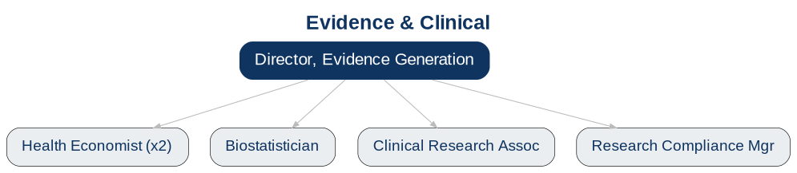
■ Director of Evidence Generation
Runs formal outcomes studies, manages IRB relationships, produces cost-effectiveness analyses that turn ‘presence works’ from thesis to proven intervention. Without evidence, enterprise sales depend on narrative. With evidence, they are ROI-positive. Must be credible to both academic reviewers and MCO medical directors.
Think: Atul Gawande (author/surgeon — evidence-based healthcare transformation), Don Berwick (IHI founder — healthcare quality measurement), Karen DeSalvo (former National Health IT Coordinator — evidence in health policy)
■ Health Economist (x2)
Build economic models: cost-effectiveness, budget impact, ROI for enterprise buyers. Must demonstrate that $25–30 PMPM prevents $10K–$60K crisis events. The work these economists produce is literally what closes enterprise contracts.
Think: Amitabh Chandra (Harvard Kennedy — health economics), Katherine Baicker (University of Chicago — Oregon Health Insurance Experiment), Joseph Newhouse (Harvard — RAND Health Insurance Experiment)

Whole Life Graph & Ontology — Survival Data Ontology, Causality
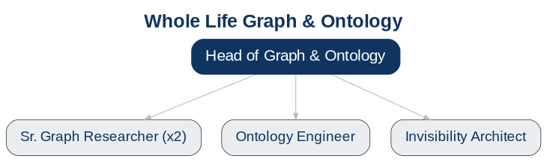
■ Head of Graph & Ontology
Owns the data model for the Invisible 80% of whole-life context. Builds the Survival Data Ontology: formal schema for housing, food, transportation, health, work, legal, financial, family, social. Tracks seed events through causality chains ($200 car repair → $12K ER visit). Designs the Invisibility Architecture translation layer.
Think: Tim Berners-Lee (MIT — invented the web, pioneered linked data), James Hendler (RPI — semantic web co-inventor), Pat Hayes (IHMC — ontology and knowledge representation)
Voice & Prosody Research — Vocal Biomarkers, Adaptive Synthesis
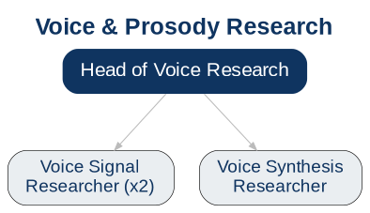
■ Head of Voice Research
Researches how to extract shame markers, avoidance signals, and capacity indicators from voice features. Also how Siani’s generated voice should modulate to activate safety circuits rather than threat circuits. Directly interfaces with both the Neuroscience team and the Voice Pipeline engineering team.
Think: Mark Hasegawa-Johnson (UIUC — speech signal processing), Julia Hirschberg (Columbia — computational prosody and deception detection), Shrikanth Narayanan (USC — behavioral signal processing)
Conversation Science — Pacing, Mirror, Culture-Coded Language
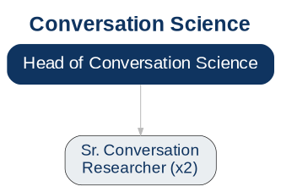
■ Head of Conversation Science
Researches the conversational mechanics that make Siani feel like the smartest, most emotionally intelligent friend: turn-taking, emotional pacing, best-friend mirror mechanics, lifestyle elevation language, culture-coded language calibration, silence architecture, and response length governance.
Think: Elizabeth Stokoe (Loughborough — conversation analysis pioneer), Justine Cassell (CMU/INRIA — embodied conversational agents), Emanuel Schegloff (UCLA — foundational conversation analysis)
Ambient Intelligence Research — Life Double: Autonomous Presence
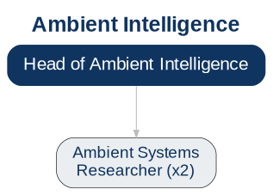
■ Head of Ambient Intelligence
Researches how Siani can operate autonomously across channels without user activation: proactive need detection, autonomous task execution, multi-channel coordination. The ultimate expression of presence without cognitive activation.
Think: Gregory Abowd (Northeastern — ubiquitous computing pioneer), Anind Dey (University of Washington — context-aware computing), Tanzeem Choudhury (Cornell — mobile sensing and behavioral inference)
Child & Adolescent Development — Youth Neuroscience, Safety, Family
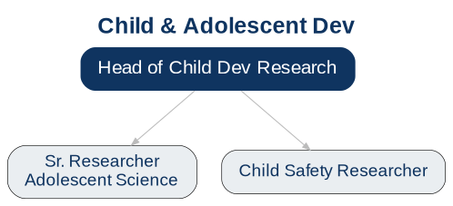
■ Head of Child Development Research
Researches how relational AI should behave differently for children and adolescents. Developmental appropriateness, safety protocols, family system dynamics, and the unique shame/identity patterns of younger users.
Think: Alison Gopnik (UC Berkeley — children’s cognitive development), Laurence Steinberg (Temple — adolescent brain development and risk), Andrew Meltzoff (UW — infant cognition and social learning)
Privacy & Safety Research — Federated Learning, AI Safety
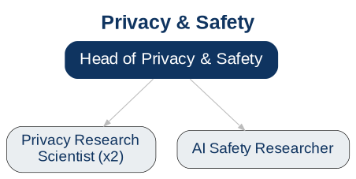
■ Head of Privacy & Safety
Ensures SAINTE can learn and improve without centralizing deeply sensitive behavioral data. Researches privacy-preserving computation, federated learning, on-device processing, and AI safety constraints that prevent Siani from causing harm.
Think: Cynthia Dwork (Harvard — invented differential privacy), Helen Nissenbaum (Cornell — contextual integrity framework), Arvind Narayanan (Princeton — de-anonymization research, AI accountability)
IP Development & Patents — 5-Layer Moat Protection
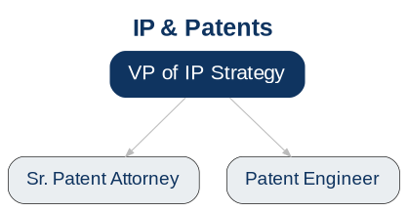
■ VP of IP Strategy
Manages the patent portfolio: what to patent, what to trade-secret, what to publish. Already-drafted claims include prosody-conditioned memory retrieval, neuroadaptive response policy, self-efficacy graph, and core platform architecture. Protects the 5-layer moat.
Think: Marshall Phelps (former IBM/Microsoft VP IP — built both companies’ patent strategies), Suzanne Harrison (IP portfolio strategist, author of Edison in the Boardroom), Mark Lemley (Stanford — IP law and technology)
Labs Operations — Compute, Admin, Coordination
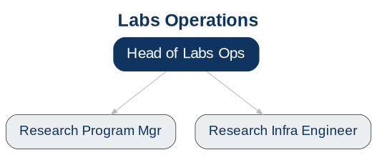
■ Head of Labs Operations
Keeps researchers productive: GPU cluster management, experiment tracking (W&B, MLflow), publication coordination, conference travel, tool procurement, cross-division project management, and the operational cadence that ensures research translates to products.
Think: John Giannandrea (Apple SVP ML — runs ML research operations at scale), Jeff Dean (Google — built Google’s research infrastructure), Joelle Pineau (Meta FAIR — research management at frontier labs)

Product & Engineering
Distribution Vehicles — 4 Teams

Core Engineering — APIs, Voice Pipeline, Infra, SRE, Security, QA
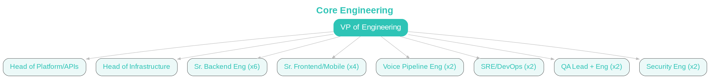
■ VP of Engineering
Owns all production technology: architecture, team structure, shipping velocity, reliability, and security. Must recruit engineers who can build real-time voice AI, multi-engine orchestration, healthcare-compliant infrastructure, and premium consumer mobile experiences — simultaneously. The technical demands of SAINTE span more domains than most companies ever touch.
Think: Will Larson (author of An Elegant Puzzle and Staff Engineer — engineering leadership at scale), Charity Majors (Honeycomb co-founder — observability and engineering culture), Werner Vogels (Amazon CTO — built the infrastructure for everything)
■ Head of Platform / APIs
Owns auth, data access, messaging, payments, Event Bus, API gateway. The central nervous system of all SAINTE products. Every service in the company communicates through this person’s infrastructure.
Think: Guillermo Rauch (Vercel — modern web infrastructure), Shawn Wang (DX engineer, Temporal — developer experience), Zack Rosen (Pantheon — platform architecture)
■ Voice Pipeline Engineer (x2)
Build and optimize the production voice pipeline: Whisper STT, ElevenLabs TTS, VAD, prosody extraction, emotion modeling, and response generation — all within the <1100ms total latency budget. Real-time voice AI at production quality is one of the hardest engineering problems in the industry.
Think: Rohit Prasad (Amazon — built Alexa’s voice pipeline), Alex Graves (Google DeepMind — sequence-to-sequence speech), Oriol Vinyals (Google DeepMind — audio/speech generation systems)

Enterprise Platform Engineering — Dual-Reality Architecture™
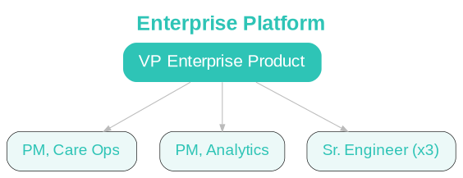
■ VP of Enterprise Product
Owns the product surface that MCOs, health systems, and employers interact with: care team dashboards, CHW Case Management (Activity, Performance, Territory, Workload, Template, Escalation, Notes, Closure, SLA Tracker services), Signal Score/Index reporting, risk stratification, ROI visualization. Users never see this; enterprises only see this.
Think: Jonathan Bush (athenahealth founder — enterprise health tech product vision), Niko Skievaski (Redox — healthcare platform and API design), Nat Turner (Flatiron Health — healthcare data platform to enterprise product)

Data Engineering — Production Data Stack
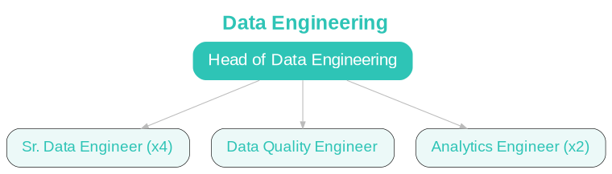
■ Head of Data Engineering
Owns the production data stack end-to-end: DocumentDB, VectorDB, TimeSeriesDB, UserHistoryDB, ingestion pipelines, real-time streaming, data quality, and the data warehouse. Must handle healthcare data (834/837 feeds, claims, FHIR) alongside conversational and behavioral data at scale.
Think: Maxime Beauchemin (creator of Apache Airflow and Apache Superset — modern data stack pioneer), Monica Rogati (former LinkedIn VP Data — data hierarchy of needs), Zhamak Dehghani (Thoughtworks — data mesh architecture)

Sainte Solutions
Enterprise Revenue — 4 Teams

Sales Organization — CFO-Aligned Enterprise Sales
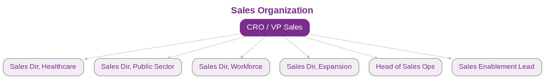
■ CRO / VP of Sales
Owns all enterprise revenue. Must sell cost avoidance infrastructure to CFOs: replacement of $10K–$60K crisis events with $50–$500 upstream actions at $25–30 PMPM. Consultative, not transactional. The sales motion requires buyer education because the category doesn’t exist yet — this person must simultaneously sell the product and create the category.
Think: Mark Roberge (HubSpot — wrote The Sales Acceleration Formula, built science-driven sales org), Aaron Ross (author of Predictable Revenue — outbound sales systems), Mary Shea (Outreach — enterprise revenue innovation)

Solutions Verticals — 13+ Vertical Business Units
■ GM, Sainte Payer
Owns the primary revenue vertical: Medicaid MCOs. 90M Medicaid members, 1% penetration = ~$120M ARR. Redetermination infrastructure is the wedge. Must understand managed care economics, VBC contracting, risk adjustment, and how to sell to medical directors and CFOs simultaneously. This is the most important P&L in the company.
Think: Mario Schlosser (Oscar Health co-founder — payer innovation), Sarah London (Centene CEO — largest Medicaid MCO operator), Bruce Broussard (Humana CEO — VBC strategy)
■ GM, Sainte Care
Health systems, FQHCs, CCBHCs. Must understand community health center economics, grant-funded operations, and the reality that these organizations are overwhelmed and understaffed. SAINTE solves their biggest problem: silent drop-off of high-risk members between visits.
Think: Tom Lee (One Medical founder — primary care innovation), Rushika Fernandopulle (Iora Health — relationship-based primary care), Myoung Cha (Health Leads — social determinants in clinical settings)

Partnerships + Channel — Tech + Channel Sales
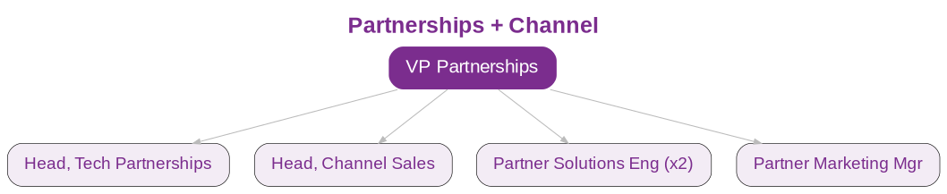
■ VP of Partnerships
Manages technology integrations (EHR, HRIS, payer platforms) and channel partnerships (consulting firms, system integrators, resellers). The partnership network is how SAINTE scales without building a 500-person sales team. Must build genuine technical partnerships, not press-release partnerships.
Think: Frank Williams (Evolent Health — health system partnerships at scale), Ed Park (athenahealth — healthcare tech ecosystem), Christina Farr (formerly a16z bio — health tech ecosystem mapping)

Corporate / Holdings
Governance Backbone — 11 Functions

Finance — Multi-Entity Financial Management
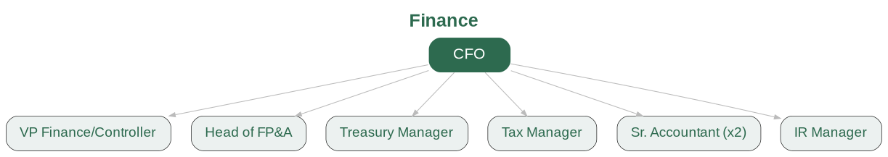
■ CFO
Financial strategy across consumer revenue, enterprise PMPM, value-based bonuses, data licensing, and grants. Must manage multi-entity accounting (HoldCo + divisions), fundraising, treasury, tax optimization, and investor relations. The complexity of SAINTE’s revenue model (B2B2C + DTC + marketplace + licensing) requires a CFO who has managed genuinely complex financial structures.
Think: Ruth Porat (Alphabet CFO — multi-business financial management at massive scale), Amy Hood (Microsoft CFO — multi-segment financial strategy), Sarah Friar (Nextdoor CEO, former Square CFO — growth + discipline)

Legal + Compliance — Multi-Domain
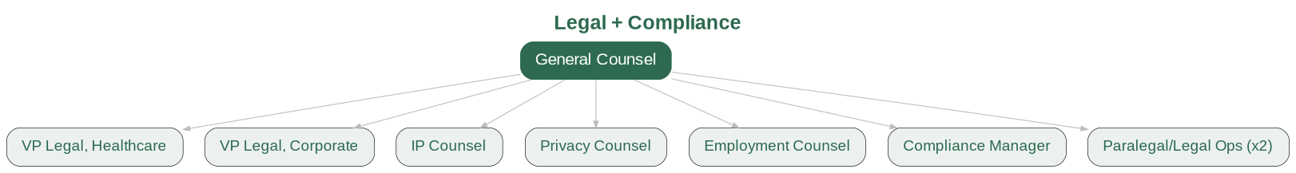
■ General Counsel
Legal strategy across consumer, healthcare, government, IP, privacy, employment, and international law. SAINTE operates in more regulated domains simultaneously than almost any startup: HIPAA, COPPA, FDA/FTC, FAR/DFAR, GDPR/CCPA, multi-state employment, and evolving AI regulation. Must be comfortable with ambiguity and able to say ‘yes, if’ rather than just ‘no.’
Think: Kent Walker (Google/Alphabet GC — multi-domain legal at scale), Brad Smith (Microsoft President/former GC — tech policy and law), Nicole Wong (former White House Deputy CTO, ex-Google/Twitter legal — tech + policy intersection)

People + Talent — Diverse Recruiting Across All Divisions
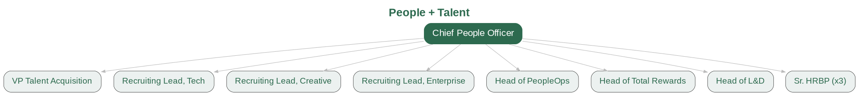
■ Chief People Officer
Must recruit and retain AI researchers, fashion designers, healthcare sales executives, behavioral scientists, event producers, community organizers, voice engineers, patent attorneys, and community health workers — all within one company culture. This is one of the most challenging CPO roles in tech because the talent pool spans worlds that normally never overlap.
Think: Laszlo Bock (Humu/former Google SVP People Ops — data-driven people strategy), Pat Wadors (UKG/former LinkedIn CHRO — belonging-centered people strategy), Katarina Berg (Spotify CHRO — creative + tech culture integration)

Security + Risk — CISO Office
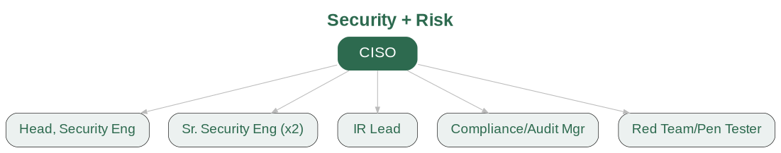
■ CISO
Cybersecurity strategy, risk management, and compliance certification (SOC 2, HITRUST, FedRAMP). Existential role given that SAINTE handles health data, behavioral data, financial data, identity data, voice recordings, and location data — among the most sensitive data combinations of any company in existence. A breach doesn’t just cost money. It destroys the trust that makes the entire product work.
Think: Alex Stamos (Stanford Internet Observatory / former Facebook CISO — security + trust), Mudge (Peiter Zatko — DARPA, former Twitter security), Parisa Tabriz (Google VP Security Engineering — ‘Security Princess’, browser security at scale)

Trust + Safety + Policy — AI Ethics, Data Governance
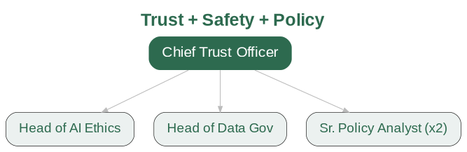
■ Chief Trust Officer
Sets company-wide policy on AI behavior, data use, safety standards, and ethical deployment. This is not a compliance role. This is the person who ensures SAINTE remains ethically defensible as it scales. Must define what Siani should never do, how data should never be used, and where the line between engagement and dependency falls.
Think: Del Harvey (former Twitter VP Trust & Safety — built trust/safety at scale), Rumman Chowdhury (Humane Intelligence / former Twitter ML Ethics — responsible AI), Timnit Gebru (DAIR Institute — AI ethics and accountability research)

Sainte Foundation — Social Impact, Philanthropy
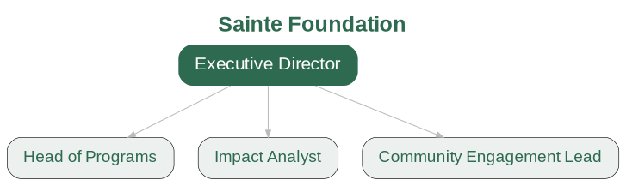
■ Executive Director
Leads the Foundation: grantmaking, programs, impact measurement, and community investment. Ensures SAINTE’s growth creates value beyond shareholders. Manages relationships with community-based organizations, funds health equity programs, and builds the evidence base for SAINTE’s social impact that supports both the mission and the enterprise sales narrative.
Think: Darren Walker (Ford Foundation president — systemic inequality through philanthropy), Jacqueline Novogratz (Acumen founder — impact investing pioneer), Mackenzie Scott (philanthropist — trust-based, community-directed giving at scale)

45 teams. 200+ roles. Every seat mapped. Every exemplar named.

SAINTE. This is what we’re on now.

