**Homework #2 Xv6**

Course

**CSE 460 Operating Systems**

Instructor

**Dr. Yan Zhang**

Meeting Time

**Mon. & Wed., 4:00 p.m. - 5:15 p.m.**

Due Date

**March 11, 2020**

Authors

**Kevin T. Vo**

**Esdras Lopez**

**Joseph Gonzales**

**Trevor Shortlidge**

**Brian Ayala**

# Group Members’ Information

|  |  |  |
| --- | --- | --- |
| **Name** | **Coyote ID** | **Responsibility** |
| Kevin T. Vo | 006316930 | * Implemented date system call & command (Part a) into xv6 * Implement part of uid, gid, ppid (Part c) * Implemented part of file protection (Part e) * Contributed to this report/documentation |
| Esdras Lopez | 006198864 | * Implemented part of uid, gid, ppid (Part c) * Contributed to this report/documentation |
| Joseph Gonzales | 006242648 | * Implemented ps command and Ctrl+P (Part d) * Contributed to this report/documentation |
| Trevor Shortlidge | 006310209 | * Implemented part of Ctrl+P (Part b) * Implemented part of file protection (Part e) * Contributed to this report/documentation |
| Brian Ayala | 006191688 | * Implemented part of Ctrl+P (Part b) * Contributed to this report/documentation |

# Table of Contents

Demonstration of the date() System Call ……………………………………………………4

Demonstration of the Ctrl-P Special Control Sequence……………………………………

Demonstration of UIDs, GIDs, and PPIDs……………………………………….

Demonstration of the “ps” Command………………………………….

Demonstration of the File System Protection Features……………………..

# **Demonstration of the date() System Call**

The system call “date” has been implemented to the Xv6 operating system where it would display the current day, month, year, hour, minute, and second in the format below:

*DAY/MONTH/YEAR HOUR:MINUTE:SECOND*

During the addition of this system call the following files have been created/modified:

|  |  |  |  |
| --- | --- | --- | --- |
| **Filename** | **Created**  **/ Modified** | **Line Numbers** | **Image** |
| syscall.h | Modified |  |  |
| user.h | Modified |  |  |
| sysproc.c | Modified |  |  |
| usys.S | Modified |  |  |
| syscall.c | Modified |  |  |
| date.c | Created | 1-18 |  |

### Result from Execution of date() System Call:

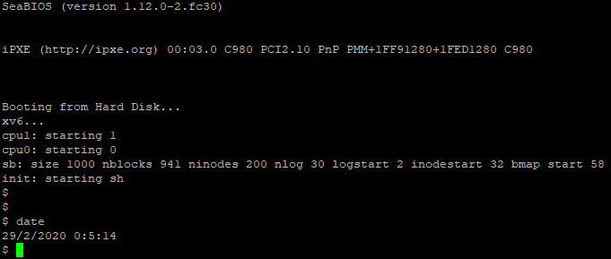

# **Demonstration of the Ctrl-P Special Control Sequence**

**Demonstration of UIDs, GIDs, and PPIDs**

The implements the feature of users and groups into xv6 through uid and gid where it be used to store ID unsigned integers