**Homework #2 Xv6**

Course

**CSE 460 Operating Systems**

Instructor

**Dr. Yan Zhang**

Meeting Time

**Mon. & Wed., 4:00 p.m. - 5:15 p.m.**

Due Date

**March 11, 2020**

Authors

**Kevin T. Vo**

**Esdras Lopez**

**Joseph Gonzales**

**Trevor Shortlidge**

**Brian Ayala**

# Group Members’ Information

|  |  |  |
| --- | --- | --- |
| **Name** | **Coyote ID** | **Responsibility** |
| Kevin T. Vo | 006316930 | * Implemented date system call & command (Part a) into xv6 * Implement part of uid, gid, ppid (Part c) * Implemented part of file protection (Part e) * Contributed to this report/documentation |
| Esdras Lopez | 006198864 | * Implemented part of uid, gid, ppid (Part c) * Contributed to this report/documentation |
| Joseph Gonzales | 006242648 | * Implemented ps command and Ctrl+P (Part d) * Contributed to this report/documentation |
| Trevor Shortlidge | 006310209 | * Implemented part of Ctrl+P (Part b) * Implemented part of file protection (Part e) * Contributed to this report/documentation |
| Brian Ayala | 006191688 | * Implemented part of Ctrl+P (Part b) * Contributed to this report/documentation |

# Table of Contents

1. Demonstration of the date() System Call ……………………………………………4
2. Demonstration of the Ctrl-P Special Control Sequence…………………………
3. Demonstration of UIDs, GIDs, and PPIDs……………………………………….
4. Demonstration of the “ps” Command………………………………….
5. Demonstration of the File System Protection Features……………………..

# **Demonstration of the date() System Call**

The system call “date” has been implemented to the Xv6 operating system where it would display the current day, month, year, hour, minute, and second in the format below:

*DAY/MONTH/YEAR HOUR:MINUTE:SECOND*

During the addition of this system call the following files have been created/modified:

|  |  |  |  |
| --- | --- | --- | --- |
| **Filename** | **Created**  **/ Modified** | **Line Numbers** | **Code** |
| syscall.h | Modified | 23 |  |
| user.h | Modified | 26 |  |
| sysproc.c | Modified | 95-106 |  |
| usys.S | Modified | 32 |  |
| syscall.c | Modified | 106  &  136 |  |
| date.c | Created | 1-18 |  |

### Result from Execution of date() System Call:

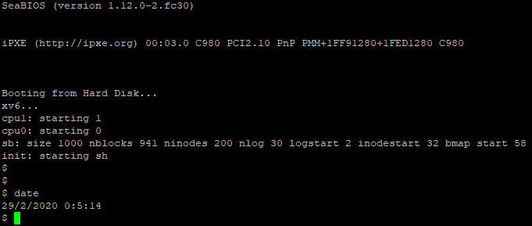

Results from the syscall “date” comes from implementing the above into a full fledge syscall. By outputing the date.c file.

# **Demonstration of the Ctrl-P Special Control Sequence**

Demonstration



Note: UID,GID, CPU are from part D, Dr.Zhang said it was ok to leave elapsed time in milliseconds.

Proc.h line 56 -> added uint start_ticks to structure proc



Modified procdump in proc.c to display our results in the ptable to output elapsed time, & size

Elapsed time result is done by subtracting ticks minus start_ticks do give us the delta in milliseconds.

However, changing it to a float and dividing by 1000 to give us the result in seconds was not working with cprintf. Refer to to the comment I made before about Dr.Zhang letting our group use milliseconds instead.

Also p->sz is a built in variable in proc that deals with the size of each block of memory.

We just outputted the size : p->sz to display.

Proc.c line 131 -> initialized start_ticks to ticks that is a global counter in milliseconds.



proc.c procdump() - line 540

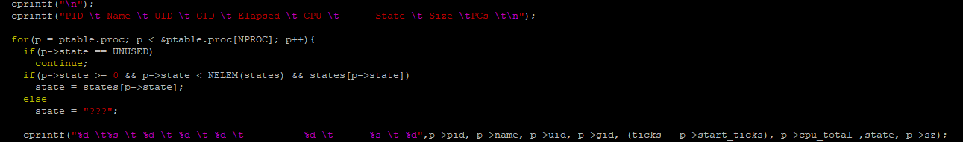

1. **Demonstration of** **UIDs, GIDs, and PPIDs**

The implements the feature of users and groups into xv6 through uid and gid where it be used to store ID unsigned integers for tracking the ownership of a process for a user or group. By typing “id” into the terminal when executing xv6, the system call will invoke and demonstrate this feature by displaying the UID, GID and PPID that has been established by the test function within “id.c”.

|  |  |  |  |
| --- | --- | --- | --- |
| **Filename** | **Created**  **/ Modified** | **Line Numbers** | **Image** |
| syscall.h | Modified | 25-29 |  |
| user.h | Modified | 28-32 |  |
| sysproc.c | Modified | 114-162 |  |
| usys.S | Modified | 34-38 |  |
| syscall.c | Modified | 108-112  &  138-142 |  |
| id.c | Created | 1-26 |  |

### Result from UIDs, GIDs, and PPIDs:

1. **Demonstration of the “ps” Command**
2. **Demonstration of the File System Protection Features**