**Homework #2 Xv6**

Course

**CSE 460 Operating Systems**

Instructor

**Dr. Yan Zhang**

Meeting Time

**Mon. & Wed., 4:00 p.m. - 5:15 p.m.**

Due Date

**March 11, 2020**

Authors

**Kevin T. Vo**

**Esdras Lopez**

**Joseph Gonzales**

**Trevor Shortlidge**

**Brian Ayala**

# Group Members’ Information

|  |  |  |
| --- | --- | --- |
| **Name** | **Coyote ID** | **Responsibility** |
| Kevin T. Vo | 006316930 | * Implemented date system call & command (Part a) into xv6 * Implement part of uid, gid, ppid (Part c) * Implemented part of file protection (Part e) * Contributed to this report/documentation |
| Esdras Lopez | 006198864 | * Implemented part of uid, gid, ppid (Part c) * Contributed to this report/documentation |
| Joseph Gonzales | 006242648 | * Implemented ps command and Ctrl+P (Part d) * Contributed to this report/documentation |
| Trevor Shortlidge | 006310209 | * Implemented part of Ctrl+P (Part b) * Implemented part of file protection (Part e) * Contributed to this report/documentation |
| Brian Ayala | 006191688 | * Implemented part of Ctrl+P (Part b) * Contributed to this report/documentation |

# Table of Contents

1. Demonstration of the date() System Call ……………………………………………4
2. Demonstration of the Ctrl-P Special Control Sequence………………………….......6
3. Demonstration of UIDs, GIDs, and PPIDs………………………………………......7
4. Demonstration of the “ps” Command………………………………….
5. Demonstration of the File System Protection Features……………………..

# **Demonstration of the date() System Call**

The system call “date” has been implemented to the Xv6 operating system where it would display the current day, month, year, hour, minute, and second in the format below:

*DAY/MONTH/YEAR HOUR:MINUTE:SECOND*

During the addition of this system call the following files have been created/modified:

|  |  |  |  |
| --- | --- | --- | --- |
| **Filename** | **Created**  **/ Modified** | **Line Numbers** | **Code** |
| syscall.h | Modified | 23 |  |
| user.h | Modified | 26 |  |
| sysproc.c | Modified | 95-106 |  |
| usys.S | Modified | 32 |  |
| syscall.c | Modified | 106  &  136 |  |
| date.c | Created | 1-18 |  |

### Result from Execution of date() System Call:

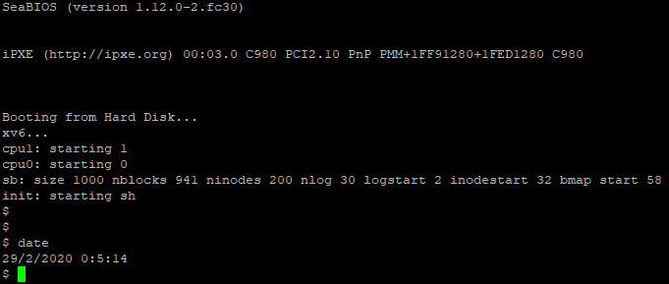

Results from the syscall “date” comes from implementing the above into a full fledge syscall. Modified syscall.h that contains the mapping of the call number linked to SYS_date. Modified defs.h to hold the kernerl wide function call for date. Modified user.h that contains the functions prototype for date that is required to run user programs. Implemented the function for date inside of sysproc.c by getting the arguments off the stack. This implementation was provided to us. Next we modified the usys.S that exports the system call. Modified syscall.c to add the extern int for being in another file. Then the last step is to add the date.c file where we invoke the syscall implementation.

# **Demonstration of the Ctrl-P Special Control Sequence**

Result for Ctrl-P Special Control Sequence:



Note: UID,GID, CPU are from part D, Dr.Zhang said it was ok to leave elapsed time in milliseconds.

Proc.h line 56 -> added uint start_ticks to structure proc



Modified procdump in proc.c to display our results in the ptable to output elapsed time, & size

Elapsed time result is done by subtracting ticks minus start_ticks do give us the delta in milliseconds.

However, changing it to a float and dividing by 1000 to give us the result in seconds was not working with cprintf. Refer to to the comment I made before about Dr.Zhang letting our group use milliseconds instead.

Also p->sz is a built in variable in proc that deals with the size of each block of memory.

We just outputted the size : p->sz to display.

Proc.c line 131 -> initialized start_ticks to ticks that is a global counter in milliseconds.



proc.c procdump() - line 540

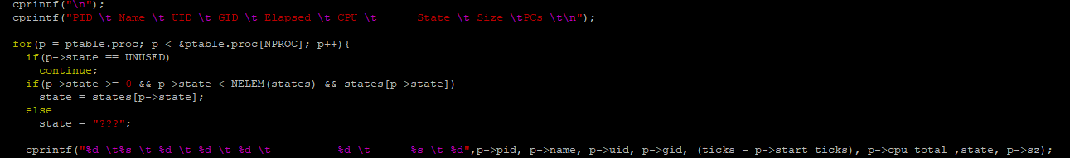

1. **Demonstration of** **UIDs, GIDs, and PPIDs**

The implements the feature of users and groups into xv6 through uid and gid where it be used to store ID unsigned integers for tracking the ownership of a process for a user or group. By typing “id” into the terminal when executing xv6, the system call will invoke and demonstrate this feature by displaying the UID, GID and PPID that has been established by the test function within “id.c”.

|  |  |  |  |
| --- | --- | --- | --- |
| **Filename** | **Created**  **/ Modified** | **Line Numbers** | **Image** |
| syscall.h | Modified | 25-29 |  |
| user.h | Modified | 28-32 |  |
| sysproc.c | Modified | 114-162 |  |
| usys.S | Modified | 34-38 |  |
| syscall.c | Modified | 108-112  &  138-142 |  |
| id.c | Created | 1-26 |  |

### Result from UIDs, GIDs, and PPIDs:

1. **Demonstration of the “ps” Command**
2. **Demonstration of the File System Protection Features**

The task requires you to implement a completely new abstraction in xv6: file system protection. This is a very large area, so you will focus on a small subset of protection that will nevertheless give you insights into how to implement additional protection and security concepts. You will implement file system protection, user programs for manipulating those protections, and add protection checking to the exec() system call.