**Homework #2 Xv6**

Course

**CSE 460 Operating Systems**

Instructor

**Dr. Yan Zhang**

Meeting Time

**Mon. & Wed., 4:00 p.m. - 5:15 p.m.**

Due Date

**March 11, 2020**

Authors

**Kevin T. Vo**

**Esdras Lopez**

**Joseph Gonzales**

**Trevor Shortlidge**

**Brian Ayala**

# Group Members’ Information

|  |  |  |
| --- | --- | --- |
| **Name** | **Coyote ID** | **Responsibility** |
| Kevin T. Vo | 006316930 | * Implemented date system call & command (Part a) into xv6 * Implement part of uid, gid, ppid (Part c) * Implemented part of file protection (Part e) * Contributed to this report/documentation |
| Esdras Lopez | 006198864 | * Implemented part of uid, gid, ppid (Part c) * Contributed to this report/documentation |
| Joseph Gonzales | 006242648 | * Implemented ps command and Ctrl+P (Part d) * Contributed to this report/documentation |
| Trevor Shortlidge | 006310209 | * Implemented part of Ctrl+P (Part b) * Implemented part of file protection (Part e) * Contributed to this report/documentation |
| Brian Ayala | 006191688 | * Implemented part of Ctrl+P (Part b) * Contributed to this report/documentation |

# 

# Table of Contents

Demonstration of the date() System Call ……………………………………………………4

Demonstration of the Ctrl-P Special Control Sequence……………………………………

Demonstration of UIDs, GIDs, and PPIDs……………………………………….

Demonstration of the “ps” Command………………………………….

Demonstration of the File System Protection Features……………………..

# **Demonstration of the date() System Call**

The system call “date” has been implemented to the Xv6 operating system where it would display the current day, month, year, hour, minute, and second in the format below:

*DAY/MONTH/YEAR HOUR:MINUTE:SECOND*

During the addition of this system call the following files have been created/modified:

|  |  |  |  |
| --- | --- | --- | --- |
| **Filename** | **Created**  **/ Modified** | **Line Numbers** | **Image** |
| syscall.h | Modified |  |  |
| user.h | Modified |  |  |
| sysproc.c | Modified |  |  |
| usys.S | Modified |  |  |
| syscall.c | Modified |  |  |
| date.c | Created | 1-18 |  |

### Result from Execution of date() System Call:

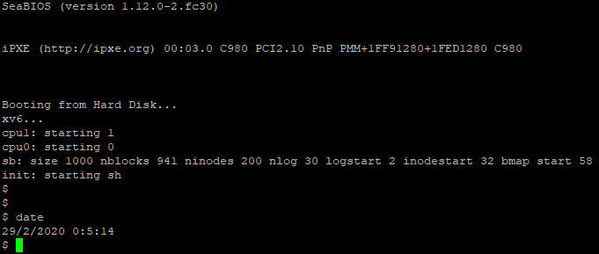

# **Demonstration of the Ctrl-P Special Control Sequence**

**Demonstration of** **UIDs, GIDs, and PPIDs**

The implements the feature of users and groups into xv6 through uid and gid where it be used to store ID unsigned integers for tracking the ownership of a process for a user or group. By typing “id” into the terminal when executing xv6, the system call will invoke and demonstrate this feature by displaying the UID, GID and PPID that has been established by the test function within “id.c”.

|  |  |  |  |
| --- | --- | --- | --- |
| **Filename** | **Created**  **/ Modified** | **Line Numbers** | **Image** |
| syscall.h | Modified |  |  |
| user.h | Modified |  |  |
| sysproc.c | Modified |  |  |
| usys.S | Modified |  |  |
| syscall.c | Modified |  |  |
| id.c | Created | 1-26 | i |

### Result from UIDs, GIDs, and PPIDs:

**Demonstration of the “ps” Command**

**Demonstration of the File System Protection Features**