2. Theoretical Tasks: Where there is light, there must be shadow (5 Points)
2.1 Blending Order
According to our lectures rendering semitransparent objects correctly requires correct rendering order (from back to front). Have a closer look at the equations for standard and additive blending and verify or debunk our statement for both equations individually.

Standard blending:
Sourcealpha * newpixel + (1 - sourcealpha) * oldpixel
a* n + (1 -a) * o
For two passes:
a2 * n2 + (1 -a2) * (a1 * n1 + (1 -a1) * o)
a2*n2 + a1*n1 + o - a1*o - a1*a2*n1 - a2*o + a1*a2*o
Switching a2/n2 and a1/n1 leads to different results aka result depends on ordering.

Additive blending:
source alpha * new pixel + old pixel
a* n + o
For two passes:
a2 * n2 + (a1 * n1 + o)
= a1 * n1 + a2 * n2 + o
Switching a2/n2 and a1/n1 leads to the same result aka not dependent on ordering.

2.2 Phong Lighting
When light is directly reflected from an object in reality the distorted forms of the objects surrounding the object can be identified in the reflection. For example in a curved mirror you can see the distorted form of yourself. The Phong lighting model tries to reproduce direct light reflections using a little formula involving a cosine. This cosine approximates the form of a specific scene object. Which object is it? What form does it have?

It is the reflection of the light source which is considered to be a small sphere.

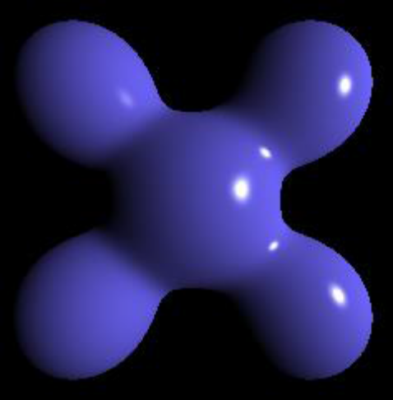

2.3 Roughness
In the literature, diffuse reflection can denote two things. In the lecture we introduced diffuse reflections as light that penetrates the molecular structure of an object and then leaves in a completely random direction. Elsewhere diffuse reflection is defined as direct reflections from rough surfaces. In reality these semi-diffuse reflections looks like blurred, direct reflections. In the lecture we showed two special kinds of texture maps, mip maps and cube maps. How can those be used to implement blurred reflections aka roughness?

Cube maps are used for direct reflections. A mip mapped cube map can be used for blurry reflections. Using a higher mip map level results in a blurrier reflection.

