2. Theoretical Tasks: Graphics Mix (5 Points)
2.1 Normal Maps
Which view angles are most advantageous and which are most disadvantageous when normal mapping is in use?

A view straight to the surface is most advantageous, a right-angled view is most disadvantageous.

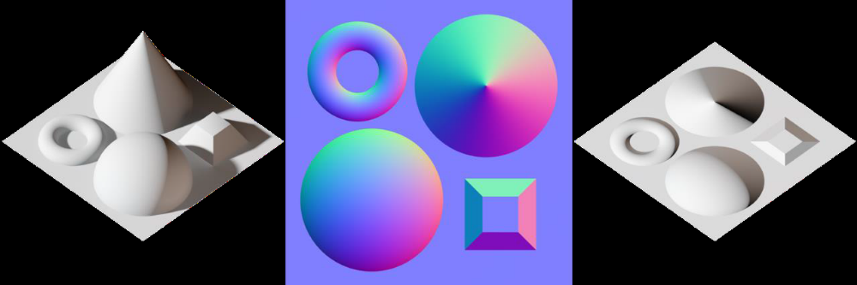

2.2 Particles
Particle systems consist of lots and lots of semi-transparent billboards. Depth buffer based 3D rendering does not handle transparency well. What problem has to be avoided and can that be done efficiently? When all is set and done, what is likely to be the biggest performance burden when rendering particles?

Particles have to be sorted by distance. This can be done efficiently because particles cannot intersect each other, because they are flat. The biggest performance problem is typically overdraw because the graphics chip renders lots of semi-transparent pixels on top of each other.

2.3 Skeletal Animations
Skeletal animations are based on the movements of bone joints which usually only do one form of transformation - rotations. We have seen three methods to calculate rotations - Euler angle rotations, rotation matrices based on an angle around an arbitrary axis and quaternion rotations. Which kind of rotation would you prefer to represent bone rotations and why?

Quaternions work fine for bone rotations – just as they work fine for just about any kind of rotations.
But Euler angles mostly work fine for bone rotations, too. Normally bones are only rotated around one or two axes and Euler angles only really become problematic when rotating around three axes.

