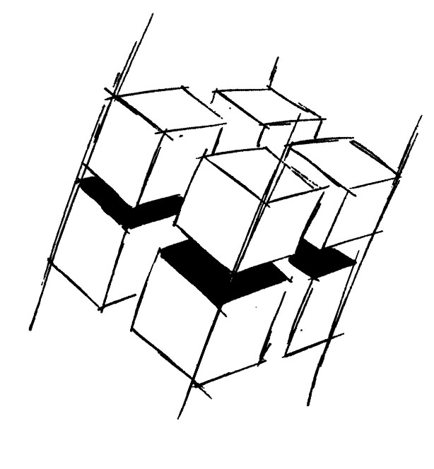
Prof. Dr.-Ing. Ralf Steinmetz
Multimedia communications Lab

Dr. Florian Mehm
Dipl. Inf. Robert Konrad


„Game Technology“
Winter Semester 2014/2015

Exercise 11

For bonus points upload your solutions until Friday the 23rd of January 2015, 11:40

General Information
- The exercises may be solved by teams of up to three people.
- The solutions have to be uploaded to the Git repositories assigned to the individual teams.
- The submission date (for practical and theoretical tasks) is noted on top of each exercise sheet.
- If you have questions about the exercises write a mail to game-technology@kom.tu-darmstadt.de or use the forum at https://www.fachschaft.informatik.tu-darmstadt.de/forum/viewforum.php?f=557

1. Practical Tasks: Coarse Texture Streaming (5 Points)
Implement coarse texture streaming – load in higher resolution textures for close objects, kick out higher resolutions for far away objects. Try to keep the framerate high and steady.
https://github.com/KTXSoftware/Exercise11.git contains additional code to help you out. You can either copy the code changes manually or just pull them into your own repository using
git pull https://github.com/KTXSoftware/Exercise11.git

2. Theoretical Tasks: Compression (5 Points)
2.1 Hardware
What makes it so important that texture compression algorithms are directly supported by the hardware?

2.2 Artifacts
ETC is a lossy texture compression algorithm. Describe what characteristics an image should have to make those losses clearly visible.

2.3 Tilemaps
Outline an algorithm to display tilemaps correctly in a 3D environment.

