2. Theoretical Tasks: Physics (5 Points)
2.1 Integration constant acceleration
Imagine a sphere with mass m=1kg that is falling down in a vacuum. At t=0, the sphere is released. The velocity v at t=0 is 0. The acceleration a is constant at 10 m/s² in the negative y-direction.

Calculate the movement of the sphere by integrating the equations of motion using the Euler method as explained in the lecture (you can use a spreadsheet application or a script).

- Use a time step of deltaT=1s and provide the values of height (z) and velocity (v) for the situation at time t=3s.
- Use a time step of deltaT = 0.5s and provide the values. Compare the results and discuss them.

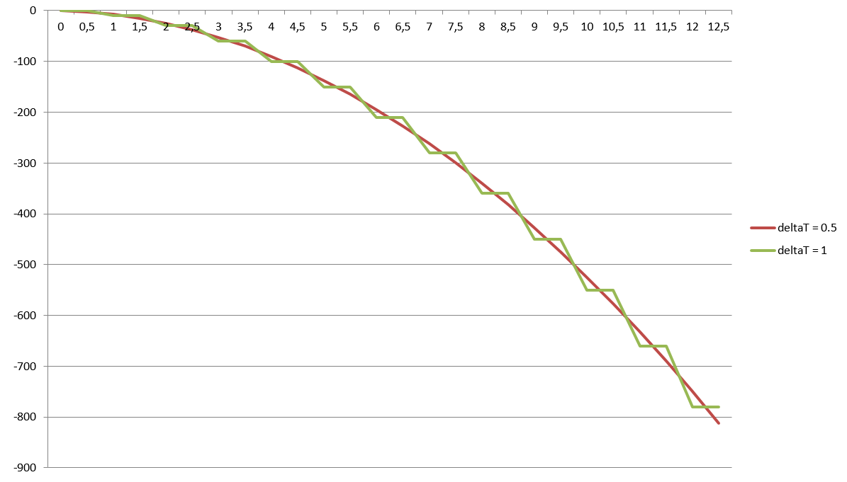
2.2 Integration under drag
The sphere of task 2.2 is now dropped in the earth’s atmosphere. Now, drag is acting on the object.

Drag is a force that acts on an object based on the velocity of the object. The faster the object, the more drag it experiences. We can approximate drag with the following formula:

F_{drag} = -v_{normalized} (k₁ |v| + k₂|v|²)

The result is a force that acts in the opposite direction of the object’s movement (indicated by -v_{normalized}, the normal vector in the direction of movement). The amount of drag results from the coefficients k1 and k2. Choose k1 = k2 = 0.1.

Calculate the movement of the sphere by integrating the equations of motion using the Euler method as explained in the lecture (you can use a spreadsheet application or script). Make sure to add the acceleration caused by the drag in the formulas you use.

- Use a time step of deltaT=1s and provide the values of height (z) and velocity (v) for the situation at time t=2s.
- Use a time step of deltaT = 0.2s and provide the values. Compare the results and discuss them.

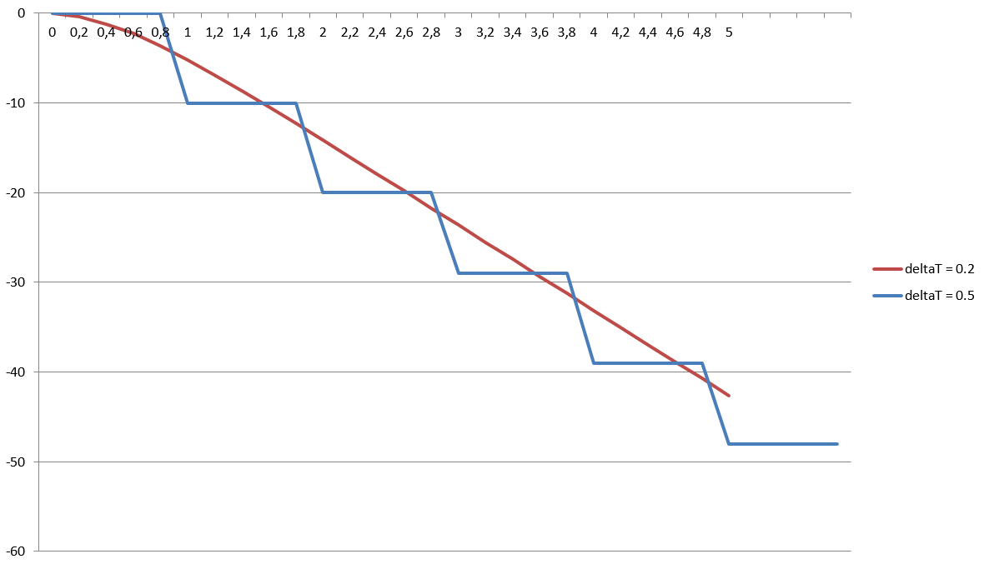

2.3 Billboard matrix
In the practical exercise, we implemented particle billboards that were set up to face the camera wherever it was positioned. Now, assume a billboard which is used to display a tree. This billboard should stay upright, i.e. it should only rotate around the global y-axis pointing upwards to face the camera.
Explain how the model matrix to align this billboard in this way can be derived from the camera’s view matrix.

Build a matrix for billboarding that keeps the y-axis in place.
- Using only the view matrix is a large restriction.
- It is easier to construct with knowledge of the object’s position.
Structure of the view matrix’s rotation part:
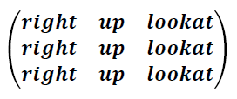
Change to:
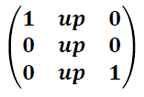
See also http://www.lighthouse3d.com/opengl/billboarding/index.php3?billInt

