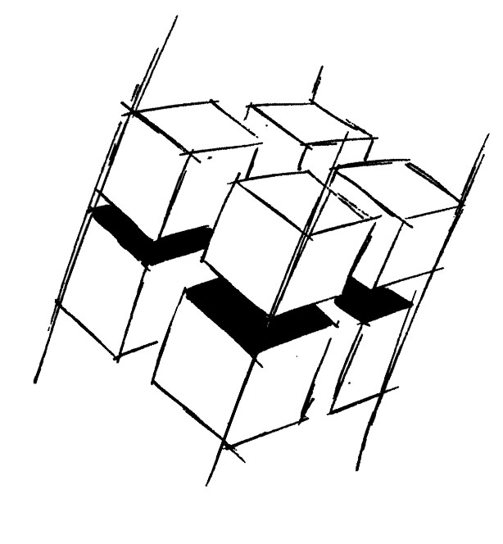
Prof. Dr.-Ing. Ralf Steinmetz
Multimedia communications Lab

Dr. Florian Mehm
Dipl. Inf. Robert Konrad


„Game Technology“
Winter Semester 2014/2015

Exercise 12

For bonus points upload your solutions until Friday the 30th of January 2015, 11:40

General Information
- The exercises may be solved by teams of up to three people.
- The solutions have to be uploaded to the Git repositories assigned to the individual teams.
- The submission date (for practical and theoretical tasks) is noted on top of each exercise sheet.
- If you have questions about the exercises write a mail to game-technology@kom.tu-darmstadt.de or use the forum at https://www.fachschaft.informatik.tu-darmstadt.de/forum/viewforum.php?f=557

1. Practical Tasks: Multiplayer (5 Points)
In the code example you can control two balls on one computer. Create a networked game using UDP package communication where each client controls one of the balls.
https://github.com/KTXSoftware/Exercise12.git contains additional code to help you out. You can either copy the code changes manually or just pull them into your own repository using
git pull https://github.com/KTXSoftware/Exercise12.git

2. Theoretical Tasks: Compression (5 Points)
2.1 Peer-to-Peer drop in
In the Peer-to-Peer Lockstep model clients can’t drop in or out while the game runs. Describe a modification of the model that allows clients to join while the game runs.

2.2 Varying data rates and Peer-to-Peer Lockstep
Some network connections are fast and some are slow. Can Peer-to-Peer games handle varying network speeds? If so, how?

2.3 Varying data rates and Client/Server
Can Client/Server games handle varying network speeds? If so, how?

