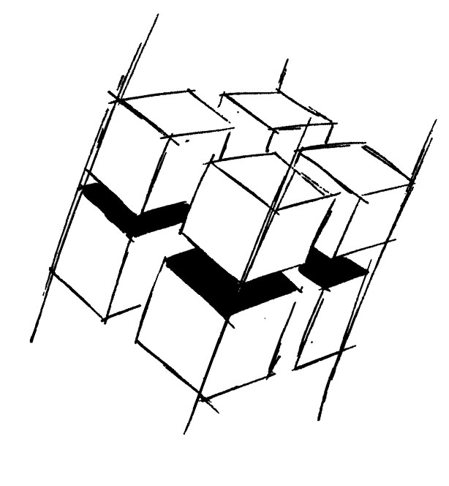
Prof. Dr.-Ing. Ralf Steinmetz
Multimedia communications Lab

Dr. Florian Mehm
Dipl. Inf. Robert Konrad


„Game Technology“
Winter Semester 2014/2015

Example Problems for Lecture 11 „Compression & Streaming“

1. Important Topics
Texture Compression
Asset repetition (aka manual compression)
Streaming

2. Example Problems
a) Why can PNG compression not be used for compressed textures?

b) Explain the difference between coarse and fine grained streaming.

