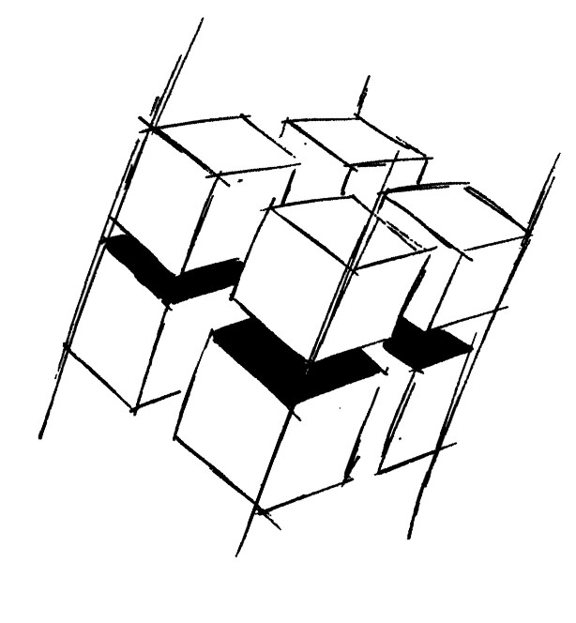
Prof. Dr.-Ing. Ralf Steinmetz
Multimedia communications Lab

Dr. Florian Mehm
Dipl. Inf. Robert Konrad


„Game Technology“
Winter Semester 2014/2015

Example Problems for Lecture 13 „Audio“

1. Important Topics
Structure of a low-level audio api
Sound mixing
Basic structure of music
Sound localization
Doppler Effect

2. Example Problems
a) What is the basic data structure used to send audio signals to the audio hardware?

b) How does an algorithm for sound mixing work?

c) What are the basic elements of a piece of music?

d) What algorithms does the brain use to differentiate sounds coming from the left and the right?

