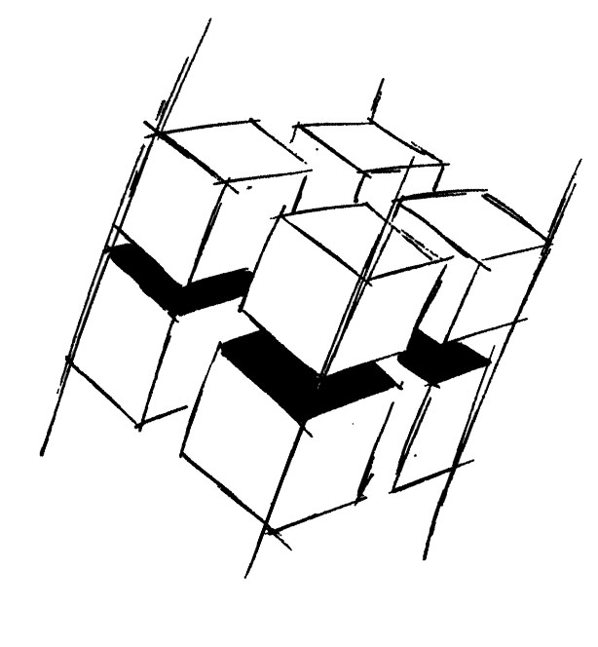
Prof. Dr.-Ing. Ralf Steinmetz
Multimedia communications Lab

Dr. Florian Mehm
Dipl. Inf. Robert Konrad


„Game Technology“
Winter Semester 2014/2015

Example Problems for Lecture 4 „Software Rendering 2“

1. Important Topics
Depth Buffering
Matrix calculations (only on a higher level, you won’t have to do matrix multiplications by hand)
Quaternion calculations (also only on a higher level)
Basic local lighting

2. Example Problems
a) Explain the benefits and shortcomings of the depth buffering algorithm.

b) Given a rotation r around the y axis (in the form of an angle), a translation t (in the form of a three component vector) and a mesh p – show how to calculate the rotation followed by the translation using only matrices and using matrices and a quaternion. You don’t have to show how the matrices and quaternions themselves are built.

c) What are the shortcomings of per-vertex lighting?

