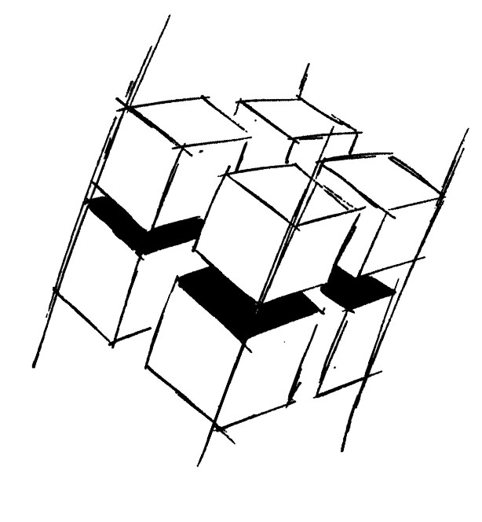
Prof. Dr.-Ing. Ralf Steinmetz
Multimedia communications Lab

Dr. Florian Mehm
Dipl. Inf. Robert Konrad


„Game Technology“
Winter Semester 2014/2015

Example Problems for Lecture 5 „Basic Hardware Rendering“

1. Important Topics
Basic structure of a GPU
Antialiasing
Texturing
Blending
Phong Lighting Model
Shadow Mapping

2. Example Problems
a) List and explain the non-programmable components of a GPU.

b) Explain the benefits and shortcomings of postprocess antialiasing.

c) What are the basic components of the Phong lighting model?

d) Explain the primary problem of shadow maps.

