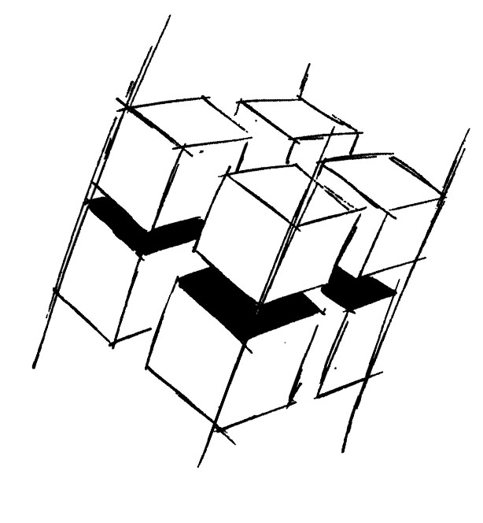
Prof. Dr.-Ing. Ralf Steinmetz
Multimedia communications Lab

Dr. Florian Mehm
Dipl. Inf. Robert Konrad


„Game Technology“
Winter Semester 2014/2015

Example Problems for Lecture 7 „Physically-based Rendering“

1. Important Topics
Different kinds of lights
Input and output of a BRDF
Diffuse and Specular
Fresnel Effect
The Microfacet Model
Image Based Lighting

2. Example Problems
a) List the different kind of lights used in computer graphics and compare them to real lights.

b) Explain diffuse light reflection.

c) The Fresnel effect gets stronger based on which value?

d) Which data structures are used for image based lighting in realtime graphics?

e) What properties do the facets have to fulfill that add light to the rendered image in a microfacet model?

