2. Theoretical Tasks: Simple Physics (5 Points)
2.1 Sunny
The sun is described as a directional light in the lecture - a light that emits light rays which all face in the same direction. Quantify this simplification, look up the sizes and distances of the sun and the earth and calculate the maximum angle between light rays from the sun which hit the earth. Outline your calculation path.
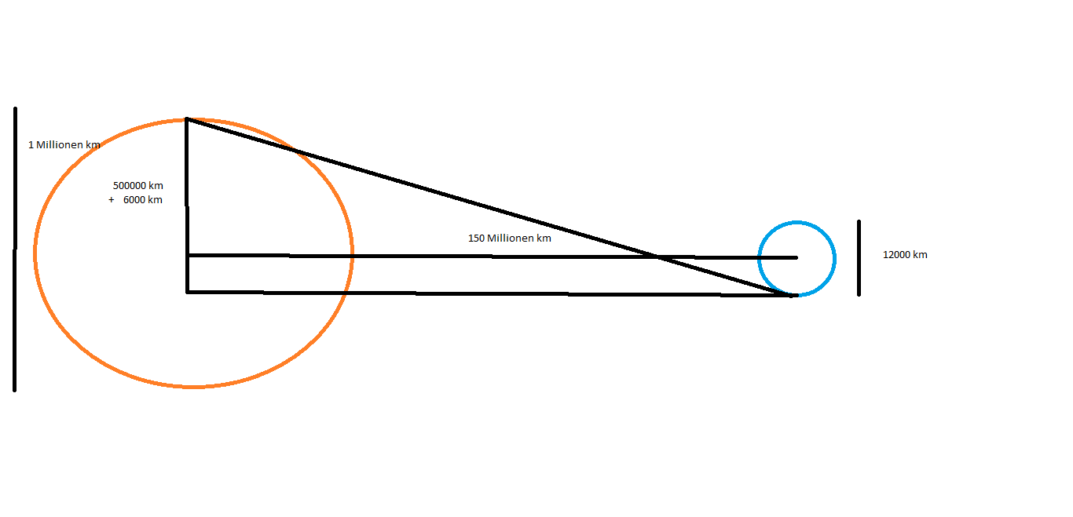
sin α = 506000 km / 150000000 km
= 506 / 150000 = 0,0034
α = 0,0034
2 * α = 0,0068 (which is pretty small)

2.2 No Subsurface Scattering
Diffuse reflection is a simplified model, because light that enters a material does not leave at the same position. This is ignored by the BRDF formulation. In realtime applications the BRDF is typically evaluated in the fragment shader. Consider the average distance between light entry and light exit positions for a material. The error is visible when this distance is larger than …?
The error is visible when this distance is larger than a pixel.

2.3 Cardboard work
Pick up a light source, a camera and two polarization filters. How do they have to be used to create the pictures in slides 39 and 40 (diffuse and specular cardboard)?

Put a filter in front of the light source and in front of the camera. Take a picture. This picture contains only specular reflections. Take away the filter in front of the camera. Take a picture. Subtract the first picture from the second picture – the result contains only diffuse reflections.

