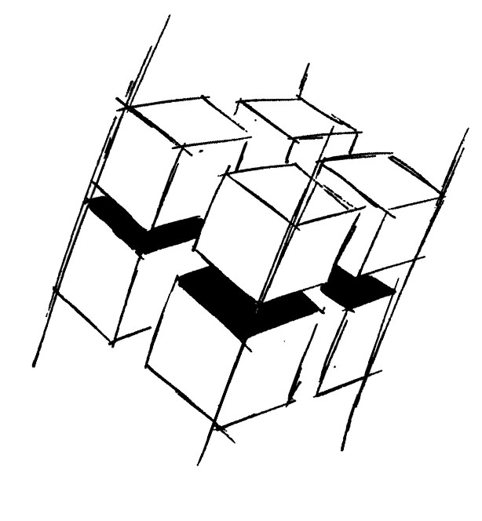
Prof. Dr.-Ing. Ralf Steinmetz
Multimedia communications Lab

Dr. Florian Mehm
Dipl. Inf. Robert Konrad


„Game Technology“
Winter Semester 2014/2015

Example Problems for Lecture 1 „Basic Input & Output“

1. Important Topics
Basic attributes of light and sound waves
Color reception
Gamma Curves
Double Buffering and Vertical Synchronization

2. Example Problems
See Exercise 1.

