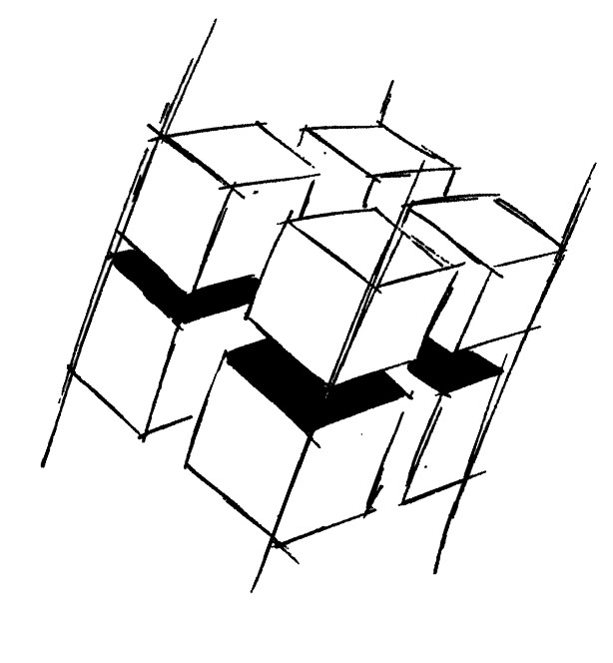
Prof. Dr.-Ing. Ralf Steinmetz
Multimedia communications Lab

Dr. Florian Mehm
Dipl. Inf. Robert Konrad


„Game Technology“
Winter Semester 2014/2015

Example Problems for Lecture 2 „Timing & Basic Game Mechanics“

1. Important Topics
Cooperative vs Preemptive Multithreading
Virtual Frame Time
Procedural vs Iterative Animations
Game Loop
Basic Collision Handling

2. Example Problems
a) Name the basic steps in a game loop.

b) List and explain the most common problems in collision handling.

