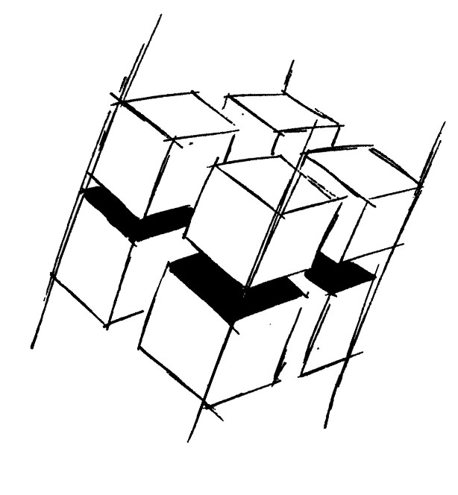
Prof. Dr.-Ing. Ralf Steinmetz
Multimedia communications Lab

Dr. Florian Mehm
Dipl. Inf. Robert Konrad


„Game Technology“
Winter Semester 2014/2015

Example Problems for Lecture 3 „Software Rendering 1“

1. Important Topics
Rasterisation
Raytracing
Perspective Projection
Rotations
Culling

2. Example Problems
a) List the basic steps of a rasterisation algorithm.

b) List the basic steps of a raytracing algorithm.

c) Explain the different kinds of culling algorithms used in 3D graphics.

