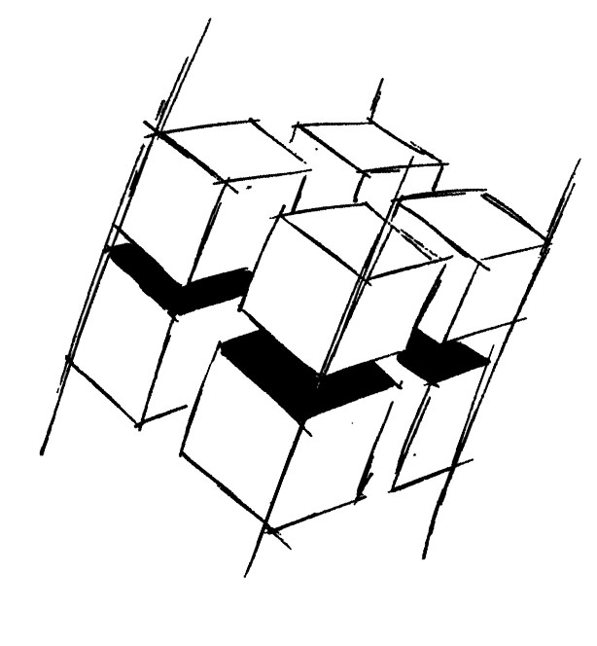
Prof. Dr.-Ing. Ralf Steinmetz
Multimedia communications Lab

Dr. Florian Mehm
Dipl. Inf. Robert Konrad


„Game Technology“
Winter Semester 2014/2015

Example Problems for Lecture 6 „Animations“

1. Important Topics
Bump Mapping
Deferred Shading
Particle Systems
Vertex Animations
Skeletal Animations

2. Example Problems
a) What are the shortcomings of normal mapping?

b) What are the benefits and problems of vertex animations?

c) What is the primary problem of vertex skinning as used in skeletal animation systems?

