2. Theoretical Task: Physics (5 Points)
2.1 Sphere-Box-Intersection
Research a method for intersection between a box and a sphere or derive your own.

Describe the chosen intersection test and write it in pseudocode.

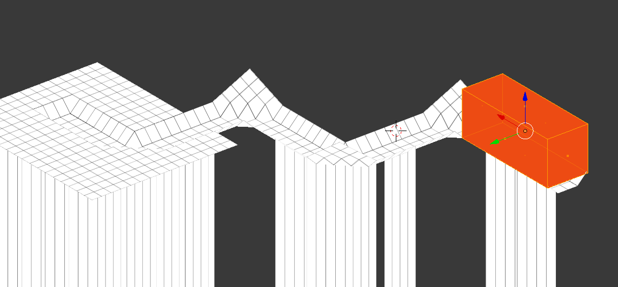

Some of the intersection tests from literature that were described:

http://theorangeduck.com/page/correct-box-sphere-intersection

A Simple Method for Box-Sphere Intersection Testing, Jim Arvo, "Graphics Gems", Academic Press, 1990

http://www.gamasutra.com/view/feature/131790/simple_intersection_tests_for_games.php?page=4

http://blog.nuclex-games.com/tutorials/collision-detection/static-sphere-vs-aabb/.

