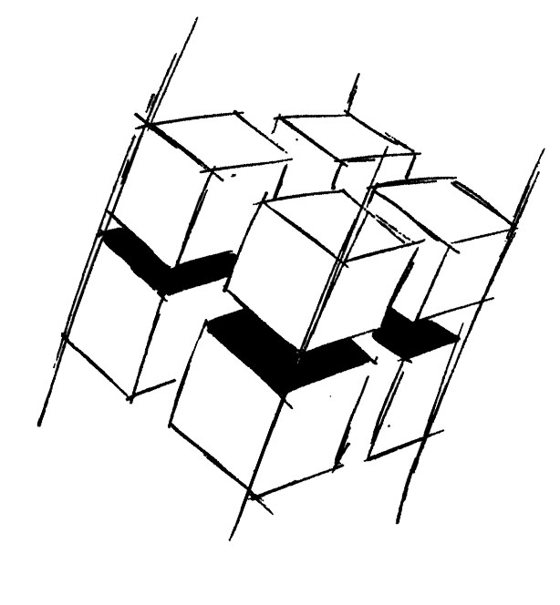
Prof. Dr.-Ing. Ralf Steinmetz
Multimedia communications Lab

Dr. Florian Mehm
Dipl. Inf. Robert Konrad


„Game Technology“
Winter Semester 2014/2015

Exercise 13

For bonus points upload your solutions until Friday the 6th of February 2015, 11:40

General Information
- The exercises may be solved by teams of up to three people.
- The solutions have to be uploaded to the Git repositories assigned to the individual teams.
- The submission date (for practical and theoretical tasks) is noted on top of each exercise sheet.
- If you have questions about the exercises write a mail to game-technology@kom.tu-darmstadt.de or use the forum at https://www.fachschaft.informatik.tu-darmstadt.de/forum/viewforum.php?f=557

1. Practical Tasks: Sound location (5 Points)
Modify the example to output basic positional audio. Change the amplitude of the sounds according to the distance to the listener and split them up properly for the left and right audio channels.
https://github.com/KTXSoftware/Exercise13.git contains additional code to help you out. You can either copy the code changes manually or just pull them into your own repository using
git pull https://github.com/KTXSoftware/Exercise13.git

2. Theoretical Tasks: Compression (5 Points)
2.1 Doppler Effect
Consider a car driving with 150 km/h and a person running away from the car with 15 km/h. The car emits lots of different sound effects. How much does the frequency of those sound effects change for the person when the car passes him?

2.2 Sound location simulation without headphones
Directional sound can be simulated effectively using headphones. Can this also be done using regular speakers? What are the expected limitations?

2.3 Sound reflection data
Considering the data available to a physically based rendering engine – what data can be reused to simulate realistic sound reflections?

