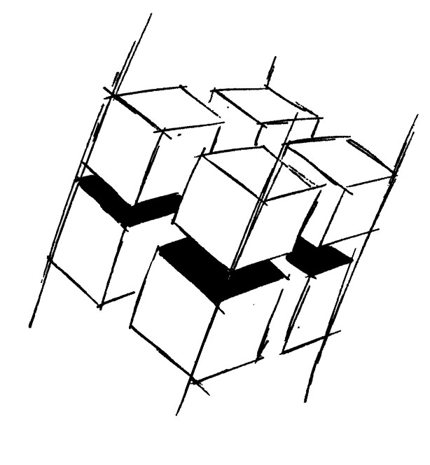
Prof. Dr.-Ing. Ralf Steinmetz
Multimedia communications Lab

Dr. Florian Mehm
Dipl. Inf. Robert Konrad


„Game Technology“
Winter Semester 2014/2015

Example Problems for Lecture 12 „Multiplayer“

1. Important Topics
Peer-to-Peer Lockstep
Client/Server
Client-Side Prediction
Latency

2. Example Problems
a) Compare the Peer-to-Peer and the Client/Server model – what are the pros and cons?

b) What is the problem with Client-Side Prediction and how can it be mitigated?

