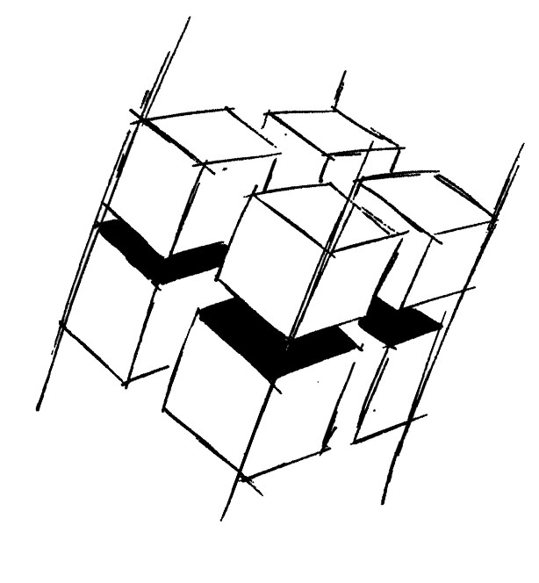
Prof. Dr.-Ing. Ralf Steinmetz
Multimedia communications Lab

Dr. Florian Mehm
Dipl. Inf. Robert Konrad


„Game Technology“
Winter Semester 2014/2015

Exercise 6

For bonus points upload your solutions until Friday the 28st of November 2014, 11:40

General Information
- The exercises may be solved by teams of up to three people.
- The solutions have to be uploaded to the Git repositories assigned to the individual teams.
- The submission date (for practical and theoretical tasks) is noted on top of each exercise sheet.
- If you have questions about the exercises write a mail to game-technology@kom.tu-darmstadt.de or use the forum at https://www.fachschaft.informatik.tu-darmstadt.de/forum/viewforum.php?f=557

1. Practical Tasks: Rock’n’Roll (5 Points)
We start implementing a game similar to Marble Madness. It will be an RPG (short for roll playing game). Implement basic ball and camera movements. Add animations to the ball as you see fit. Some rotation, scaling or shearing has to be involved.
https://github.com/KTXSoftware/Exercise6.git contains additional code to help you out. You can either copy the code changes manually or just pull them into your own repository using
git pull https://github.com/KTXSoftware/Exercise6.git

2. Theoretical Tasks: Graphics Mix (5 Points)
2.1 Normal Maps
Which view angles are most advantageous and which are most disadvantageous when normal mapping is in use?

2.2 Particles
Particle systems consist of lots and lots of semi-transparent billboards. Depth buffer based 3D rendering does not handle transparency well. What problem has to be avoided and can that be done efficiently? When all is set and done, what is likely to be the biggest performance burden when rendering particles?

2.3 Skeletal Animations
Skeletal animations are based on the movements of bone joints which usually only do one form of transformation - rotations. We have seen three methods to calculate rotations - Euler angle rotations, rotation matrices based on an angle around an arbitrary axis and quaternion rotations. Which kind of rotation would you prefer to represent bone rotations and why?

