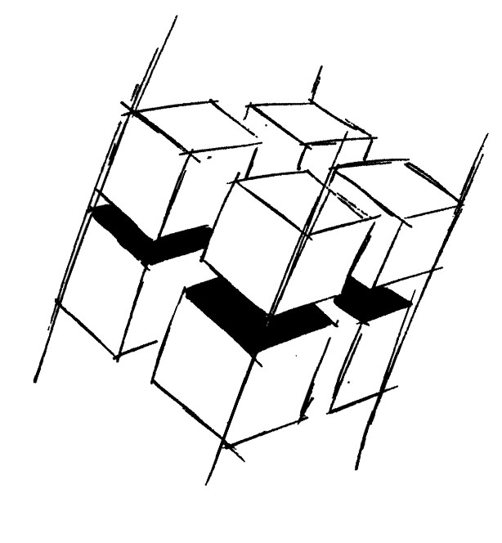
Prof. Dr.-Ing. Ralf Steinmetz
Multimedia communications Lab

Dr. Florian Mehm
Dipl. Inf. Robert Konrad


„Game Technology“
Winter Semester 2014/2015

Exercise 7

For bonus points upload your solutions until Friday the 5th of December 2014, 11:40

General Information
- The exercises may be solved by teams of up to three people.
- The solutions have to be uploaded to the Git repositories assigned to the individual teams.
- The submission date (for practical and theoretical tasks) is noted on top of each exercise sheet.
- If you have questions about the exercises write a mail to game-technology@kom.tu-darmstadt.de or use the forum at https://www.fachschaft.informatik.tu-darmstadt.de/forum/viewforum.php?f=557

1. Practical Tasks: Physically Based Rendering (5 Points)
Implement the microfacet BRDF specified in the current lecture (Schlick’s Fresnel Approximation, the Trowbridge-Reitz Normal Distribution Term, Cook and Torrance’s Geometry Factor).
https://github.com/KTXSoftware/Exercise7.git contains additional code to help you out. You can either copy the code changes manually or just pull them into your own repository using
git pull https://github.com/KTXSoftware/Exercise7.git

2. Theoretical Tasks: Simple Physics (5 Points)
2.1 Sunny
The sun is described as a directional light in the lecture - a light that emits light rays which all face in the same direction. Quantify this simplification, look up the sizes and distances of the sun and the earth and calculate the maximum angle between light rays from the sun which hit the earth.

2.2 No Subsurface Scattering
Diffuse reflection is a simplified model, because light that enters a material does not leave at the same position. This is ignored by the BRDF formulation. In realtime applications the BRDF is typically evaluated in the fragment shader. Consider the average distance between light entry and light exit positions for a material. The error is visible when this distance is larger than …?

2.3 Cardboard work
Pick up a light source, a camera and two polarization filters. How do they have to be used to create the pictures in slides 39 and 40 (diffuse and specular cardboard)?

