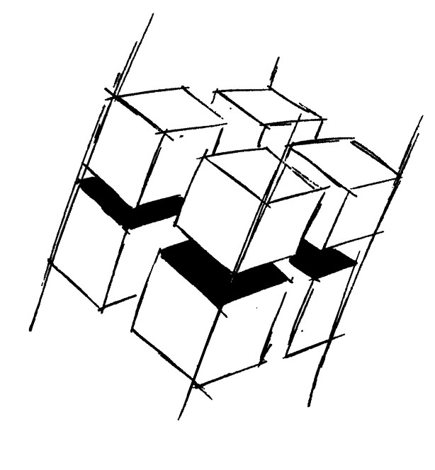
Prof. Dr.-Ing. Ralf Steinmetz
Multimedia communications Lab

Dr. Florian Mehm
Dipl. Inf. Robert Konrad


„Game Technology“
Winter Semester 2014/2015

Exercise 1

For bonus points upload your solutions until Friday the 24th of October 2014, 11:40

General Information
- The exercises may be solved by teams of up to three people.
- The solutions have to be uploaded to the Git repositories assigned to the individual teams.
- The submission date (for practical and theoretical tasks) is noted on top of each exercise sheet.
- If you have questions about the exercises write a mail to game-technology@kom.tu-darmstadt.de or use the forum at https://www.fachschaft.informatik.tu-darmstadt.de/forum/viewforum.php?f=557

1. Practical Tasks: Basic Setup (1 Point)
Create a Kore application which displays a simple geometric form (for example a line or a rectangle). Make sure it actually works and push it to your team’s Git repository. Start out by cloning https://github.com/KTXSoftware/Exercise1.git recursively (git clone --recursive).
You can find introductions to Kore and Git at http://wiki.ktxsoftware.com

2. Theoretical Tasks: Light and Sound (5 Points)
2.1 Light Waves
List the basic wave parameters of electromagnetic waves in the visible spectrum (aka light).

2.2 Sound Waves
List the basic wave parameters of sound waves.

2.3 Sci-Fi Monitors
What is the minimum amount of values necessary to encode a pixel for a bird who can see four base colors and the polarization of light?

2.4 Gamma Curves
Image data is usually gamma encoded. Which gamma value is optimally used for encoding for (a) internal lighting calculations and (b) for writing a final image to the framebuffer?

2.5 Vertical Synchronization
Consider a monitor that runs vsynced with 60 Hz and a game which consistently calculates one frame in 10 milliseconds. How much time does the game spend waiting for the monitor when (a) double buffering or (b) triple buffering is used?

