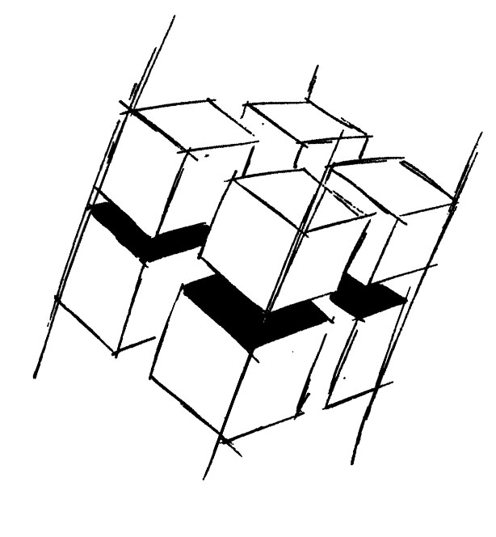
Prof. Dr.-Ing. Ralf Steinmetz
Multimedia communications Lab

Dr. Florian Mehm
Dipl. Inf. Robert Konrad


„Game Technology“
Winter Semester 2014/2015

Exercise 3

For bonus points upload your solutions until Friday the 7th of November 2014, 11:40

General Information
- The exercises may be solved by teams of up to three people.
- The solutions have to be uploaded to the Git repositories assigned to the individual teams.
- The submission date (for practical and theoretical tasks) is noted on top of each exercise sheet.
- If you have questions about the exercises write a mail to game-technology@kom.tu-darmstadt.de or use the forum at https://www.fachschaft.informatik.tu-darmstadt.de/forum/viewforum.php?f=557

1. Practical Tasks: Triangle Mesh Rendering (5 Points)
Implement a basic software triangle renderer. Implement keyboard camera controls.
https://github.com/KTXSoftware/Exercise3.git contains code for triangle rasterizing and mesh loading and a mesh to get you started. You can either copy the code changes manually or just pull them into your own repository using
git pull https://github.com/KTXSoftware/Exercise3.git

2. Hypertheoretical Task: Line Rendering Performance (5 Points)
Implement basic line rendering using a digital differential analyzer algorithm (using floating point values) and the Bresenham algorithm based on the corresponding Wikipedia articles (please don’t edit the articles).
Test the performance of both algorithms. Draw lots of lines and measure the time using Kore::System::time(). Make sure to compile in Release mode (most IDEs have a small Debug/Release dropdown menu). Try to pinpoint which operations slow the respective algorithm down the most. Write down your results and also check in the corresponding source code.

