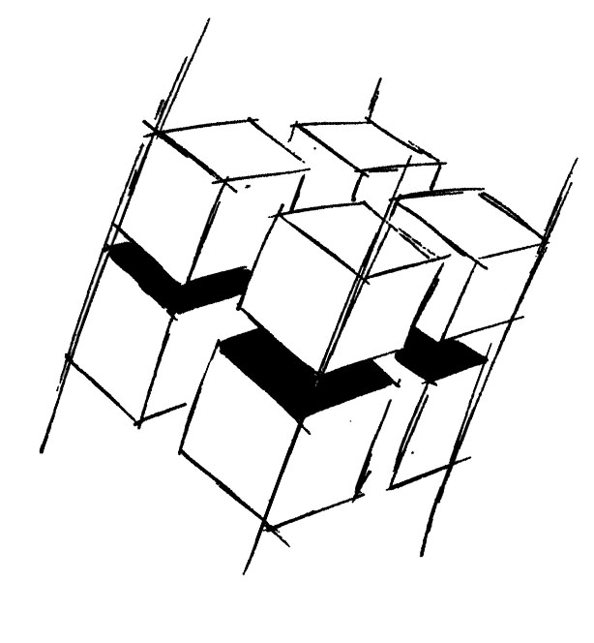
Prof. Dr.-Ing. Ralf Steinmetz
Multimedia communications Lab

Dr. Florian Mehm
Dipl. Inf. Robert Konrad


„Game Technology“
Winter Semester 2014/2015

Exercise 4

For bonus points upload your solutions until Friday the 14th of November 2014, 11:40

General Information
- The exercises may be solved by teams of up to three people.
- The solutions have to be uploaded to the Git repositories assigned to the individual teams.
- The submission date (for practical and theoretical tasks) is noted on top of each exercise sheet.
- If you have questions about the exercises write a mail to game-technology@kom.tu-darmstadt.de or use the forum at https://www.fachschaft.informatik.tu-darmstadt.de/forum/viewforum.php?f=557

1. Practical Tasks: Textures and Depth Buffers (5 Points)
Extend your software renderer to support texture mapping and depth buffering. For closer instructions see the comments in the shadePixel function in the source code.
https://github.com/KTXSoftware/Exercise4.git contains code for texture coordinate loading and interpolation. You can either copy the code changes manually or just pull them into your own repository using
git pull https://github.com/KTXSoftware/Exercise4.git

2. Hypertheoretical Task: Matrix Multiplication Performance (5 Points)
Implement 4x4 matrix multiplication using regular float arithmetic and using SSE (see slide 47). Test the performance of both algorithms. Multiply a lot of matrices and measure the time using Kore::System::time(). Make sure to compile in Release mode (most IDEs have a small Debug/Release dropdown menu). Write down your results and also check in the corresponding source code.

