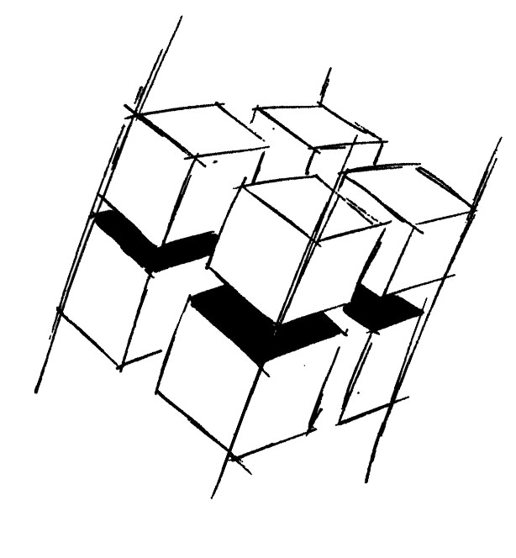
Prof. Dr.-Ing. Ralf Steinmetz
Multimedia communications Lab

Dr. Florian Mehm
Dipl. Inf. Robert Konrad


„Game Technology“
Winter Semester 2014/2015

Exercise 5

For bonus points upload your solutions until Friday the 21st of November 2014, 11:40

General Information
- The exercises may be solved by teams of up to three people.
- The solutions have to be uploaded to the Git repositories assigned to the individual teams.
- The submission date (for practical and theoretical tasks) is noted on top of each exercise sheet.
- If you have questions about the exercises write a mail to game-technology@kom.tu-darmstadt.de or use the forum at https://www.fachschaft.informatik.tu-darmstadt.de/forum/viewforum.php?f=557

1. Practical Tasks: Blinn-Phong lighting (5 Points)
Implement the Blinn-Phong shading model in GLSL. Also port your camera code to GLSL. Define the camera parameters using uniform declarations and set their values using Kore’s Graphics api.
https://github.com/KTXSoftware/Exercise5.git contains additional code to help you out. You can either copy the code changes manually or just pull them into your own repository using
git pull https://github.com/KTXSoftware/Exercise5.git

2. Theoretical Tasks: Where there is light, there must be shadow (5 Points)
2.1 Blending Order
According to our lectures rendering semitransparent objects correctly requires correct rendering order (from back to front). Have a closer look at the equations for standard and additive blending and verify or debunk our statement for both equations individually.

2.2 Phong Lighting
When light is directly reflected from an object in reality the distorted forms of the objects surrounding the object can be identified in the reflection. For example in a curved mirror you can see the distorted form of yourself. The Phong lighting model tries to reproduce direct light reflections using a little formula involving a cosine. This cosine approximates the form of a specific scene object. Which object is it? What form does it have?

2.3 Roughness
In the literature, diffuse reflection can denote two things. In the lecture we introduced diffuse reflections as light that penetrates the molecular structure of an object and then leaves in a completely random direction. Elsewhere diffuse reflection is defined as direct reflections from rough surfaces. In reality these semi-diffuse reflections looks like blurred, direct reflections. In the lecture we showed two special kinds of texture maps, mip maps and cube maps. How can those be used to implement blurred reflections aka roughness?

