SCHOOLOGY GRADE TRACKER · UI MOCK-UPS
Import a screenshot, see your real grade.
Schoology Grade Tracker is a privacy-first grades app for high-school students — with no API, login, or scraping. The student imports their own Schoology grades from a screenshot, and everything is computed and stored on the device.
App | Schoology Grade Tracker — Flutter (iOS / Android)
User role | Student (own data only — no admin or teacher roles)
Primary use case | Import grades → see the computed grade → plan with What-If
Authentication | None — keyless manual import
Data | Stays on the device
Screens rendered from the app’s real Material 3 theme (seed #4F46E5) using the student’s real American Heritage sample courses.

01 The screens
Eight screens make up the primary journey — from first launch to a planned grade. Each is annotated with the user role and what the student is doing.
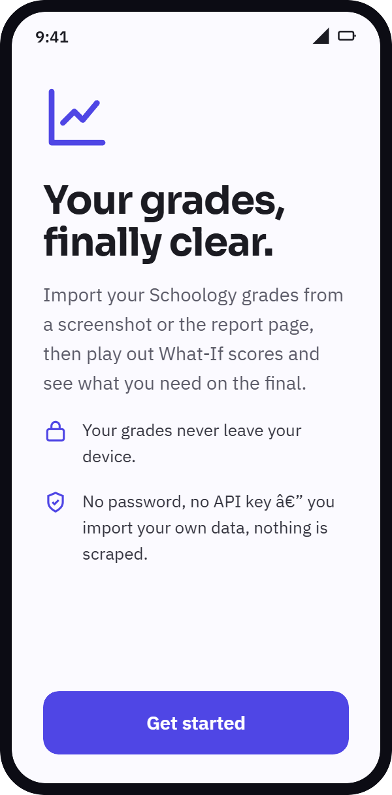 | SCREEN 01  Onboarding  Student · first run  The value proposition and the privacy promise. There is no account to create and no credentials to enter — “Get started” opens the gradebook.  On this screen  - States the on-device, keyless model up front  - A single primary action leads to Home

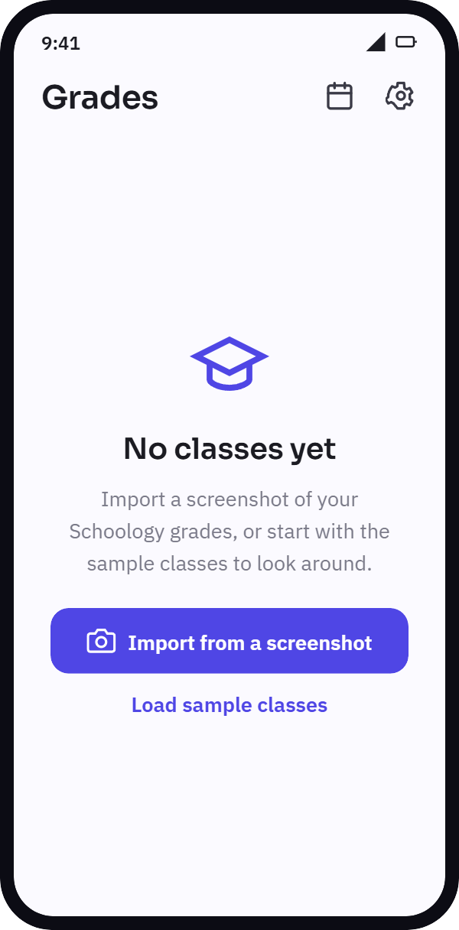 | SCREEN 02  Home — empty state  Student · first run  The gradebook before any import. Two ways in: import a real screenshot, or load the sample classes to explore risk-free.  On this screen  - App-bar actions: Upcoming (calendar) and Settings  - The primary path is the screenshot import

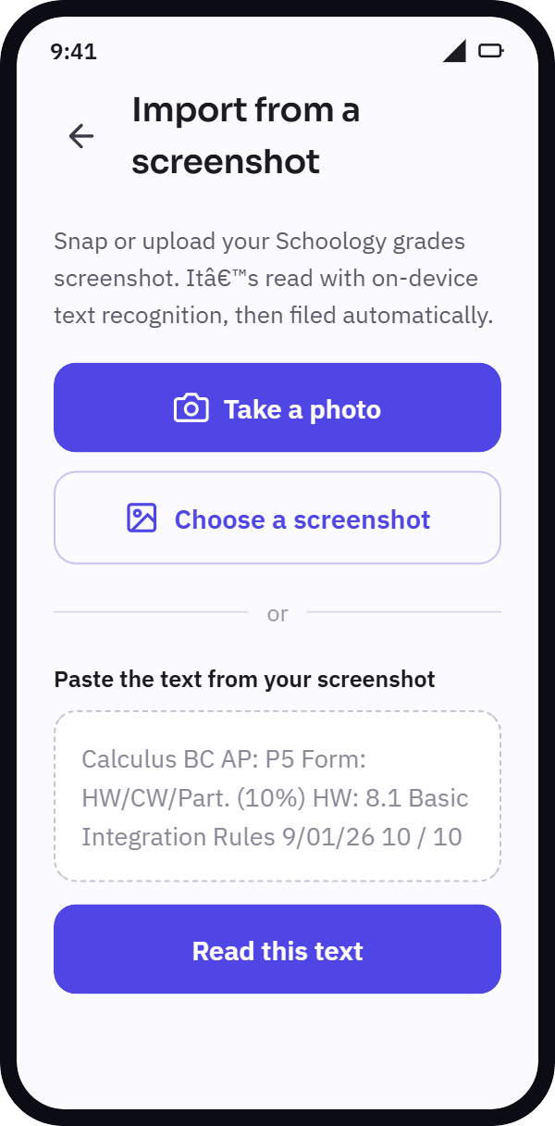 | SCREEN 03  Import — capture  Student · on-device OCR  The student takes or picks a photo of a graded item. On-device text recognition reads it — nothing is uploaded. A paste fallback covers desktop and web.  On this screen  - Three inputs: camera, gallery, paste  - OCR runs locally on the phone

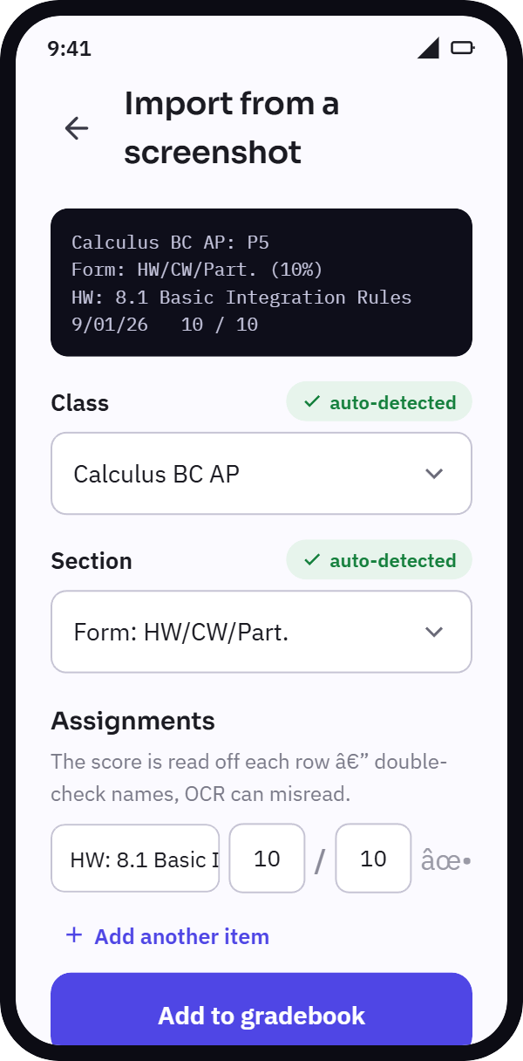 | SCREEN 04  Import — cascade & review  Student · signature feature  The cascading importer auto-sorts the item into a class, then a section. Each field shows its status — green “auto-detected / set,” or amber “pick one” when the student must choose. Scores are pre-filled for a final check.  On this screen  - Auto-then-manual: falls through to a picker when unsure  - The OCR preview stays visible for verification  - Commits the parsed rows to the gradebook

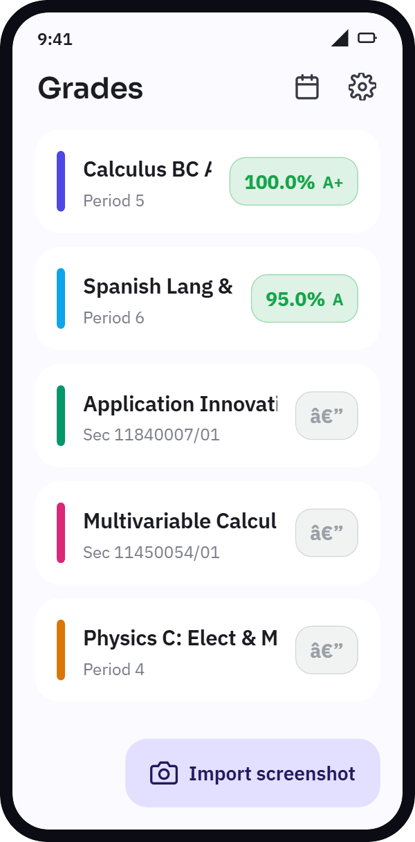 | SCREEN 05  Home — gradebook  Student · daily use · main surface  The app’s home. Every class with its current computed grade — a color-coded pill and letter. Classes not yet started show “—.” The button imports more screenshots.  On this screen  - The grade rolls up: categories → quarter → course  - The left color bar is the course’s identity  - Tapping a card opens the course detail

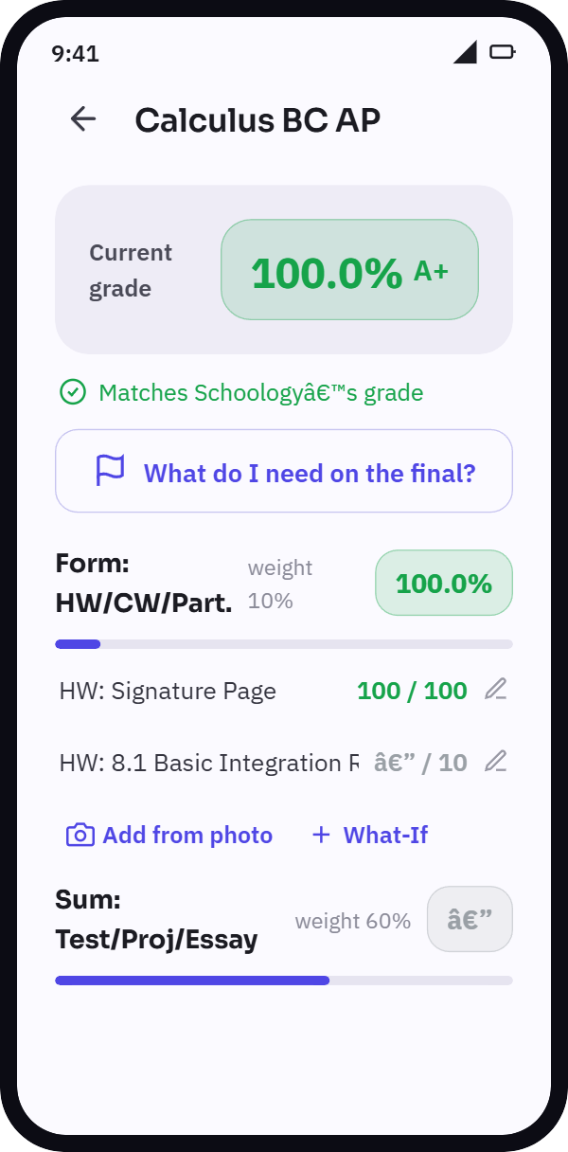 | SCREEN 06  Course detail  Student  One course, broken down by weighted category. The header shows the overall grade; a banner confirms it matches Schoology’s own number. Each category shows its weight, its grade, and its assignments.  On this screen  - Tap any score to run a What-If  - “Add from photo” imports straight into a section  - A shortcut opens the final-grade calculator

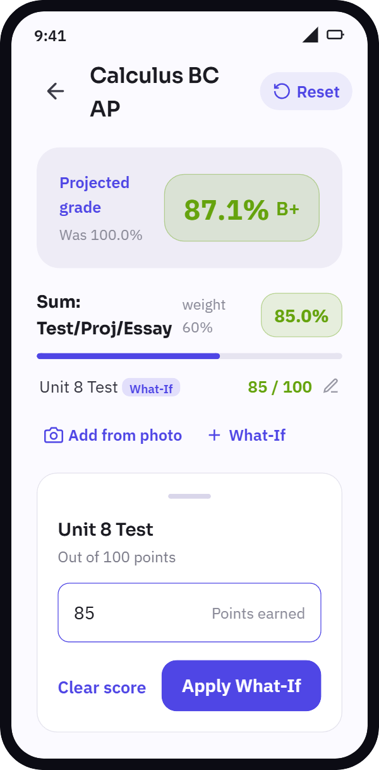 | SCREEN 07  What-If projection  Student · planning  The student types a hypothetical score into a sheet; the header instantly recomputes to a projected grade and remembers what it was. Everything is local math — nothing is changed on Schoology.  On this screen  - The header flips to “Projected grade” with “Was …”  - Hypothetical rows are tagged “What-If”  - “Reset” restores the real scores

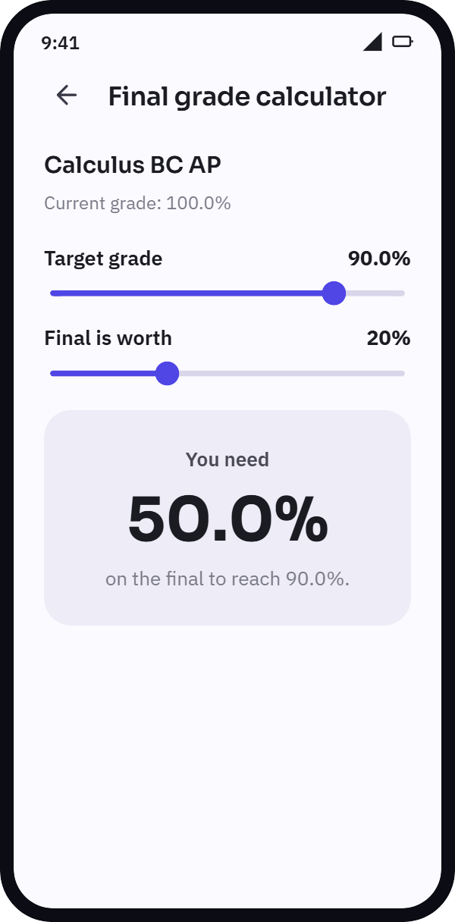 | SCREEN 08  Final-grade calculator  Student · planning  “What do I need on the final?” Two sliders — the target grade and the final’s weight — drive a live answer, and it handles the edge cases (already locked in, or out of reach).  On this screen  - Solves for the required final score  - Reachable from any course detail

02 Screen flow
The path a student walks. The journey is linear until the course detail, where it branches into the two planning tools.
From | Action | To
Onboarding (01) | → “Get started” | Home — empty (02)
Home — empty (02) | → Import from a screenshot | Import — capture (03)
Import — capture (03) | → Read text / on-device OCR | Import — cascade & review (04)
Import — cascade (04) | → Add to gradebook | Home — gradebook (05)
Home — gradebook (05) | → Tap a course | Course detail (06)
Course detail (06) | → Tap any score | What-If projection (07)
Course detail (06) | → “What do I need on the final?” | Final-grade calculator (08)
Branch: from Course detail (06) the student can open either What-If projection (07), by tapping any score, or the Final-grade calculator (08), via “What do I need on the final?”. Both return to the course detail.
Schoology Grade Tracker — Flutter grades app · mock-ups for the primary “import & plan” flow · seed #4F46E5 · Material 3

