**Mask Vending Machine**

Product design:

1. **Front**

In this image, we can see the coin insertion slot, LCD display as well as the stack compartment of mask along with its opening at the top. The outlet of mask is visible at the bottom left. Fig. 1a depicts the exterior of a vending machine. Fig. 1b, on the other hand, represents the hidden internal structure that reveals the vending machines internal mechanism which includes the Arduino Uno, Motor driver, Coin collector box, BO motor, IR sensors, Rotor rod and wheels.

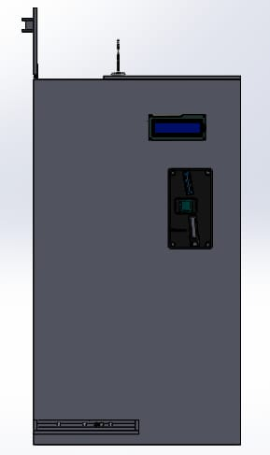 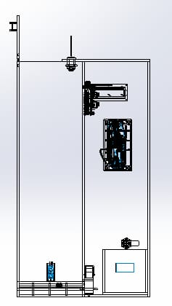 figure 1a: Front (external) figure 1b: Front (internal)

1. **Back**

Fig. 2a show the two keyholes used to mount the machine to the wall. Fig. 2a depicts the position of keyholes as well as the opening of the coin collector box along with the lock whose key insertion compartment can be seen. Fig. 2b illustrates the hidden internal structure that reveals the vending machines internal mechanism.

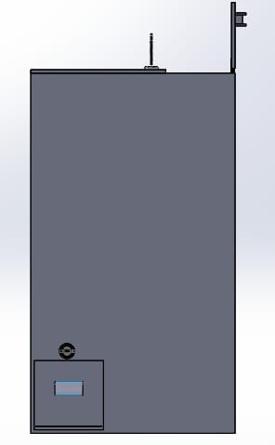 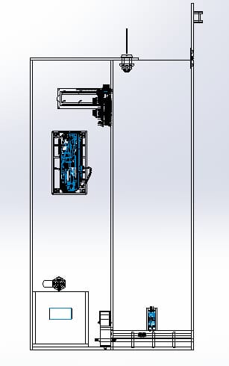

figure 2a: Back (external) figure 2b: Back (internal)

1. **Left Hand Side**

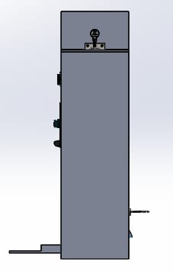 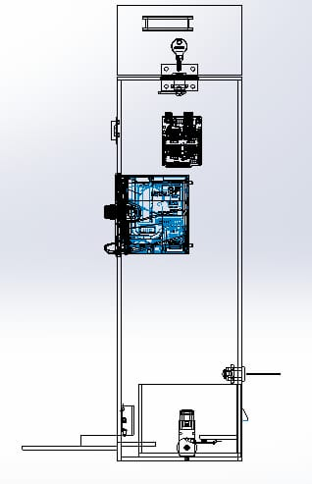

figure 3a: Left Hand Side (external) figure 3b: Left Hand Side (internal)

1. **Right Hand Side**

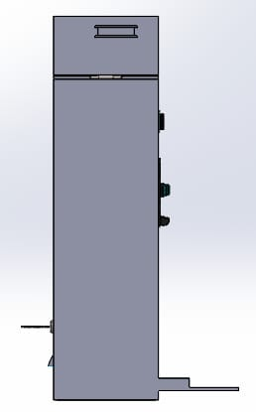 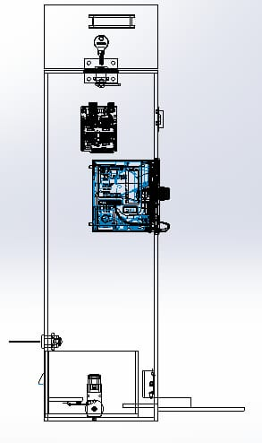

figure 4a: Right Hand Side (external) figure 4b: Right Hand Side (internal)

1. **Top**

Fig. 5a shows the opening of the stack compartment of masks form the top as well as the width of the stacking compartment. Fig. 5b, on the other hand, depicts the lock whose key insertion compartment can be seen and other internal mechanisms.

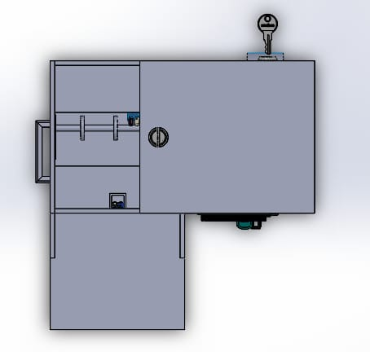 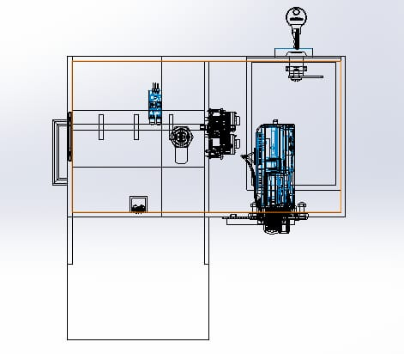

figure 5a: Top (external) figure 5b: Top (internal)

1. **Bottom**

Fig. 6a describes the bottom of the machine which includes the outlet tray for the ejected mask. Fig. 6b, on other side, depicts the other internal mechanisms.

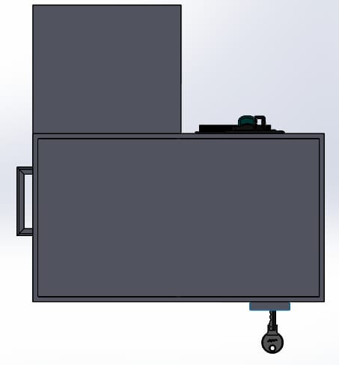 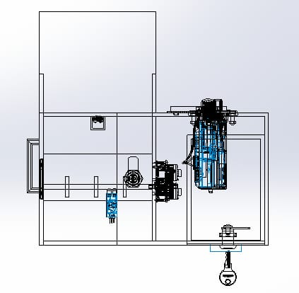

figure 6a: Bottom (external) figure 6b: Bottom (internal)