**MASK VENDING MACHINE**

**Made by:**

Kunal Thakur

Nandani Rabra

Jay Awale

Pranjlee Kolte

**Objective**:

Face masks are important in the COVID-19 pandemic to hold the coronavirus at bay. With a simple insertion of coins, the Face Mask vending machine provides a smart and secure solution for ensuring that face masks are always accessible and sanitized.

**Components Used:**

* Arduino Uno
* Motor Driver Shield
* Coin Acceptor
* IR Sensors
* LCD Display
* BO Motor
* Container

**Working**:

* The Mask Vending Machine is configured to accept coins in denomination of Rs.5 and Rs.10 only and the cost of the Mask is Rs.10.
* The customer gets to choose to either insert a Rs.10 coin or two coins of Rs.5 to activate the machine.
* If the machine is out of mask, the IR sensor will detect this and will display, “Out of Masks”.
* The Coin Acceptor is capable of detecting whether the coin of Rs.5 or Rs.10 or any other.
* If Rs.5 is detected, it will display the user “Insert Rs.5 more”, on the LCD display.
* If Rs.10 is detected, it will enable the BO motor to dispense the mask out of the machine and will display, “Please collect your Mask, Thank Your”.
* If any other coin is inserted by the user, it will simply get rejected by the machine.
* When the mask is dispensing out of the machine, the IR sensor will detect it and stop the rotation of BO motor and the user will obtain the mask.

**Block Diagram**:

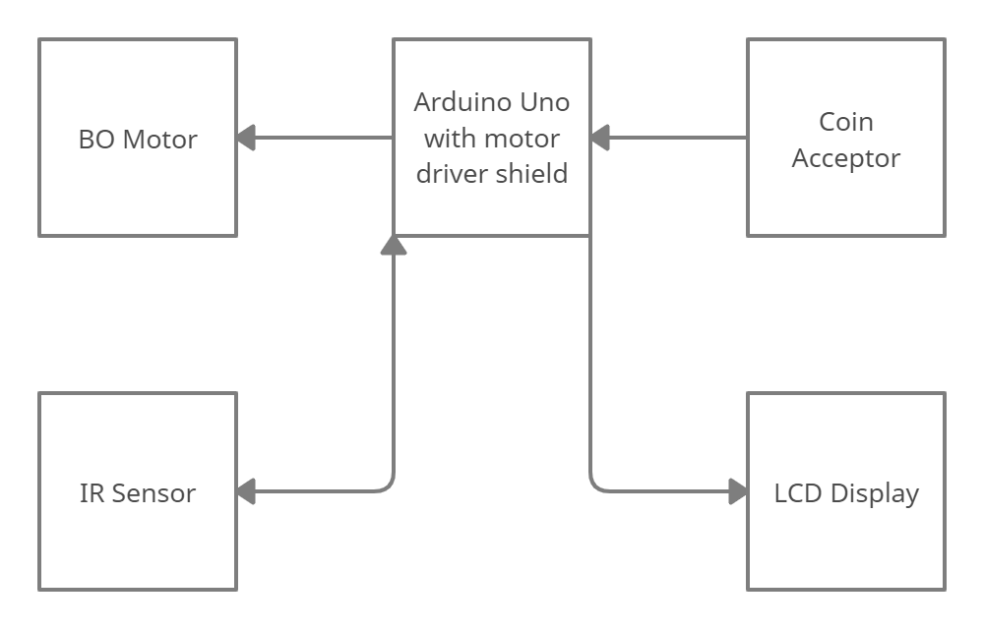

**Flowchart**:

