**GPS GNSS**

GPS (Global Positioning System) is a specific type of GNSS (Global Navigation Satellite System). GNSS is a generic term used to describe any system that uses satellites to provide positioning, navigation, and timing information to users worldwide. Examples of other GNSS include GLONASS (Russia), Galileo (Europe), and BeiDou (China). GPS (USA) consists of the space segment, control segment and user segment. The control segment consists of 1 master control station, injection stations and monitoring stations and is mainly used to detect and control the satellite’s movement, compose satellite ephemeris and monitor system time. The user segment is mainly composed of the GPS receiver system used to receive and process satellite signals and provide navigational positioning information. There are two types of receivers: navigational receiver (handheld, vehicular and airborne) and geodetic receiver (single-frequency and dual-frequency).

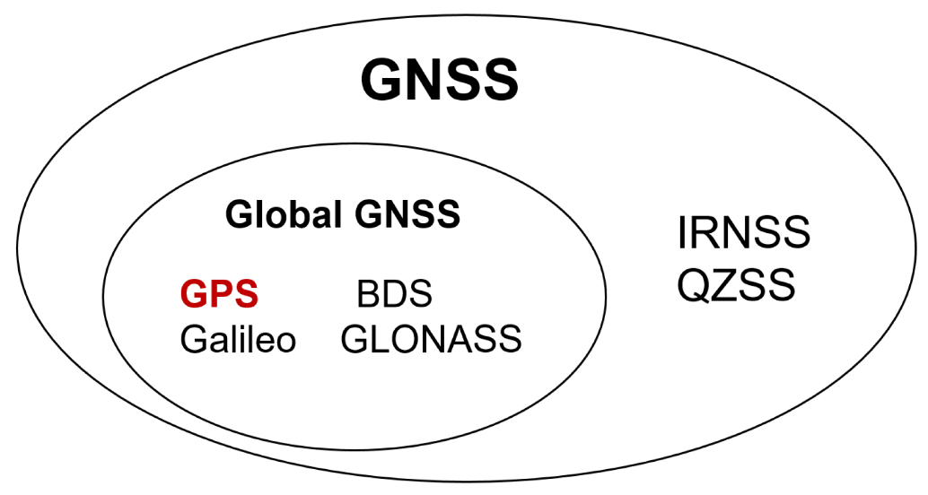

GPS satellites continuously transmit broadcast signals, that is, navigation messages, which mainly carry the current timestamp and orbital coordinates of the satellite. The time when the ground receiver receives the signal is subtracted from the time stamp carried by the message and then multiplied by the speed of light, *c*, to obtain the relative distance between the receiver and a single satellite. Therefore, when the ground receiver can receive more than three groups of GPS signals, the absolute position of the receiver on the earth can be solved directly according to the topological relationship of the satellites. It is worth mentioning that the timestamp carried by the satellite is verified by the atomic clock, and the accuracy is much higher than that of the clock of the ground receiver. In order to eliminate this error, a fourth satellite is generally introduced, and the current time is also used as a variable. This is the typical four-star positioning. The specific calculation process is as follows:

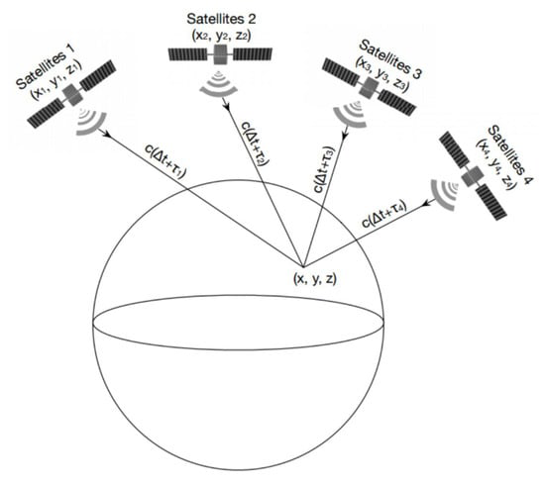

**Figure** Topological relationship between GPS signal receiver and satellites: typical four-star positioning.

According to the timing characteristics of the satellite signal received by GPS, the formula can be obtained for the signal of satellite **i** in the spatial coordinate system:

*(∆t+τi)∗c=P(xi,yi,zi)−P(x,y,z)*

where *∆t=T−T0, T0* is the transmission time of the satellite signal, *T* is the reference receiving time, τi is the time delay of the received satellite *i* signal relative to the reference time, *c* represents the speed of light, *P(xi,yi,zi)* are the space coordinates of satellite *i*, and *P(x,y,z)* are the space coordinates of the GPS receiver. The two vectors are subtracted into distance.

**Figure.** Example timing diagram of signal received by GPS receiver in four-star positioning.

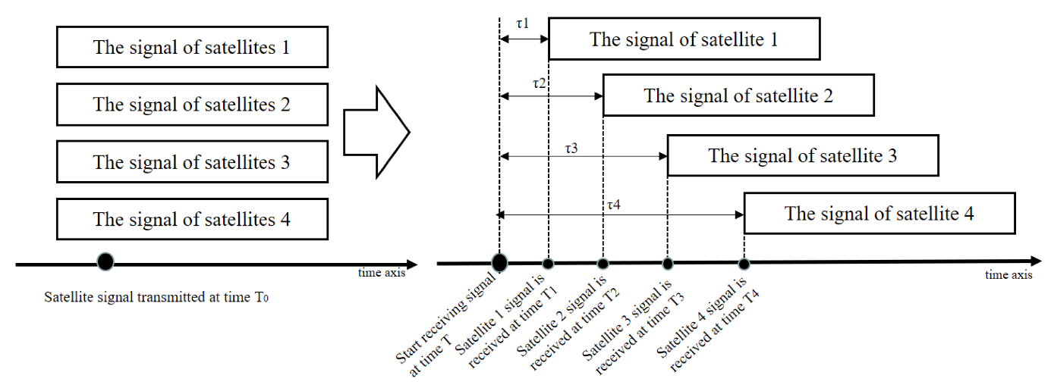

For four satellites, there are equations as follows:

*(∆t+τ1)∗c=P(x1,y1,z1)−P(x,y,z)*

*(∆t+τ2)∗c=P(x2,y2,z2)−P(x,y,z)*

*(∆t+τ3)∗c=P(x3,y3,z3)−P(x,y,z)*

*(∆t+τ4)∗c=P(x4,y4,z4)−P(x,y,z)*

Thus, the quaternion equation can be solved and the receiver coordinates, P(x,y,z), can be obtained as long as the coordinate position of each satellite is known and the relative propagation delay of each satellite signal is measured. This achieves accurate positioning of the receiver.

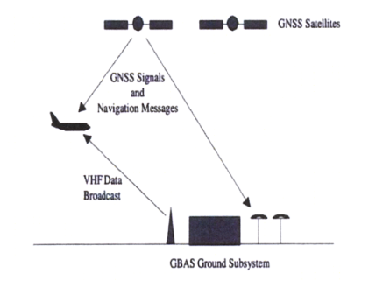

**Typical gnss signal**

The overall designs of all forms of GNSS are remarkably similar. All transmit three basic messages:

a) A ranging signal for position, velocity and timing (PVT),

b) Precise ephemeris data, which speciﬁes the exact location of the individual satellite,

and

c) An almanac, which speciﬁes the locations and orbits of all satellites in the constellation, along with status information, used to select satellites for tracking.

All types of GNSS satellites transmit on at least two bands: using the predominant GPS terminology, on frequency L1 an encrypted military code, called P(Y), and an unencrypted civilian code, called C/A, while on the L2 band the P(Y) code is repeated.

At the lowest level a GNSS navigation signal can be seen as an analog sinusoidal wave at a frequency that varies roughly between 1.2 and 1.6 GHz. In order to carry digital information, segments of this basic signal are phase-shifted, in the case of GPS or GLONASS L1 by π radians. The usual method is BPSK (binary phase shift keying), which encodes 1 bit per phase-shift. Other variations are QPSK (quadphase), which uses four phase shifts to encode 2 bits per shift, as used in Beidou-2, and MBOC (multiplexed binary offset carrier), as used in GalileoE1, which is designed to interoperate with the existing GPS L1 signal. The information transmitted on a given frequency is composed of two separate signals: the in-phase (I) and quadrature (Q) components. These are phase-shifted by 90◦ with respect to each other. In the case of GPS L1 (1575.42 MHz) the in-phase signal carries the civilian C/A code and the Q component the military P(Y) code. In all cases what is encoded onto the analog carrier wave is a PRN (pseudo randomnumber) sequence. The PRN is transmitted at an order of magnitude slower than the carrier, in the case of GPS L1, at 1 megabits per second. The length of the civilian PRN sequence is 1023 bits, which lasts for 1 millisecond, then it repeats. The W-code used in GPS L2, on the other hand, is 6.1871 ×1012 bits long and takes a week to transmit.

The encrypted military signal can be used to compensate for this delay by correlating the two versions of the P(Y) code, which are delayed by differing amounts due to their different frequencies. However, it is possible even for civilian receivers to align the two P(Y) signals, using codeless techniques, and so derive the same ionospheric delay to correct the C/A code.

**Principle of gps signal system**

The distribution of satellites has been ingeniously designed to guarantee at least 4–8 satellites can be observed at any place and moment on earth surface and in territorial space. Why need at least 4 of satellites? The principle of GPS positioning is shown in the below figure. GPS positioning is implemented by distance measurement. The GPS receiver needs to measure the distance of every satellite to itself, and the distance is equal to light speed c multiplied by time, so we have: . Therefore, distance measurement is essentially time measurement. As shown in figure, the GPS receiver on the ground can receive the signals of 4 satellites. Suppose all satellites send their respective messages at the same moment *T0*, and the messages reach the receiver via different paths. Since time delay applies to all messages, their arrival times should be different. In the figure, represent the times it takes for the 4 satellites to reach the receiver, respectively.

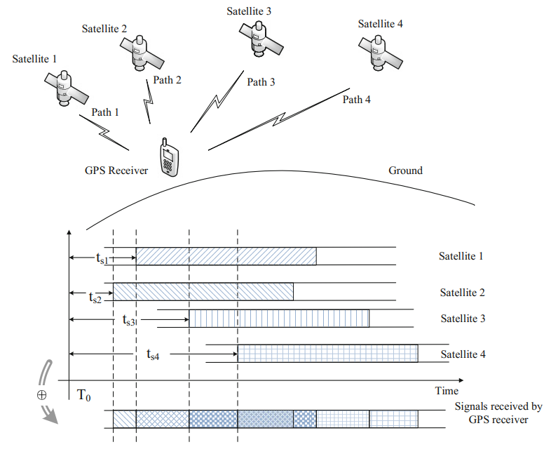

Principal of gps positioning

GPS signal is the product of carrier wave, PRN code and navigation messag. PRN, or pseudo random noise code, guarantees the ground user can detect and process weak signals with its spread spectrum characteristic. Meanwhile, the selfcorrelation and cross-correlation characteristics of these PRN code ensure the signals of multiple satellites which share the same carrier frequency can be differentiated. Navigation message is the modulated data in a GPS signal and plays a significant role in the signal’s composition. Every satellite is continuously transmitting its unique navigation message, which provides the signal’s accurate time of transmission and the satellite’s ephemeris data. And the satellite’s accurate position can be obtained by the receiver based on the above two parameters. The navigation message also provides information about the satellite’s health status, configuration, anti-spoofing technology, correction parameters of ionosphere and troposphere and almanac data. The above orbital parameters improves accuracy of positioning on one hand, and accelerates signal capturing on the other.

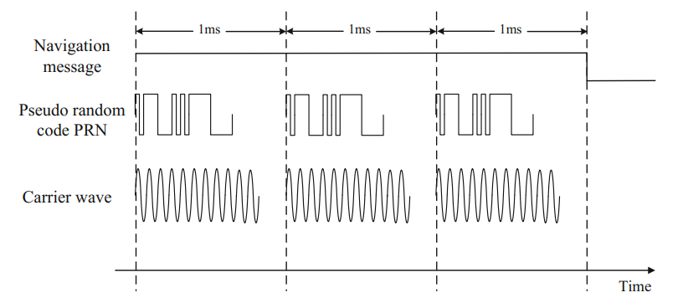

Basic components of a gps signal

The navigation message can be divided into 5 different layers. The most fundamental structure is bytes. The data rate of navigation message is 50 bps, which means one effective byte outputs every 20 ms. So, the data rate of GPS modulation is really slow. It was designed in this way in order to ensure minimum bit error rate with a sufficient spreading gain. The second layer is word, which consists of 30 bytes. And the 3rd layer is subframe, consisting of 10 words. Therefore one subframe contains 300 bytes. The fourth layer is page or frame. 5 subframes comprise a page. Lastly, 25 pages comprise a full-cycle navigation message. Every satellite is continuously transmitting cycled navigation messages consisting of 25 pages each.

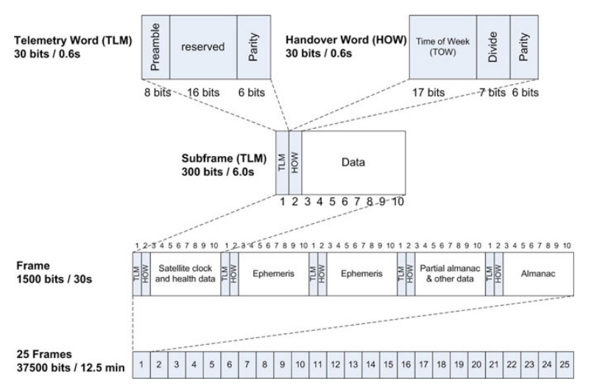

layered structure of the navigation message

The receiver receives every satellite’s ephemeris data to determine the satellite’s position. It also needs the time of transmission and clock correction data to work out the pseudo distance (ρ in the formula) and thereby the receiver’s position. The above information is transmitted in the first three subframes, therefore the receiver needs at least 16 s (in the worst case 30 s) to obtain it. However, the satellite is moving at 3–4 km/s at high altitudes during spatial transmission, and the user might also be moving, therefore the satellite signal received by the user must have a Doppler frequency shift phenomenon. Besides, the relative movement between the satellite and the user’s receiver must be considered because of Doppler effect. As a result, The GPS simulator must simulate Doppler effect.

**GPS Vulnerabilities Analysis**

The vulnerability of GNSS itself is the basis of GNSS spoofing. The vulnerability of GPS mainly includes:

**Navigation signal format disclosure:** GNSS currently uses three public frequencies *L1, L2* and *L5* to broadcast navigation signals. The spectrum characteristics, signal modulation format and pseudo-random code sequence of each frequency point have been disclosed. Because the main signal parameters have been disclosed, this means that there is no “secret” for the spoofer. Spoofers can often take targeted spoofing actions according to relevant signal parameters and characteristics.

**Navigation data format disclosure:** GNSS navigation message data usually include ephemeris, almanac, satellite clock parameters, ionosphere/troposphere and other important parameters. These parameters play a very important role in accurate user positioning. However, in order to facilitate the use of relevant users, GNSS disclosed the arrangement mode, data definition and application method of its navigation message from the beginning. This also means that a spoofer can easily and pertinently intercept and tamper with relevant navigation data, which means relevant users can receive wrong navigation data for the location solution without being aware, so as to achieve the purpose of spoofing.

**Unprotected broadcast channel:** in order to ensure the convenience of users, GNSS adopts a broadcast communication mode, that is, directly broadcast navigation signals to the majority of users. This mode actually makes its communication channel directly exposed in the social space and vulnerable to interference, monitoring and tampering. In addition, because the GPS signal is extremely weak when it reaches the ground (the average signal power is often −150 dbw∼−160 dbw) , only low directional power is needed in order to interfere with and suppress the legal GNSS signal, which objectively leads to a more fragile GNSS signal in practice.

**3.Spoofing**

Because the position and clock difference of the receiver depend on the satellite position and observation pseudo-range, the receiver can get wrong results by changing the satellite position or observation pseudo-range through spoofing. There are two main spoofing modes: generating false message information and increasing signal propagation delay, which correspond to two spoofing modes: generating mode and forwarding mode. Generative spoofing is a kind of spoofing device that produced false navigation signals independently. By giving false satellite position information, the receiver's solution results deviate from the real position and time. Forwarding spoofing was to receive real satellite navigation signals and delay and forward them. By changing the observation pseudorange of the receiver, the result of the receiver's calculation will be wrong. Regardless of the spoofing mode, in order to achieve spoofing to the user receiver, the spoofing equipment need to modify the parameters such as signal power, navigation message and signal propagation delay when the spoofing signal enters the receiver. It is very difficult to control the power and direction of the spoofing signal when it entered the receiver, which was different from the real signal. The detection of spoofing signal was to detect and identify spoofing signal by comparing the difference of signal power, carrier-to-noise ratio, relative power of different frequency points, Doppler consistency, message information and other parameters between deception signal parameters and real signal parameters.

3.2 Meaconing.

The simplest form of spooﬁng is meaconing, which is the capture and retransmission of legitimate GNSS signals after a delay. Meaconing, however, is difﬁcult in the case of the encrypted military signal, such as the GPS P(Y), because it is modulated onto a far longer PRN sequence. Since receivers have their own clock they could easily detect the out of phase alignment of the W code. Also, because the P(Y) GPS signal is transmitted well below the background noise level, re-transmitting it would require an accurate estimation of the secret W code, which can be achieved via “semi-codeless” techniques. For the civilian signals, however, no such difﬁculty of spooﬁng arises. Since the relative arrival times of the four signals are unchanged by the meaconing process, the navigation solution will be that of the meaconer. The timing solution will likewise be that of the meaconer, plus the time taken to retransmit the signals to the victim. However, meaconing does not seem suitable for attacks against timers. The ﬁrst stage of an attack is to substitute the spoofed signal for the real one. Since a timer already knows its own location, it would read the delayed time being transmitted by the meaconer, resulting in a sudden shift in the timing solution equal to the time required to retransmit the signal. This would clash with the known local time maintained by the clock, and could be used to raise an alarm. However, meaconing could also be performed initially with a zero-delay, by predicting the signal values in advance and synchronising with the true signals.

3.2.1. SCER. A variation of meaconing called SCER (security code estimation and re-play) or “selective delay” involves the rebroadcast of individual satellite signals after a delay. This can modify both the position and/ortiming solutions. An attacker could then manipulate the position solution only and soavoid a time jump when starting an attack.

3.2.2. Other forms of spooﬁng. Other forms of spooﬁng are categorized by the level of so-phistication. Humphreys and Motella divide these into “simplistic” (broadcast of arbitrary GNSS signals without synchronization with legitimate signals), “intermediate”(spooﬁng synchronized with legitimate signals) and “sophisticated” (using multiple phase-locked intermediate spoofers). A spooﬁng device, called as “limpet spoofers”, can be attached to the vehicle or timer it is intended to spoof. These devices overcome many of the practical limitations on spooﬁng described in Section 5 below, but require both compromise of the physical security of the receiver, and in practice also a level of miniaturization that has not yet been achieved

In addition to the general definition mentioned above, there are also different classifications of spoofing. To properly understand the attacks that are carried out, it is necessary to take a look at these different approaches as well.

**4. Classification and Research Progress of Spoofing Technology**

*4.1. Traditional Classification of Spoofing Types Based on Signal-Generation Mode*

It is a typical classification method to classify the types of spoofing according to the generation mode of the spoofing signal. This is generally divided into two categories: production spoofing and forwarding spoofing.

* Production spoofing

Production spoofing usually refers to transmitting the signal generated by the signal generation equipment itself directly to the USE receiver so that the target USE produces the wrong position solution to achieve the purpose of cheating the USE by the attacker. Its advantage is that the navigation signal and transmission time have their own flexible decision, which can lag or advance the transmission time of the signal and can also give wrong location information in the navigation message.

* Forwarding spoofing

As its name implies, forwarding spoofing collects the real satellite signals then enhances them and delays forwarding so that the target receiver tracks the deception signal and gets the wrong navigation and positioning result. Compared with production spoofing, this type does not need to master the structure and setup of the signal in advance. Further, the essence of forwarding spoofing is to forward the real signal, which has strong consistency with the real signal, so it has good spoofing effect on GNSS civil code and military code receivers. However, at the same time, because its implementation is based on forwarding of the real phase signal, the delay processing of the signal can only be greater than the delay of the real signal. So the generation of the deception signal is less flexible and more restrictive. This also determines that it is not easy to achieve more complex deception purposes in the deception mode, and the enhancement processing before transmitting the deception signal also amplifies the noise.

* Gradual self-synchronization spoofing

Under this classification standard, in addition to the above two traditional types, there has been a gradual self-synchronization spoofing developed in recent years that deceives the receiver tracking loop and is classified as an advanced type of spoofing in the relevant literature. After receiving the real signal, the spoofer carries out range delay and Doppler modulation according to the dynamic performance of the target receiver so as to control the satellite delay when the target is not aware. This method can realize the gradual guidance deception of booking location or path. It is a new concealed and efficient deception method. The key to the realization of gradual self-synchronization spoofing technology is how to effectively invade the target receiver to realize covert synchronization spoofing. For civil and military receivers, the technical implementation difficulty is different. For the civil receiver, due to disclosure of the civil pseudo-random code system, the pseudo-random code periodic signal can be repeatedly generated locally. When the spoofing signal has Doppler offset, it can move to the same code phase of the real signal within a period of time, so as to realize spoofing. For the military receiver, because the military pseudo-random code is unknown, it is necessary to use an antenna with strong directionality to isolate different satellite signals and spoof by forwarding indirect control. Moreover, it is difficult to predict the general position and motion trend of the target in advance to obtain the spoofing phase conditions. Gradual self-synchronization spoofing technology will be the research focus of GNSS spoofing in the future.

*4.2. Classification of Spoofing Types Based on Spoofing Implementation Stage*

Another attack classification method is based on the receiving state of the GNSS signal by the receiver. The receiving of GNSS signals by the receiver is mainly divided into two stages: capture signal and tracking signal. The attacker’s spoofing attack behavior can be expanded according to the characteristics of the receiver in different phases of receiving signals.

* Capture-phase spoofing

In the capture phase, as the receiver has not locked the signal, it needs to implement three-bit searches in a large range. The receiver needs to traverse 1023 code phases for each satellite signal (taking GPS C/A code as an example) to search for a wide range and carrier frequency. At this time, the deception signal power only needs to be slightly stronger than that of the real signal to successfully realize the deception attack, that is, to let the target receiver lock the deception signal. Because it does not need strong power and does not need to consider the synchronization of the phase and carrier frequency between the deception signal and the real signal number at the beginning, the implementation of a deception attack is easier. For a target receiver that has normally tracked the real signal, the target receiver can lose lock and recapture by suppressing interference to realize a deception attack.

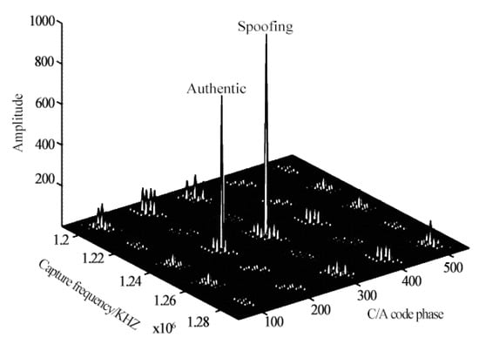

**Figure.** Spoofing attack in capture stage.

* Tracking-phase spoofing

When the receiver finishes locking the signal and enters the tracking stage, the receiver will no longer carry out fuzzy search over a large range as in the capture stage. If the carrier frequency and code phase of the spoofing signal are not aligned with the real signal, even a strong spoofing signal cannot easily affect the normal tracking of the receiver, so it is difficult to achieve the goal of spoofing. At this time, the synchronization of code phase and carrier frequency must be considered. The feasible method is to realize the traction of the tracking loop of the target receiver by sliding-step self-synchronization. It is worth mentioning that this can also be called the gradual self-synchronization spoofing method.

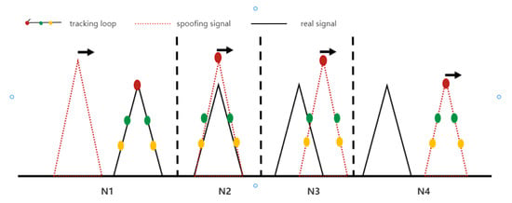

**Figure.** Schematic diagram of sliding self-synchronization mode of spoofing attack in tracking stage. N1: Align the phase of the spoofing signal number with the real signal; N2: Carrier ring of control receiver; N3: Introduce code phase change to spoofing signal; N4: Properly reduce the power of spoofing signal and complete the tracking loop control of receiver.

*4.3. Traditional Classification of Spoofing Types Based on Priori Knowledge*

* CS Spoofing starts before acquisition and the receiver has no a priori knowledge: This situation occurs after a receiver is switched on (cold start). It provides a maximum of options to the spoofer who wants the receiver to capture his signal first. The receiver cannot distinguish the spoofer’s signal from an authentic GNSS signal unless the signal is somehow authenticated. The receiver’s clock might have drifted substantially and the position might be completely different at power-up than it was at power-down.
* Ra Spoofing starts before acquisition but the receiver has a priori knowledge: This occurs if the receiver has lost one or all satellites for a short while, or acquires satellites that have newly raised above the horizon. Snap-shot receivers are in this situation for every estimate that they perform once they have prior knowledge. In all these cases, the spoofer has to be aware that the receiver combines knowledge about its state, the environment, and their evolution to detect spoofer activity. Changes that a receiver might analyze against models include position, clockoffsets, and atmospheric delays.
* Tr Spoofing during tracking: This is the most demanding situation for the spoofer, since the signals now have to change in a manner compatible with the detailed physical movement of the receiver, as well as with the changes in its environment. Vector tracking can be used to further harden the receiver in this state. The above description provides a characterization with respect to the relative timing of spoofing and acquisition.

The naming of these states is CS for “Cold Start,” Ra for “Reacquisition,” and Tr for “Tracking.” The first situation, i.e., “Cold Start,” gives the largest freedom to the spoofer. The last situation, “Tracking” (Tr), is easiest to defend by the receiver. The spoofer might thus aim at provoking a “Reacquisition” by jamming the receiver before initiating the spoofing procedure. Although such jamming creates a signature, the latter signature could also have a natural cause. If the target receiver uses this signature as a sole trigger for detecting the spoofer, this might reduce service availability to an unacceptably low level. The spoofer has the final option to willingly cause a denial of service if he feels that he cannot deceive the receiver otherwise.

*4.4. New Classification of Spoofing Types Based on Spoofing Strategies*

With the development of anti-spoofing technology, spoofing attacks are no longer carried out in a single way; rather, they have become gradually diversified and complex. In some papers there are some proposes that a new classification method by analyzing the spoofing strategies taken by attackers to achieve their goals. The new classification method puts forward three new classification indexes.

* Self-consistent spoofing

Self-consistent spoofing is generally used to cheat the traditional RAIM strategy of considering pseudo range residuals. This method provides the desired position/timing for the potentially deceived receiver by synthesizing the false code phase and maintaining a small pseudo-range residual. In this method, the calculation required in the phase stage of synthesizing error code is very simple. The change of the false beat carrier phase is usually designed to be consistent with the phase of the false deception code. Otherwise, the potentially deceived receiver may issue a warning due to unusual C/A differences or may lose the lock on the spoofing signal.

The main difficulty of self-consistent spoofing is how to induce the potentially deceived receiver to lock the false signal it provides. There are two main ways to achieve this goal.

The first is to interfere with the victims, destroy their original normal signal acquisition and induce them to try to obtain a new signal. If the deception signal power is significantly stronger than the real signal power, the receiver will most likely lock onto the deception signal during signal re-acquisition. Another method is to send false signals from low power to make them code match and Doppler match with the real signal at the position of the victim receiver antenna. The power of deception starts low and then increases until it is sufficient to capture the tracking loop. Finally, the deceiver completes the deception of the coding phase and carrier phase to the deceived receiver in a self-consistent way.

* Signal estimation and replay spoofing

The deception method described in self-consistent spoofing must recreate the spread spectrum code  to be transmitted and the data bit stream  to be transmitted. If they are completely predictable, they are easy to synthesize. However, the enhanced civil GNSS signal will adopt orthogonal modulation and protect the unpredictable part of the short segment in the spread spectrum code .

In this case, one of the choices of the deceiver is signal interference. The signal jammer records the real GNSS signal as in a conventional receiver and replays the signal through a transmitter with sufficient gain to drown the real signal on the antenna of the victim receiver. The deceiver may deceive any GNSS signal, even encrypted military signals.

If the unpredictable part of the signal is only in the low-rate bit, it is possible to complete deception without interference. Instead, spoofers can use a secure code estimation and replay (SCER) attack: spoofers estimate unpredictable bits and broadcast them immediately after obtaining reliable estimates. Before broadcasting them, it can broadcast random guesses of these bits or its own best estimates.

* Advanced-form spoofing

Nowadays, with the continuous advancement of the research works of various spoofing defense technologies, the means of spoofing are also improving daily. An advanced technique is called zeroing. The spoofer sends two signals for each spoofing signal. One is the spoofing signal, which works in conjunction with all other spoofing signals to cause incorrect location/timing positioning. The other is the negative value of the real signal, which is used to cancel the real signal at the receiver. The zeroing attack will delete all traces of the real signal. However, the principle of many current defense measures is to look for signs that two signals from the same satellite are received. They may look for different signals with sufficient spread between their coding phases or carrier Doppler shifts. Alternatively, they may look for interfering signals with similar code phase and carrier Doppler shift. In either case, clearing will eliminate all signs of duplicate signals, and defense measures relying on these signs will not be able to detect such attacks.

The other is used to combat advanced spoofing with multiple-antenna victim receivers. This method generally uses multiple independent spoofing transmitting antennas and matches each antenna to the corresponding receiver antenna. Moreover, the deceiver must be close enough to the victim, and the gain pattern of each antenna must be obtained and reduced sufficiently so that each victim antenna receives only the signal from the deceiver antenna. This technology will enable the deceiver to control the difference between the beat carrier phase of each spoofing signal received at different antennas of the victim receiver in the time axis.

These and other high-level forms of spoofing usually do not change the location or time of the victim too quickly. Otherwise, the victim can identify the attack through physical properties. For example, an inertial measurement unit (IMU) can be used as a physical anti-spoofing detection, which further limits the possible growth rate of deception navigation. If the growth rate is too high to be suspected, the conventional IMU drift level cannot be used to explain this anomaly. The same is true of the increase in the clock offset of the victim receiver.

**PRACTICAL DIFFICULTIES OF SPOOFING**

Covert operations

Knowledge of the exact location of the relevant antenna and make and model of the GNSS receiver it is connected to, and its spoofability, would be essential for the attackto have any realistic chance of success. If an off-the-shelf simulator was chosen, police forces could use the record of purchase to track down the offender if the attack was detected. Thiscould result from simultaneous disruption of mobile GNSS services in the vicinity, through mobile jamming detectors, or through direct detection by sensor networks.

Inverse square law

One of the major problems faced by the would-be spoofer is the simple inverse square

law:

Where is the transmitted power, the received power, and d the distance between the receiving and transmitting antennas. As the distance between spoofer and target varies even by a small amount, for example, when spooﬁng a navigation receiver in a vehicle, the received signal strength varies more widely, in accordance with the term. As a result the spoofer must either maintain a precise distance to the target or vary signal strength to compensate. Otherwise, the receiver may detect the unexpectedly strong signal and report loss of lock, or will fall back onto the legitimate signals. In either case the spoofer would have to start all over again, but would not know that the attack had failed. The signals from legitimate satellites also vary with the inverse square law, but their distance from the receiver doesn’t vary signiﬁcantly for distances of several kilometres on the earth’s surface, but such variations make a very big difference in the spooﬁng case because the transmitter and receiver are much closer together. Some of the variations that do occur in the legitimate signals depend on known factors such as satellite elevation, but received power can also vary by as much as ±6dbW due to the orientation of the transmitting antenna and changes in altitude of the SV. All of the cited spooﬁng experiments carried out in the laboratory have emphasized this need for closely controlling signal strength for a spooﬁng attack to succeed.

Moving targets

One consequence of the inverse square law is the difﬁculty of spooﬁng a moving target such as a ship, aeroplane or car. In order to maintain correct signal strength it would be necessary for the spoofer also to be moving with the target. Similarly, in order to spoof a truck’s navigation system, Warner had to follow 15 feet behind the target truck after ﬁrst disabling the its GPS satellite lock and establishing a fake one at close proximity for several minutes. Kerns notes the need for accurate tracking of aircraft for spooﬁng to succeed, requiring the use of the aircraft’s own ADS-B broadcasts. Jafarnia and Wesson note that for a synchronous spooﬁng attack (the precise alignment of the legitimate and spoofed PRN sequences) to avoid detection through the vestigal signal defense requires precise “centimetre level knowledge” of the position of the spoofer in relation to its target. Ideally, a spooﬁng device needs to be either physically on the receiving antenna or at a ﬁxed distance from it. Although these were experiments, or theoretical scenarios, these kinds of limitations make the remote spooﬁng of vehicles very difﬁcult in many cases, and in the case of ground-based vehicles jamming is often easier, more reliable and far cheaper.

Direct line of sight

The most common GNSS signals are transmitted around 1.5 GHz (GPS L1, etc.), which has a wavelength of just 20cm. As a result, GNSS signals do not bend much around obstacles. Hence a spoofer would have to be in direct line of sight with the target’s antenna. Aircraft are already considered immune from ground-based GNSS interference when in ﬂight, because of the shielding effect of the aircraft underside, while the antenna is typically situated on the top of the aircraft. Terrestrial broadcasting of spooﬁng signals inside a city or in uneven terrain would also likely fail because of shielding from buildings and hills.

**Overview of Anti-Spoofing Technology**

*5.1.* **Power detection technology**

When the receiver was on the ground, the received satellite signal power was generally below the maximum power. Without occlusion, the received signal power level is low. For example, the maximum receiving power of GPS signal will not exceed -150dBW, and the receiving power of L1, L2 and L5 frequency points was generally between -150dBW and - 162dBW. Deception attack made the receiver to capture and track deceptive signals incorrectly, and the deceptive signal power was generally larger than the real signal power, so that deceptive signals can be detected and identified by limiting the signal power through a reasonable power upper limit. Signal power can be measured by capturing peak value, tracking correlation value and carrier-to-noise ratio. However, not only signal power, but also interference and noise power affected the above three detection statistics. Acquisition was a two-dimensional search procedure for PN phase and carrier frequency of GNSS satellite signal for a specific PRN number. The acquisition peak value was the correlation between the GNSS spatial signal and the aligned local signal, and its peak value reflected the signal power and noise power. Therefore, the acquisition peak spoofing detection algorithm can be formed. For the tracking correlation value of I and Q branch, which reflected the signal power and noise power. Therefore, the tracking correlation value spoofing detection algorithm can be formed. Carrier-to-noise ratio (C/N0) reflected the relationship between signal power and noise power, and was an important index to describe the signal quality of receivers. The correlation signal power was mainly reflected in the I branch and the correlation noise power was mainly reflected in the Q branch. Carrier-to-noise ratio (C/N0) was usually determined by the correlation values of I and Q paths. Because the carrierto-noise ratio of GNSS satellite signal was affected by the correlation between noise and other jamming signals, the carrier-to-noise ratio (C/N0) deception detection algorithm can be formed by using the distribution of carrier-to-noise ratio (C/N0) of GNSS satellite signal under receiving noise.

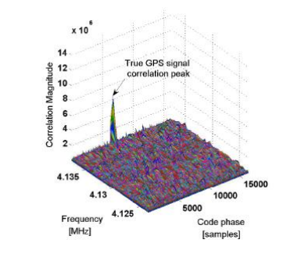 the correlation peaks without jamming

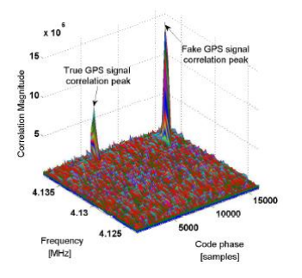 the correlation peaks with jamming

*5.2. Anti-Spoofing Technology Based on Encryption*

Such technologies use encryption to create unpredictable parts of the transmission signal that make it difficult for the deceiver to make the above estimation and replay the deception. The strongest defense measure is to encrypt the whole extension code  with a symmetric key.

One method is to use symmetric encryption. A GNSS signal encrypted with a symmetric key can be used to detect spoofing in a civil GNSS receiver without accessing the private key. It is not necessary to distribute the key to the civil receiver, but it can use the known relationship between the open civil extension code and the encrypted military code. In GNSS, they are quadrature modulated on the same carrier. Under this method, the receiver uses its civil code tracking system to record the noisy baseband version of encryption coding. This is done on a potential victim receiver and another receiver that can prevent spoofing. The two noisy versions of the encrypted code are then interacted to find the correlation peak that will exist if the signal in the potential victim is real. If the correlation peak is very high, it indicates that the signal is true; otherwise, an alarm will be issued. However, this needs a secure receiver network to generate a noisy “real” version of the encrypted code. It also requires a secure communication network to bring real and unverified versions of the encrypted code to a common signal processing unit that can check the correlation. The purpose of this is to check the authenticity of the signal.

Another method is to use delayed symmetric key encryption. In the spreading code, the short segment of the symmetrically encrypted spread spectrum security code (SSSC) is interleaved with the long segment of the predictable spreading code. The receiver uses the known part to track the signal and records the unknown part. Shortly after the unpredictable SSSC is broadcast, bitstream data containing the key arrives, which can be used to generate the SSSC. The key is digitally signed, so it can be reliably traced back to the relevant GNSS control segment. After verification, the key is used to synthesize the unknown spreading code, and the receiver associates the code with its recorded signal part to verify the authenticity of the signal. However, the technology using this method will involve a large number of detection delays when waiting for a complete digital signature, which may take a few seconds to a few minutes.

The third method is asymmetric private/public key navigation message authentication (NMA). A subset of the broadcast data stream  contains an unpredictable digital signature generated using the private key of the control segment. This signature signs the rest of the data in . The receiver knows the position of these bits in the demodulated data stream. It collects all the numbers needed to check the signature and verifies it with a known public key. The implementation of a delayed symmetric key SSSC method and asymmetric private key/public key NMA method are needed to modify the satellite signal. This is difficult or impossible for existing GNSS satellites and expensive for future satellites.

*5.3. Anti-Spoofing Technology Based on Drift*

Drift-based anti-spoofing technologies aim to find abnormal changes in receiver position or clock. If spoofing causes the receiver clock error to change too fast, the victim receiver can detect that the clock drift rate is greater than a reasonable value of its oscillator category. IMU or other motion sensors can impose similar constraints on the reasonable drift rate of the position. Similarly, the rolling constraint of the vehicle and its known maximum values of speed, acceleration and turn rate can be used to check whether there is excessive drift. As with clock drift, if an untrue motion track is detected, the receiver will issue a deception alarm. However, the deceiver can avoid being detected by the drift detection method by slowly establishing the wrong clock offset and wrong position.

*5.4. Anti-Spoofing Technology Based on Signal/Geographical Location*

Signal location techniques monitor the direction of arrival of the signal by considering the received beat carrier phase. The receiver can use interferometry by using three or more different antennas to sense Δd(t) offsets or by using the direction of arrival vector as measured by a single antenna’s Δd(t)motion curve.

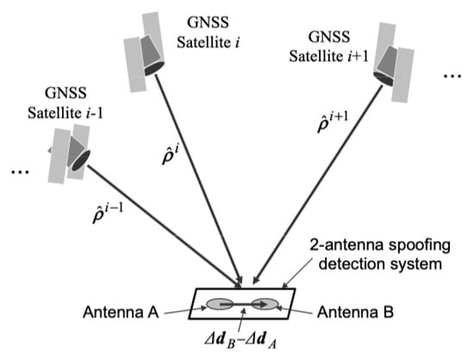

**Figure.** Schematic diagram of interferometry model.

*5.5. Complementary Strategy of Multiple Anti-Spoofing Technologies*

At present, in order to avoid the likelihood of the target detecting the attack to the greatest extent, spoofers usually use a complex attack method combining multiple spoofing strategies rather than a single method. Based on this situation, it is a relevent yet difficult point for researchers to develop more effective detection methods that can adapt to complex spoofing scenes.

For example, one of the combination strategies is that the spoofer can choose to use a higher carrier amplitude to avoid the obvious distortion of complex correlation function in the process of drag off. If the defense object checks the complex correlation at many stages when implementing received power monitoring (RPM), which views the total received power in absolute proportion, it can detect the beginning of the attack, regardless of how much power the spoofer uses. If the clock offset drift rate and position drift rate are also monitored, the spoofer will be forced to perform a slow drag-off operation so that the receiver has more time to detect the distortion of the complex correlation function or the high received power level.

Another combination strategy is to use the unpredictable data bits of NMA to monitor the distortion of those bits, plus IMU and clock drift monitoring. IMU and clock drift monitoring will force spoofer to launch attacks slowly. This restriction will prevent the formation of dangerous position or timing errors in the latency of NMA-based spoofing detection. If the spoofer implements an SCER attack to estimate and replay unpredictable NMA bits, the victim will be able to detect the initial uncertainty of these bits. Because clock-drift monitoring will limit the initial ability of the spoofer to use the delay, this will allow a reliable estimation of the bits before starting the broadcast.

**Example of spoofing**

**RQ-170**

On 4 December 2011, Iran announced the capture of a U.S. stealth unmanned reconnaissance aircraft RQ-170. A participating Iranian engineer said they took advantage of the weakness of the UAV navigation system. First, through interference, they shielded the communication link of the UAV, cut off its connection with the ground command and control center, and cut off the data connection with the GNSS satellite, forcing the UAV to enter automatic driving state. Then, they sent navigation spoofing signals and reconstructed the coordinates of the GNSS. By such means, they induced the drone to land in the Tabas desert area of Iran, 140 km away from the U.S. military base, but the drone mistakenly thought it was landing at the U.S. military base designated by the U.S. military.

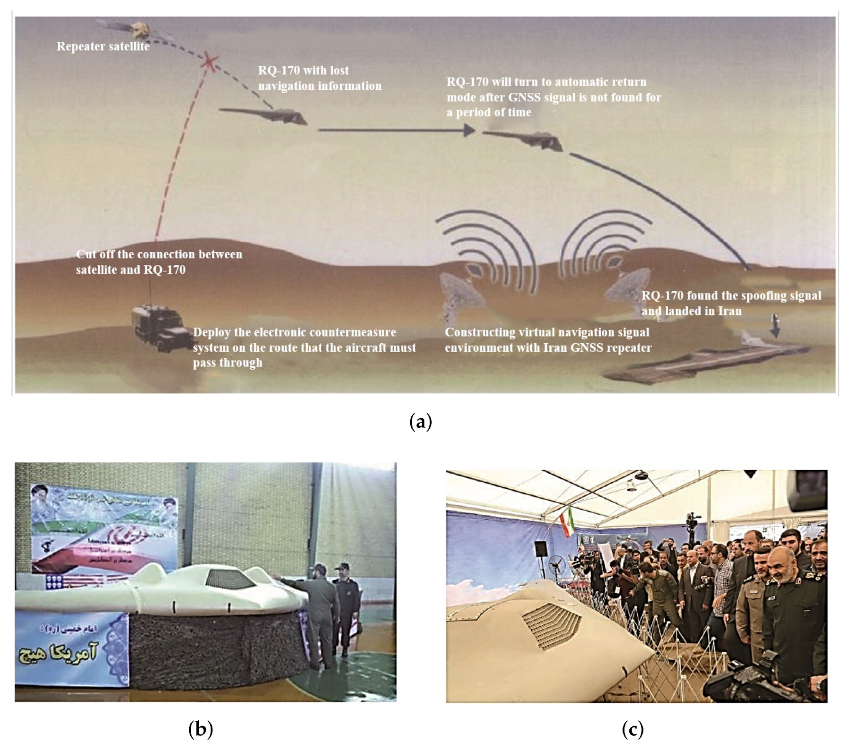

**The technology behind this attack**

SkyGrabber is a software application designed to intercept satellite signals for personal use. It is commonly used to capture digital satellite television or internet signals, and it can be purchased online for a relatively low cost. The software can be installed on a computer, and with the use of additional hardware, it can intercept and decrypt satellite signals. However, SkyGrabber has also been used for illegal purposes, such as intercepting sensitive military and government communications. In some cases, it has been used by terrorist organizations to monitor and intercept sensitive information. Because of its potential for misuse, some countries have banned the sale and use of SkyGrabber. Also it is not officially reported that SkyGrabber used in RQ-170 attack but in some resources we can find this information.

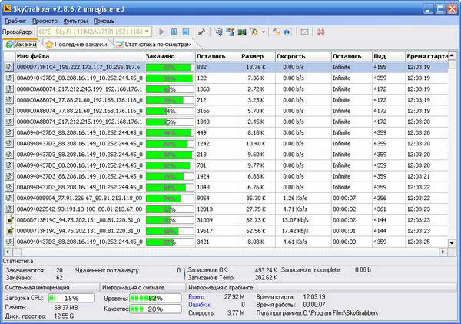

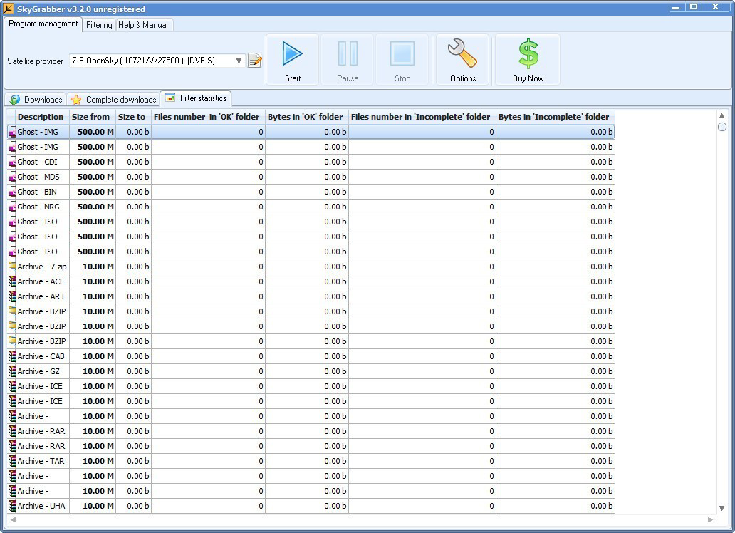

**JAMMING**

When a GNSS tracking device is jammed, most devices report their last known location, rather than raise an alarm. Loss of lock can occur for legitimate reasons such as when a vehicle goes through a tunnel or in heavily built-up areas. In such cases, sending an alarm signal would be more of an annoyance than help as it happens so often. However, this weakness can also be exploited by attackers to falsify the where abouts of a truck carrying valuable cargo, as reported by Economist in 2011 and ABC in 2013. This can have a significant impact on vehicles in the vicinity, including emergency vehicles. Therefore, it is important to have appropriate security measures in place to prevent such attacks. The two forms of satellite jamming are “orbital” and “terrestrial”:

* In orbital jamming, the attacker sends a beam of contradictory signals directly toward a satellite via a rogue uplink station. The jamming signals are mixed with the legitimate signals, thus interfering with them. The jamming signals are able to override the legitimate transmission, blocking its transmission to the recipient.

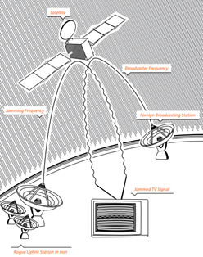

In terrestrial jamming, the attacker transmits rogue frequencies in the direction of terrestrial targets (ground satellite dishes). Rather than targeting the satellite itself, as is the case in orbital jamming, terrestrial jamming involves transmitting rogue frequencies in the direction of local consumer-level satellite dishes. The jamming frequencies are limited to a specific area and are able to interfere only with the frequency emanating from the satellite in a specific location. Small, portable terrestrial jammers are easy to purchase and use; they typically have a range of 3-5 kilometers in urban areas, while in rural areas their range can increase to up to 20 kilometers.

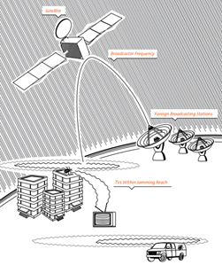

**Uplink Jamming**

Uplink jamming against a payload signal is an attractive electronic attack strategy because all recipients of the target transmission are affected. The jamming uplink signal is a radio frequency (RF) signal of approximately the same frequency as the target uplink signal. It is transmitted up to the satellite onto the same transponder as the target signal and affects the transponder’s ability to distinguish the true signal from the jamming signal. Note that the target uplink source and signal are not affected; the inability of the satellite’s transponder to distinguish between the signals results in a loss of downlink or corrupted downlink. The effectiveness of uplink jamming is extremely dependent on obtaining detailed information on the target signal. This can be done through formal signals intelligence (SIGINT) processes or (in some cases) open-source intelligence (OSINT) research. Once this is gathered and analyzed, the uplink jamming source must be able to acquire the proper satellite and transponder, as well as produce a signal with the correct characteristics andpower necessary to overcome the signal to be jammed. Targets of uplink jammers are the satellites’ radio receivers, including their sensors and command receivers. Uplink jamming is more difficult, since considerable jammer transmitter power is required. However, its effects may be global, since the satellite or space system could be impaired for all users.

**Downlink Jamming**

There are two main targets for downlink jamming: SATCOM broadcasts and navigation satellite (NAVSAT) broadcasts. In a downlink jamming scenario, the objective of the elctronic attack is to disrupt or temporarily keep the spacecraft’s transmission (communication or navigation signal) from being received by select ground users. A downlink jamming system accomplishes this by broadcasting an RF signal of approximately the same frequency as the targeted downlink signal but with more power. This jamming signal is transmitted toward a terrestrial (ground-based) or airborne satellite downlink reception antenna where it overpowers the satellite’s signal. With smart jamming (vicebruteforce jamming), the jamming signal attempts to emulate the satellite’s signal and, if successful, can provide the targeted user with false data or information. The effectiveness ofdownlink jamming is dependent upon the jammer being able to operate within line of sight (LOS) of the ground site and within the field of view of the ground site’s antenna; effectiveness is also dependent upon the jamming signal being processed by the SATCOM receiver. LOS restrictions can be overcome to a degree by utilizing an airborne platform; the altitude gained by the airborne platform expands the coverage and aids in overcoming ground-based obstacles. It is difficult toassess the effectiveness of downlink jamming as this normally requires monitoring the output ofthe targeted receiver (often not possible). The targets of downlink jammers are ground-based satellite data receivers, ranging from large, fixed ground sites to handheld GPS user sets. Downlink jamming only requires a very low-power jammer, though its effects are local (from tens to hundreds of miles, depending on the power ofboth the jammer and downlink signal). Since downlink telemetry contains the mission informationand health and status information, successfully attacking the downlink directly attacks informationflow and, therefore, has a more immediate effect on denying or disrupting the satellite’s mission Sophisticated technologies for jamming satellite signals are emerging.

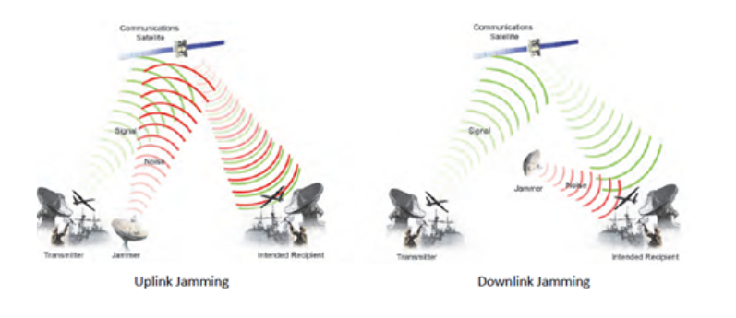

**An experience of spoofing**

BladeRF and GPS-SDR-SIM are GPS SDR applications that can be used to generate GPS signals for testing and research purposes. By using these tools, researchers can send out fake GPS data which generated from Matlab. In this example we have specified geographical location: latitude 39.9813, longitude 116.4841, and altitude 100 m. PRN: 8, 14, 25, 31 and 32 are part of the signals of 5 satellites. With this basic process we can distort the location and time information of the devices.

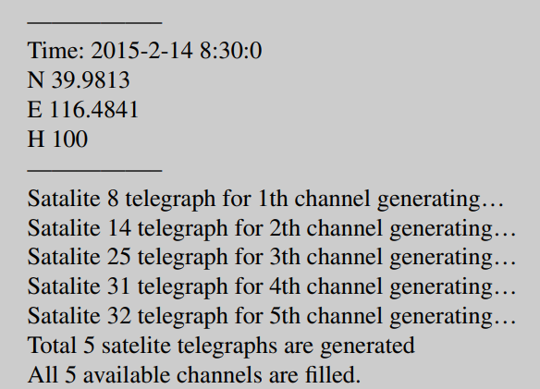

Various experiments have been conducted using different devices, such as phones, cars, dual-mode positioning chips, drones, and others, to test the accuracy and effectiveness of these tools. For example, experiments have shown that a car parked in a parking lot in China can be made to appear as if it is in the middle of an ocean in another country. Similarly, drones can be made to appear as if they are flying in restricted areas where they are actually not allowed to fly.

These experiments demonstrate the potential for GPS spoofing attacks, where false GPS signals are generated to deceive GPS receivers and manipulate their behavior. It highlights the need for improved GPS signal authentication and security measures to prevent such attacks from occurring.

**COUNTERMEASURES**

6.1. Signal processing based defenses

There are several stages to signal processing by a digital GNSS receiver before the navigation and time solutions can be computed. The incoming analog RF signal from the antenna is ﬁrst ampliﬁed, then down-converted toa lower frequency, and its signal strength adjusted via AGC (automatic gain control). After digital conversion, a replica PRN code, plus the computed Doppler shift (caused by the relative motion of the receiver and the satellite vehicle), is used to separate the individual satellite signals. The digital data of the individual channels, including their in-phase (I) and quadrature (Q) components is then available for computing the navigation and time solutions. As discussed in the following sections, at various stages in this process it is possible to monitor the acquisition and tracking of signals for anomalies that may indicate a spooﬁng attack is in progress. These approaches differ from cryptographic and physical defences, in that they do not require physical modiﬁcations to existing equipment or signal protocols, but only the updating of the device ﬁrmware.

6.1.1. RAIM

Receiver autonomous integrity monitoring (RAIM) is the oldest and mostwidely used anti-spooﬁng strategy in GNSS receivers. This checks all available GNSS signals for spatial consistency, and can exclude aberrant satellites. For example, the ephemeris data predicts the location of satellites in advance, and should closely agree with their reported positionin the navigation message and external sources. In the case of au-thentic signals, the frequency changes due to the Doppler effect, and the PRN codeis delayed to maintain signal lock. A low quality spoofer might not be able to keepthis correlation. Another RAIM-like check is for clockconsistency between times of other satellites not currently being tracked. The basic weakness of RAIM is that it assumes any spooﬁng attack will be conﬁned to one or two aberrant satellites, not an entire constellation. The owner of a timer also has no detailed knowledge of which sanity checks are performed, and hence cannot assess the degree of protection they provide.

6.1.2. Absolute Power.

Absolute power monitoring involves monitoring the received signal strength (RSS) versus expected signal levels. Some researchers argues that using absolute power level rather than SNR considerably reduces receiver vulnerability to spooﬁng. However, signal levels vary due to atmospheric and solar interference. They may also be changed by the AGC in the receiver (unless the changes are detected in the AGC controller itself), and only moderately increased signals levels of +1-2dB are required to executea “lift”. Also, the risk of false alarms would be a serious problem for this technique, which would be therefore limited to detecting only highly elevated signals.

6.1.3. Doppler shift detection. Due to satellites’ high orbital speeds relative to a receiver, the Doppler effect: the shortening of wavelengths when moving towards, or lengthening when moving away, induces detectable effects in the received frequency of GNSS signals. These effects are normally corrected for in the receiver, and vary in a predictable way for each satellite. Hence a defence based on detecting anomalies in Doppler shift between real and simulated constellations, might be an effective spooﬁng detection technique. In the Volpe report [Volpe 2001] detection of such anomalies was listed as a defence, but it was also observed that simulators regularly provide controlover Doppler shift. However, such simulation might leave tell-tale traces that could beused as the basis for detection, even in the case of a sophisticated spoofer. There are identiﬁed two kinds of Doppler simulation: consistent Doppler attacks, where the spoofer keeps the code delay rate and frequency consistent with one another, and attack where the spoofer locks the Doppler frequency of the spooﬁng signal to that of the authentic signal. Both scenarios, however, leave strong traces of an attack such as ﬂuctuation in signal strength caused by interactions between the spoofed and authentic signals. This form of signal analysis, therefore, already tested in the laboratory by seeral researchers, seems one of the most promising detection techniques.

6.1.4. Correlation Peak Monitoring. Cavaleri investigated the feasibility of using this tech-nique as a means of spooﬁng detection. Under the name “vestigal signal defense” (VSD) it has also been evaluated. How-ever, authentic GNSS signals frequently suffer from multipath signals reﬂected offbuildings in a similar way to spoofed signals.

**Digital signatures**

Digital signatures can be used to add a layer of security to GPS transmissions and prevent spoofing attacks. In fact, the current GPS system already uses a form of digital signatures called the "Public Key Infrastructure" (PKI) to authenticate the signals from GPS satellites.

The extensible ephemeris messages (EEMs) that are transmitted by GPS satellites contain information about the satellite's orbit and clock corrections, which are used by GPS receivers to calculate their own positions. By adding digital signatures to these messages, it would be possible to verify that the messages are authentic and have not been tampered with by a spoofing attacker.

However, implementing digital signatures on a large scale would require significant changes to the current GPS infrastructure, including updates to both the GPS satellites and receivers. Additionally, digital signatures are not foolproof and can also be susceptible to attacks if the private key used for signing the messages is compromised. Therefore, a combination of different security measures would be necessary to effectively prevent spoofing attacks.

**Multi-mode Chips**

The normal positioning process is carried out by receiving signals from 4 satellites and calculating the intersection points of these signals. A multi-mode positioning device can perform position calculation by using signals from different satellite systems (GPS, Galileo, Beidou, etc.). When the positioning chip is multi-mode, we can determine the position by combining other systems supported by the chip in order to avoid fragility of single-mode positioning. Although it does not provide full protection against spoofing attacks alone, a multi-mode positioning chip is one of the measures that can be taken.

REFERENCES:

Dessiatnikoff, A., Deswarte, Y., Alata, E., & Nicomette, V. (2012). Potential Attacks on Onboard Aerospace Systems. IEEE Security & Privacy, 10(4), 71–74. doi:10.1109/msp.2012.104

Tedeschi, P., Sciancalepore, S., & Di Pietro, R. (2022). Satellite-based communications security: A survey of threats, solutions, and research challenges. *Computer Networks*, 109246.

Meng, L., Yang, L., Yang, W., & Zhang, L. (2022). A Survey of GNSS Spoofing and Anti-Spoofing Technology. *Remote Sensing*, *14*(19), 4826.

Bardin, J. (2013). Satellite cyber attack search and destroy. In *Computer and Information Security Handbook* (pp. 1173-1181). Morgan Kaufmann.

Yang, Q., & Huang, L. (2018). *Inside Radio: An Attack and Defense Guide* (pp. 1-369). Springer.

Schmidt, D., Radke, K., Camtepe, S., Foo, E., & Ren, M. (2016). A survey and analysis of the GNSS spoofing threat and countermeasures. *ACM Computing Surveys (CSUR)*, *48*(4), 1-31.

Kodheli, O., Lagunas, E., Maturo, N., Sharma, S. K., Shankar, B., Montoya, J. F. M., ... & Goussetis, G. (2020). Satellite communications in the new space era: A survey and future challenges. *IEEE Communications Surveys & Tutorials*, *23*(1), 70-109.

Santamarta, R. (2018). *Last call for SATCOM security*. Seattle, WA: IOActive.

|  |
| --- |

Santamarta, R. (2014). A wake-up call for satcom security. *Technical White Paper*.

Shuli, D., Taotao, Z., & Min, L. (2019, May). A GNSS Anti-Spoofing Technology Based on Power Detection. In *2019 IEEE 8th Joint International Information Technology and Artificial Intelligence Conference (ITAIC)* (pp. 1134-1137). IEEE.

Lohani, S., & Joshi, R. (2020, February). Satellite network security. In *2020 International Conference on Emerging Trends in Communication, Control and Computing (ICONC3)* (pp. 1-5). IEEE.

Zidan, J., Adegoke, E. I., Kampert, E., Birrell, S. A., Ford, C. R., & Higgins, M. D. (2020). GNSS vulnerabilities and existing solutions: A review of the literature. *IEEE Access*, *9*, 153960-153976.

Hudaib, A. A. Z. (2016). Satellite network hacking & security analysis. *International Journal of Computer Science and Security (IJCSS)*, *10*(1), 8.