**Compile Commands**

gcc -std=c99 -Wall -Werror worms.c -o worms.exe

There is also a Makefile which does the same thing.

**Code Logic**

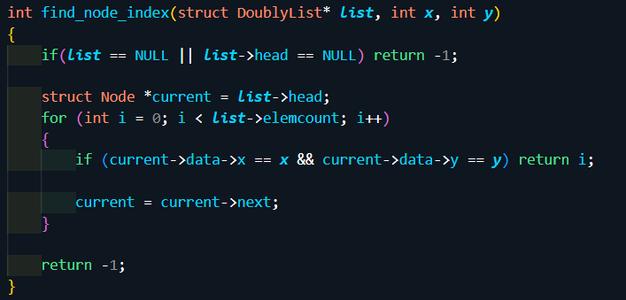

First of all, I created this helper method to get the Node indexes.

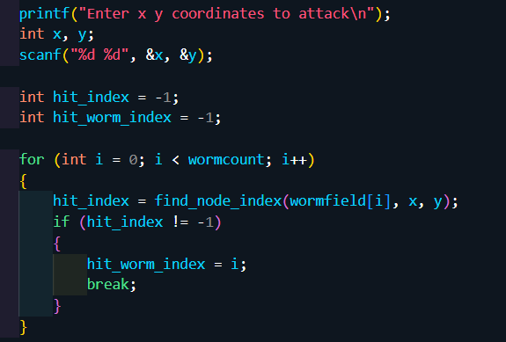

In here, I checked if any worm got hit and if it did where did it get hit and which one got hit.

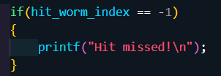

If it didn’t get hit, I printed this message.

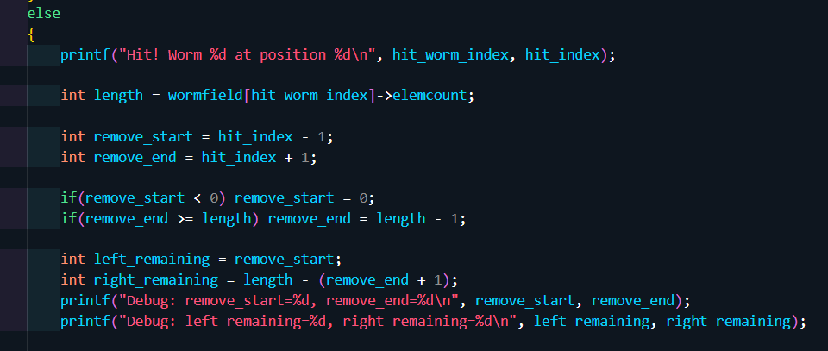

If it got hit, I printed the worm that got hit and the position. I calculated the positions to start and end removing from the worm, and the lengths of those.

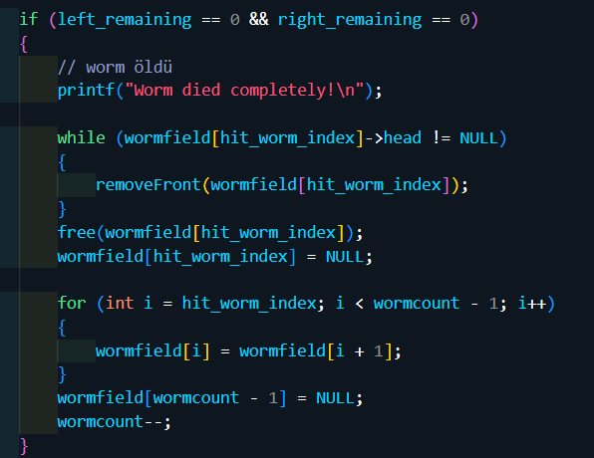

If neither the left or right part survived, I killed the worm.

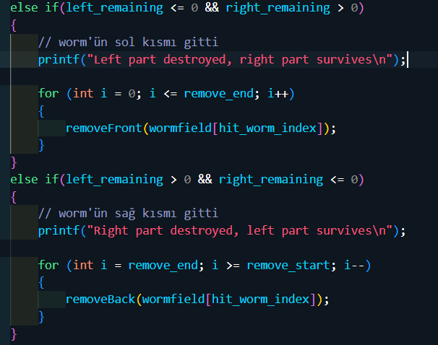

If either the left or right part got destroyed but the other part survived, I just removed the dead part.

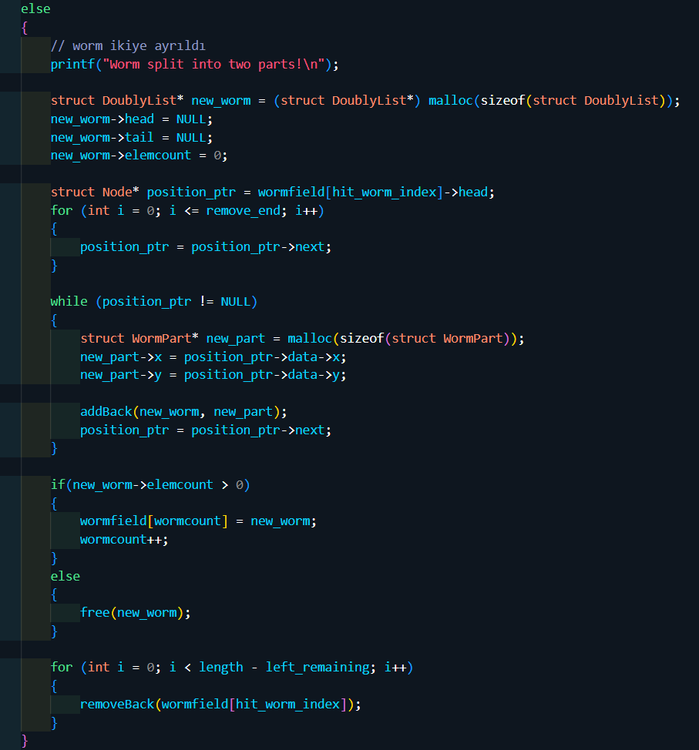

If it was none of the above cases, it meant that the worm will still have two parts, therefore it should be split in half. So I created the right part as a new worm, and removed every part starting from the first part that will be removed from the original worm, therefore I split the worm in half.