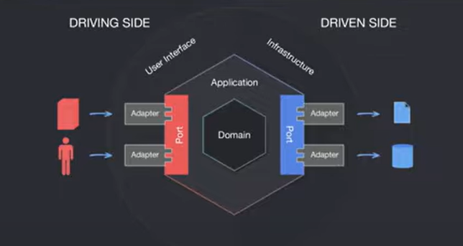

The class you provided is a good start for representing an order in the **Order Management Service**, but there are a few areas to consider for improvement and alignment with the specified functionality. Here's an analysis:

**Key Requirements**

1. **Verify Product Availability:** Interaction with the **Product Catalog Service** to fetch productPrice and productQuantity should be handled at the service or business logic level, not directly in the entity.
2. **Create Order Record:** The provided class represents the structure of the Order table in the database.

**Current Class Review**

**Strengths:**

* **Annotations for JPA**:
  + @Entity, @Id, and @GeneratedValue are correctly used.
* **Lombok Annotations**:
  + @Data, @AllArgsConstructor, and @NoArgsConstructor simplify boilerplate code.
* **Timestamp**:
  + @CreationTimestamp correctly captures when the order is created.

**Suggestions for Improvement:**

1. **Field Design**:
   * productName, productPrice, and productQuantity are all coming from the **Product Catalog Service**, which makes them more suitable for inclusion in an **OrderItem** class or DTO (Data Transfer Object) rather than the Order entity.
   * Consider making Order represent only **order-level details** (e.g., customerId, totalPrice, status).
2. **Structure**:
   * Introduce an **OrderItem** entity for better normalization and clarity. An order might have multiple products, so OrderItem can represent individual products within the order.

**Improved Design**

**Order Entity**

java

Copy code

package com.example.order_management_service.entity;

import jakarta.persistence.*;

import lombok.AllArgsConstructor;

import lombok.Data;

import lombok.NoArgsConstructor;

import org.hibernate.annotations.CreationTimestamp;

import java.time.LocalDateTime;

import java.util.List;

@Entity

@Data

@AllArgsConstructor

@NoArgsConstructor

public class Order {

@Id

@GeneratedValue(strategy = GenerationType.IDENTITY)

private Long orderId;

private Long customerId; // Assuming orders are associated with a customer.

private Double totalPrice;

private String status; // e.g., "Pending", "Completed", "Cancelled".

@OneToMany(mappedBy = "order", cascade = CascadeType.ALL, fetch = FetchType.LAZY)

private List<OrderItem> items;

@CreationTimestamp

private LocalDateTime createdDate;

}

**OrderItem Entity**

java

Copy code

package com.example.order_management_service.entity;

import jakarta.persistence.*;

import lombok.AllArgsConstructor;

import lombok.Data;

import lombok.NoArgsConstructor;

@Entity

@Data

@AllArgsConstructor

@NoArgsConstructor

public class OrderItem {

@Id

@GeneratedValue(strategy = GenerationType.IDENTITY)

private Long id;

private String productName;

private Double productPrice;

private Integer productQuantity;

@ManyToOne

@JoinColumn(name = "order_id", nullable = false)

private Order order;

}

• **customer-role-service**: Handles user authentication and assigns roles (e.g., ROLE_CUSTOMER, ROLE_ADMIN).

• **product-catalog-service**: Provides product-related endpoints, which need to be secured. Only authorized users (with specific roles) should access these endpoints.

• **customer-role-service** to issue JWT tokens with user roles after authentication.

• **product-catalog-service** to validate these JWT tokens and allow/deny access to its endpoints based on roles.