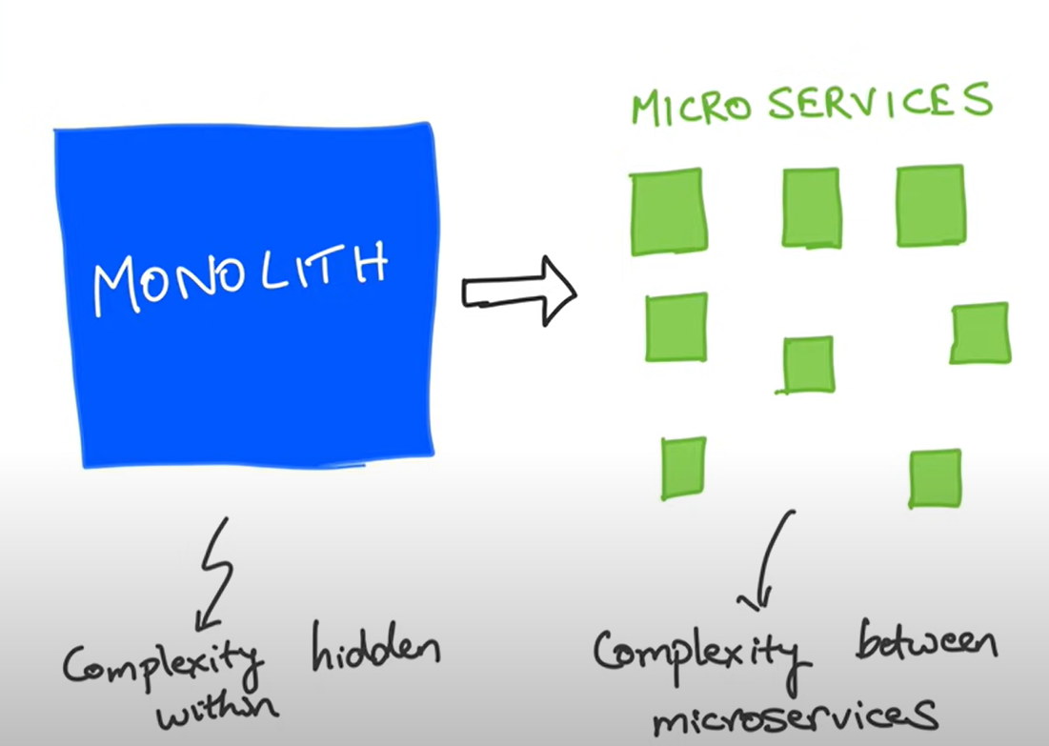

Returning object:

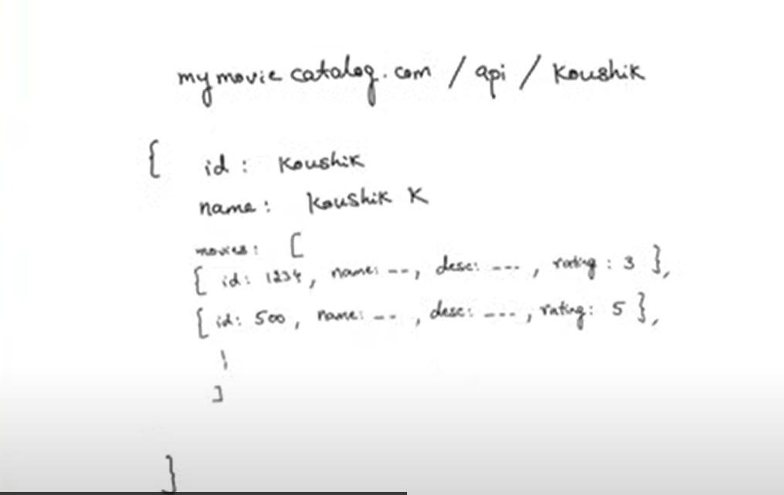

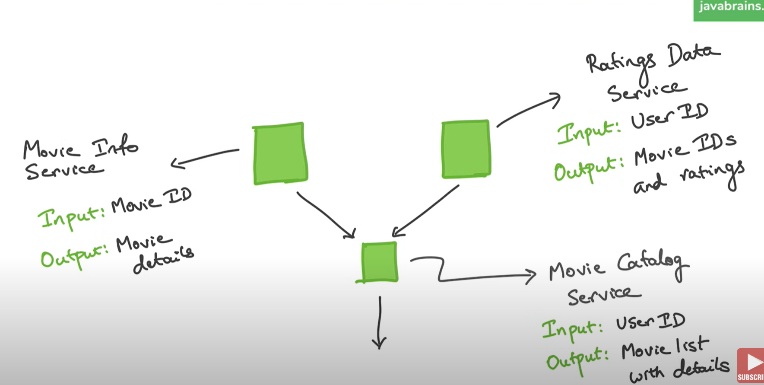

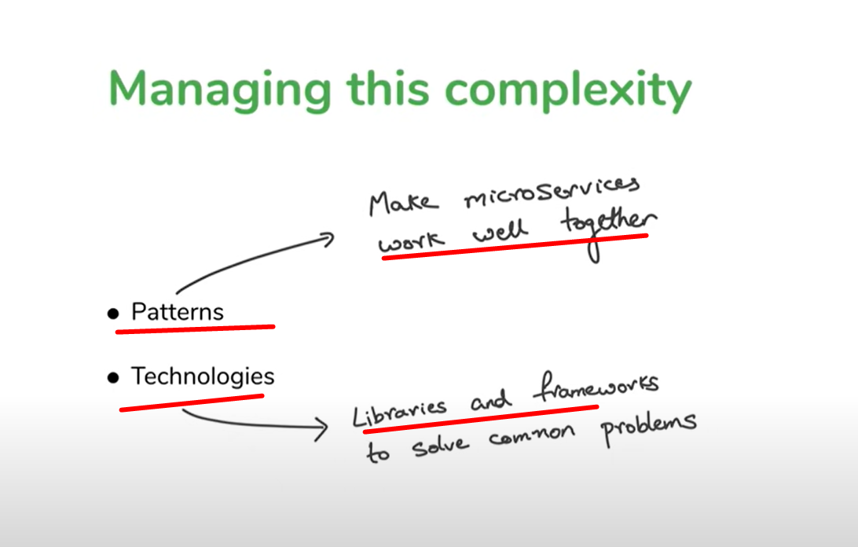

SOAP and REST are both ways for programs to communicate over the internet, but they work differently. Let me explain in simple terms:

**What They Have in Common**

* Both are used to allow systems (apps, websites, servers) to **talk to each other**.
* Both send and receive information over the internet using standard protocols like **HTTP**.
* Both use endpoints (URLs) as the address for sending requests and receiving responses

**Which One Should You Use?**

* **Choose SOAP** when:
  + Security and reliability are critical (e.g., banking, healthcare).
  + You need complex features like **transactions or sessions**.
* **Choose REST** when:
  + You want simplicity, speed, and flexibility.
  + You're building modern apps (e.g., web and mobile apps).

In summary:

* SOAP is like a **formal letter**: structured, detailed, and secure.
* REST is like a **text message**: quick, flexible, and easy to use.