**Project Design**

**CMSC 496 – 6380**

**Group 8**

**Robert Hunter Robinson**

**Jered Russell**

**Keith Tulloch**

**Program Name: Forget Me Not**

**Date of Revision: 9/15/2018**

**Revision Number: 1**

**Revision History**

|  |  |  |  |
| --- | --- | --- | --- |
| **Revision Number** | **Date** | **Description** | **Name** |
| 1 | 9/15/2018 | Add startup, shutdown, and normal scenarios | Keith |

**Event-trace diagrams:**

**Startup scenario:**

Description: open connection to database and prompt user for input

Precondition: system has adequate resources to run

Post-condition: connected to database; application awaits user input or change to current date

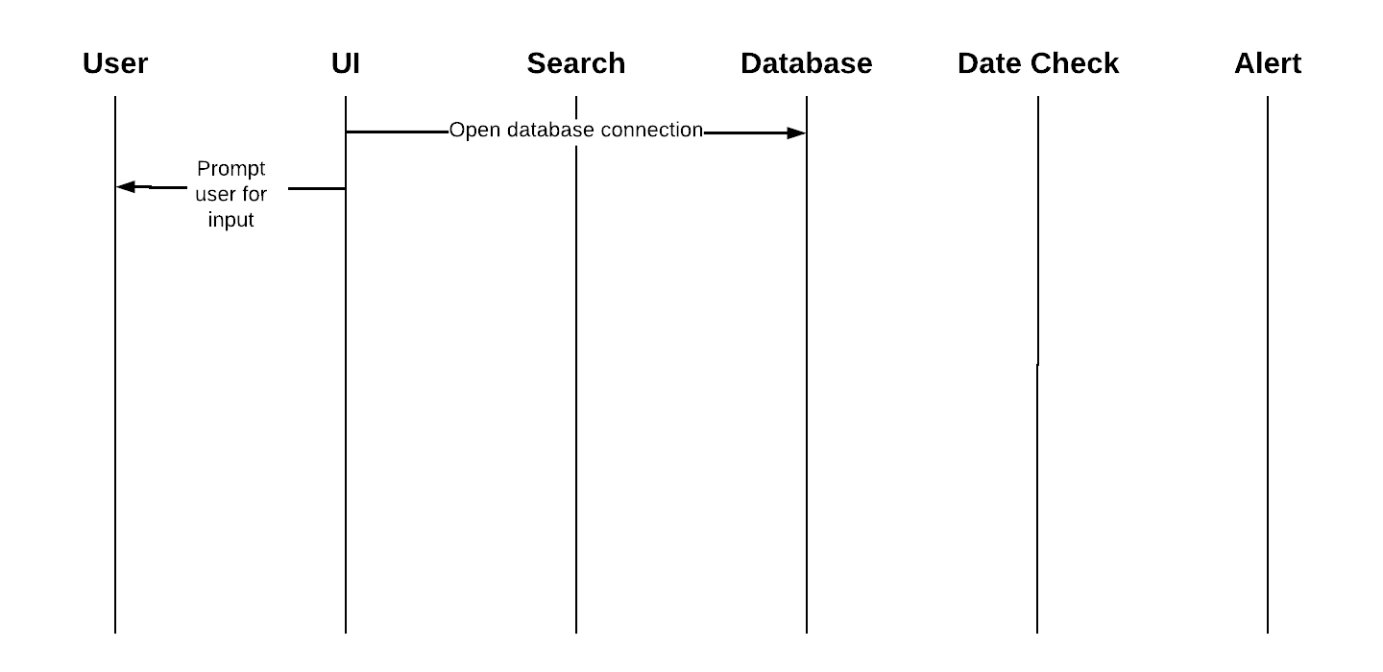

**Shutdown scenario:**

Description: display shutting down message; close connection to database

Precondition: application is running

Post-condition: database connection stopped; application closed

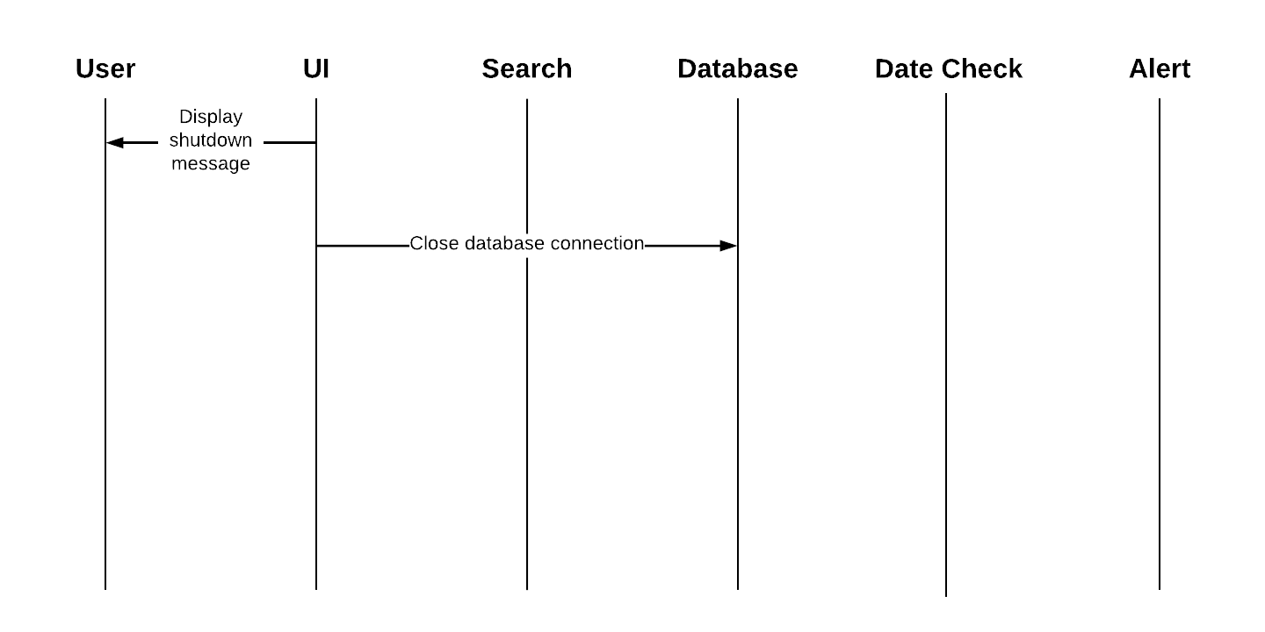

**Scenario 1:**

Description: the user adds a special date and relevant info to be stored in database

Precondition: application is running; connection to database

Post-condition: entry is added to database

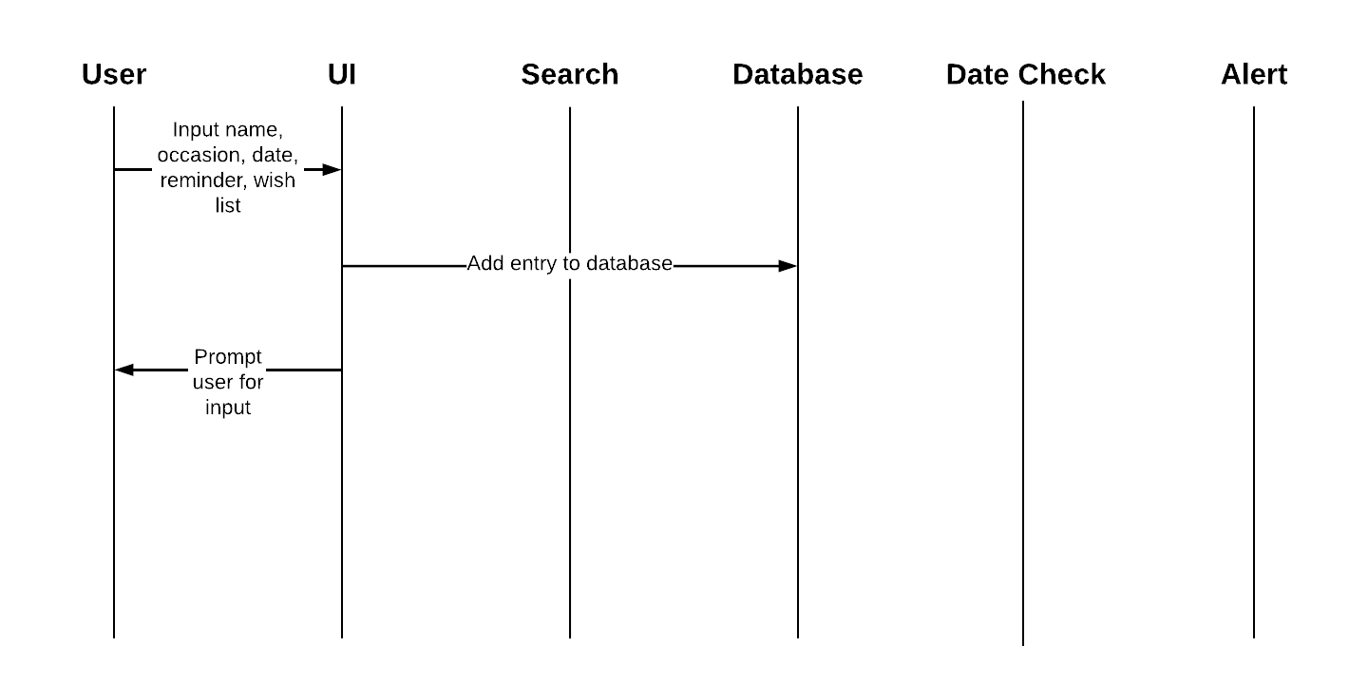

**Scenario 2:**

Description: the user searches for a special date previously added to database by name

Precondition: application is running; connection to database

Post-condition: entries matching the name are displayed to user

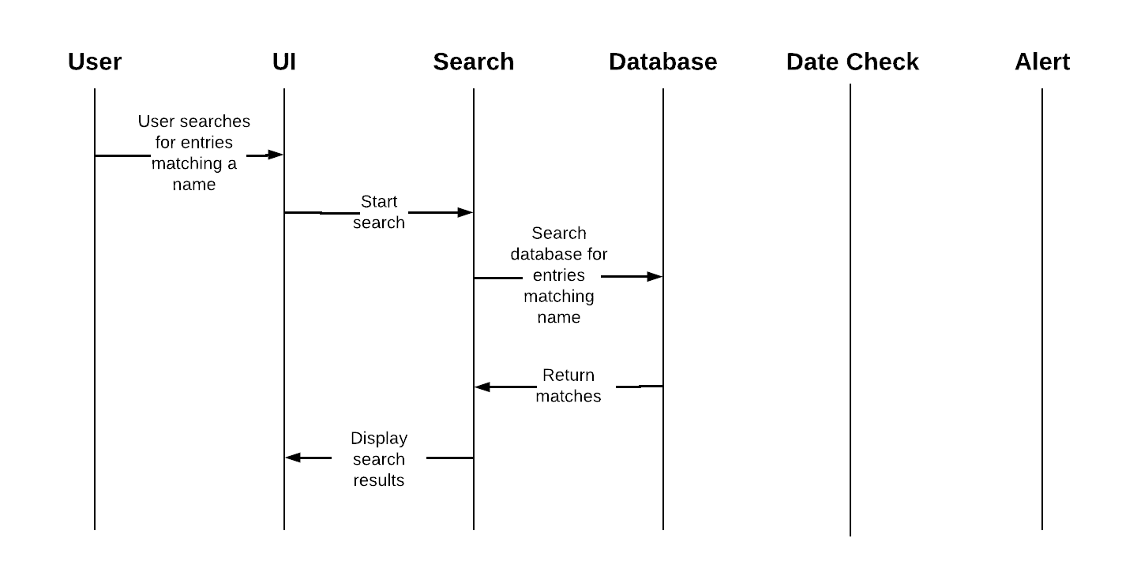

**Scenario 3:**

Description: system running on or near a day that has a saved occasion

Precondition: application is running; connection to database

Post-condition: user notified of any upcoming occasions and/or events on current date

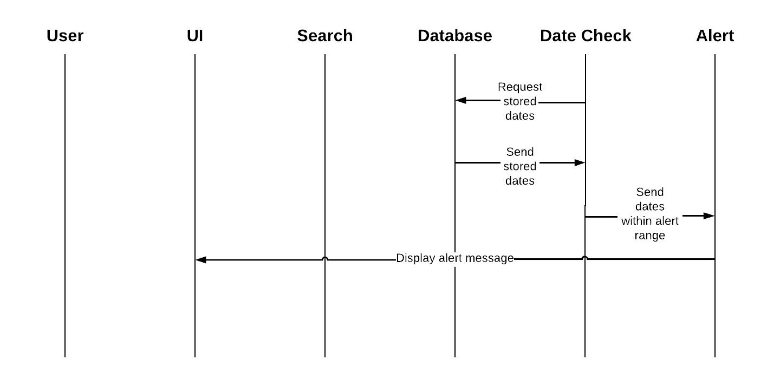

**Error-handling scenario 1:**