**USER’S**

**GUIDE**

***Forget Me Not***

**for Organizing Life’s Events**

By: Hunter Robinson, Jered Russell, Keith Tulloch

University of Maryland University College

**Revision Sheet**

|  |  |  |
| --- | --- | --- |
| **Revision No.** | **Date** | **Revision Description** |
| R.0 | 09/26/18 | User’s Guide Created |
| R.1 | 10/04/18 | Added information to all areas as outlined in previous revision. Added images. Edited formatting for easier readability. |
|  |  |  |
|  |  |  |
|  |  |  |
|  |  |  |

**USER'S MANUAL**

**TABLE OF CONTENTS**

Page #

1.0 GENERAL INFORMATION 1-1

1.1 Purpose 1-1

1.2 Scope 1-1

2.0 SYSTEM SUMMARY 2-1

2.1 System Requirements 2-1

2.2 Key Features 2-1

3.0 GETTING STARTED 3-1

3.1 Install 3-1

3.2 First Time Users 3-1

3.3 Access Control 3-1

4.0 USING the CLIENT APPLICATION 4-1

4.1 Starting Forget Me Not 4-1

4.2 User Interface Layout 4-1

4.3 Adding a Special Occasion Entry 4-1

4.4 Search Function 4-1

4.5 Deleting a Special Occasion Entry 4-1

4.6 Enabling Reminders 4-2

5.0 APPENDIX A - REFERENCE DOCUMENTS 5-1

5.1 Appendix A – Reference Documents 5-1

6.0APPENDIX A - REFERENCE DOCUMENTS 6-1

6.1 Appendix B – Glossary of Terms 5-1

**1.0 GENERAL INFORMATION**

# GENERAL INFORMATION

## 1.1 Purpose

The purpose of Forget Me Not is to store, organize, and remind a user about special occasions. This is accomplished by the user inputting a new entry into user interface (UI) upon application launch. The entries are stored in a database to be queried for. Reminders are generated per special occasion by request from user.

## 1.2 Scope

This guide covers only user operation of Forget Me Not and does not provide troubleshooting information. The guide assumes that the system employing Forget Me Not meets all requirements outlined within this guide.

**2.0 SYSTEM SUMMARY**

# SYSTEM SUMMARY

## 2.1 System Requirements

## Forget Me Not requires:

* Windows Vista or greater
* Mac OSX 10.7 or greater
* Java JRE 8.0 or greater

## 2.2 Key Features

**3.0 GETTING STARTED**

# GETTING STARTED

## 3.3 Install

The delivered .jar file is executable and does not need to be installed. Java JRE 7 or higher is required for Forget Me Not to execute.

## 3.3 First Time Users

It is recommended the first time user do the following:

* Place ForgetMeNot.jar inside a folder. (Multiple files will be created during execution)
* Control Forget Me Not through keyboard and mouse.
* Internet access is not required at any point for Forget Me Not.

## 3.3 Access Control

This application does not have security measures in place to prevent unauthorized access. All user inputted data is saved to the machine’s local disk drive. To prevent unauthorized access use on personal computer that has predictable user activity.

**4.0 USING THE APPLICATION**

# USING the CLIENT APPLICATION

## 4.1 Starting Forget Me Not

To start Forget Me not, open ForgetMeNot.jar by double-clicking icon.

🡨-------- INSERT IMAGE HERE ---------🡪

Forget Me Not will open and the user interface will be visible as shown below.

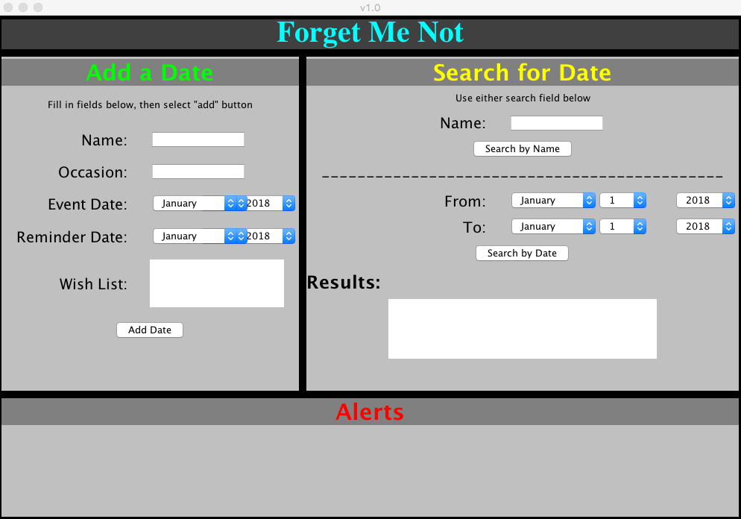

## 4.2 User Interface Layout

It is recommended the first time user do the following:

* Place ForgetMeNot.jar inside a folder. (Multiple files will be created during execution)
* Control Forget Me Not through keyboard and mouse.
* Internet access is not required at any point for Forget Me Not.

## 4.3 Adding a Special Occasion Entry

It is recommended the first time user do the following:

* Place ForgetMeNot.jar inside a folder. (Multiple files will be created during execution)
* Control Forget Me Not through keyboard and mouse.
* Internet access is not required at any point for Forget Me Not.

## 4.4 Search Function

It is recommended the first time user do the following:

* Place ForgetMeNot.jar inside a folder. (Multiple files will be created during execution)
* Control Forget Me Not through keyboard and mouse.
* Internet access is not required at any point for Forget Me Not.

## 4.5 Deleting a Special Occasion Entry

It is recommended the first time user do the following:

* Place ForgetMeNot.jar inside a folder. (Multiple files will be created during execution)
* Control Forget Me Not through keyboard and mouse.
* Internet access is not required at any point for Forget Me Not.

## 4.6 Enabling Reminders

It is recommended the first time user do the following:

* Place ForgetMeNot.jar inside a folder. (Multiple files will be created during execution)
* Control Forget Me Not through keyboard and mouse.
* Internet access is not required at any point for Forget Me Not.

**5.0 APPENDIX A – REFERENCE DOCUMENTS**

# APPENDIX A - REFERENCE DOCUMENTS

**6.0 APPENDIX B – GLOSSARY OF TERMS**

6.1 Appendix B – Glossary of Terms

|  |  |
| --- | --- |
| **Term** | **Meaning** |
| **.jar** | Java archive file is used to aggregate many Java class files and other associated files into one file for distribution |
| **JRE** | Java Runtime Environment. An application provided by Oracle that provides for execution of java applications. |
| **Database** | A storage system for managing data on computers. Usually a database is stored separately from the application that uses the information stored in the database. |
|  |  |
|  |  |
|  |  |